Eksamen 2015

Exercise 1:
$$\frac{2}{3}x_{T}=4$$
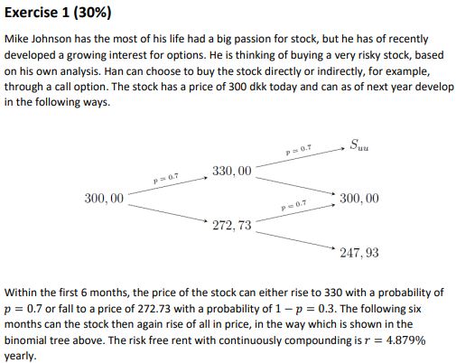
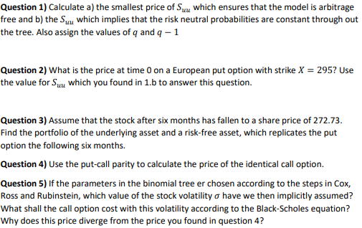
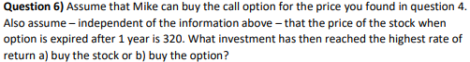
1)
First, we calculate the rate at which we are going up and down respectively.
$$d=\frac{272,73}{300}=0,9091$$
$$u=\frac{330}{300}=1,1$$

Then we calculate the discount rate by the formula for continuous compounded risk-free rate:
$$d_{t}=e^{-r·t}$$
$$d_{t,Δt}=e^{-0,04879·0,5}≈0,97590015$$
$$\frac{1}{d_{t,Δt}}=e^{0,04879·0,5}≈1,024695$$
For the model to be free of arbitrage, we must have that:
$$d<\frac{1}{d_{t,Δt}}<u$$
$$0,9091<1,0247<1,1$$
We assume now we can vary $u$. We find the $S_{uu}$ where $u≥1/d_{t,Δt}$
$$330·1,0247≈338,151$$
Since we must have a sharp inequality, the smallest price will be infinitesimal greater than 338,151.
b)
We know that formula for the risk-neutral probability $q$ is given by:
$$q=\frac{\frac{1}{d_{t,Δt}}-d}{u-d}$$
For a one-period model. We calculate $q$.
$$q=\frac{e^{0,04879·0,5}-0,9091}{1,1-0,9091}≈0,60552641$$
$$1-q=1-0,6055≈0,3945$$
At the first period $u=1,1$. If we change $u$ in the second period, we will also change $q$. Hence $u$ must remain constantly equal to $1,1$. The price then becomes:
$$S_{uu}=330·1,1=363,0000000000001$$

2)
We use the general pricing formula for a derivative:
$$P_{0}=d_{0,T}·E^{Q}\left[f\left(S\left(T\right)\right)\right]$$
Where $f\left(S\left(T\right)\right)$ is the payoff function evaluated in at maturity. We remember that the payoff function for a put option is given by:
$$\max\left(K-S\left(T\right);0\right)$$
We calculate the price.
$$P_{0}=e^{-2·0,04879·0,5}·\left({0,6055}^{2}·0+2·0,6055·0,3945·0+{0,3945}^{2}·\left(295-247,93\right)\right)≈6,9766829$$
3)
The amount of stocks we invest in the underlying asset is given by:
$$x=\frac{P_{u}-P_{d}}{\left(u-d\right)·S\left(0\right)}$$
And the amount we invest in the risk-free asset is given by:
$$b=d_{t,Δt}\frac{uP_{d}-dP_{u}}{\left(u-d\right)}$$
$$x=\frac{\max\left(295-300;0\right)-\max\left(295-247,93;0\right)}{\left(1,1-0,9091\right)·272,73}=-0,9040768680841211$$
$$b=e^{-0,04879·0,5}·\frac{1,1·\max\left(295-247,93;0\right)-0,9091·\max\left(295-300;0\right)}{\left(1,1-0,9091\right)}≈264,68927$$
Hence, we short $-0,9041$ of the underlying and invest 264,6893 in the bank.
4)
We use put-call parity to find the price of the call option. Put-call parity is given by:
$$C_{t}-P_{t}+d_{t,T}K=S\left(t\right)⇔C_{t}=S\left(t\right)+P_{t}-d_{t,T}·K$$
We set $t=0$ since we want to find the price today.
$$C_{0}=300+6,9767-e^{-2·0,04879·0,5}·295≈26,024273$$

5)
We need to use the estimation:
$$u=e^{σ·\sqrt{Δt}}$$
$$Δt=0,5$$
$$σ=\frac{\ln\left(1,1\right)}{\sqrt{0,5}}≈0,13478895$$
$$d_{1}=\frac{\ln\left(\frac{300}{295}\right)+\left(0,04879+\frac{{0,1348}^{2}}{2}\right)·1}{0,1348·\sqrt{1}}≈0,55402551$$
$$d_{2}=0,554-0,1348·\sqrt{1}=0,4192$$
$$Φ\left(d_{1}\right)=\frac{1}{\sqrt{2π}}\int_{-∞}^{0,554}{e^{\frac{-x^{2}}{2}}dx}≈0,71021058$$
$$Φ\left(d_{2}\right)=\frac{1}{\sqrt{2π}}\int_{-∞}^{0,4192}{e^{\frac{-x^{2}}{2}}dx}=\frac{\operatorname{erf}\left(0,2096·\sqrt{2}\right)+1}{2}≈0,66246501$$
$$C_{0}=300·0,7102-295·e^{-0,04879·1}·0,6625≈26,929017$$
6)
The rate of return on the stock is
$$\frac{320-300}{300}=\frac{1}{15}≈0,066666667$$
The rate of return on the call option is
$$\frac{320-295-26,0243}{26,0243}≈-0,039359368$$
Hence, the rate of return is better on buying the stock.

Exercise 2:
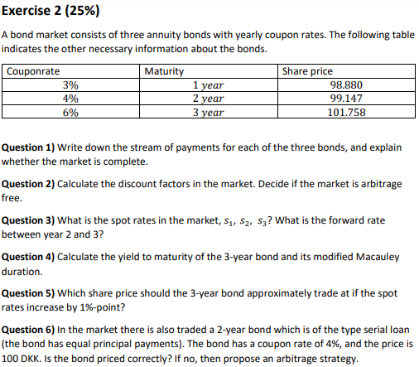

1)
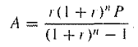
$$A_{1}=\frac{0,03·\left(1+0,03\right)·100}{\left(1+0,03\right)-1}≈103$$
$$A_{2}=\frac{0,04·{\left(1+0,04\right)}^{2}·100}{{\left(1+0,04\right)}^{2}-1}≈53,01961$$
$$A_{3}=\frac{0,06·{\left(1+0,06\right)}^{3}·100}{{\left(1+0,06\right)}^{3}-1}≈37,41098$$

$$B=\left(\begin{matrix}103 & 0 & 0 \\ 53,0196 & 53,0196 & 0 \\ 37,411 & 37,411 & 37,411\end{matrix}\right)$$
The market is complete if the payment matrix $B$ has full rank.
$${\left(\begin{matrix}103 & 0 & 0 \\ 53,0196 & 53,0196 & 0 \\ 37,411 & 37,411 & 37,411\end{matrix}\right)}^{-1}≈\left(\begin{matrix}0,009708738 & 0 & 0 \\ -0,009708738 & 0,01886095 & 0 \\ 0 & -0,01886095 & 0,02673011\end{matrix}\right)$$
Since it is invertible, it has full rank, and the market is complete.

2)
We know that the price of the price vector for the annuities is given by:
$$P=B·d$$
Where $d$ is a vector of discount factors. Since $B$ is invertible we can find the discount factors.
$$P=B·d⇒d=B^{-1}·P$$
$${\left(\begin{matrix}103 & 0 & 0 \\ 53,0196 & 53,0196 & 0 \\ 37,411 & 37,411 & 37,411\end{matrix}\right)}^{-1}·\left(\begin{aligned}98,880 \\ 99,147 \\ 101,758\end{aligned}\right)≈\left(\begin{matrix}0,96 \\ 0,9100066 \\ 0,8499956\end{matrix}\right)$$
Since the discount factors are strictly positive and they solve the equation $P=B·d$, there is no arbitrage.
3)
$$d_{k}=\frac{1}{{\left(1+s_{k}\right)}^{k}}⇒{\left(1+s_{k}\right)}^{k}=\frac{1}{d_{k}}⇒s_{k}=\frac{1}{d_{k}^{\frac{1}{k}}}-1$$
$$s=\left(\begin{aligned}s_{1} \\ s_{2} \\ s_{3}\end{aligned}\right)=\left(\begin{aligned}\frac{1}{0,96}-1 \\ \frac{1}{{0,91}^{\frac{1}{2}}}-1 \\ \frac{1}{{0,85}^{\frac{1}{3}}}-1\end{aligned}\right)≈\left(\begin{matrix}0,04166667 \\ 0,04828484 \\ 0,05566719\end{matrix}\right)$$
Forward rate:

$$f_{ij}={\left(\frac{{\left(1+s_{j}\right)}^{j}}{{\left(1+s_{i}\right)}^{i}}\right)}^{\frac{1}{j-i}}-1={\left(\frac{d_{i}}{d_{j}}\right)}^{\frac{1}{j-i}}-1$$
$$f_{2,3}={\left(\frac{0,91}{0,85}\right)}^{\frac{1}{3-2}}-1≈0,07058824$$

4)
$$P=\frac{a}{λ}·\left(1-\frac{1}{{\left(1+\frac{λ}{m}\right)}^{mT}}\right)$$
Third annuity:
$$101,758=\frac{37,411}{λ}·\left(1-\frac{1}{{\left(1+λ\right)}^{3}}\right)$$
$⇕$ Ligningen løses for λ vha. WordMat.
$$λ=0,05063673$$
Generel formel for yield. Samme som at diskontere med spot rates. Blot med flad spot-rate struktur. Den e
$$101,758=\frac{37,411}{1+λ}+\frac{37,411}{{\left(1+λ\right)}^{2}}+\frac{37,411}{{\left(1+λ\right)}^{3}}$$
$⇕$ Ligningen løses for λ vha. WordMat.
$$λ=0,05063683$$

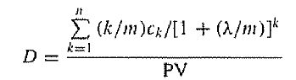
$$\frac{1·\frac{37,411}{1+0,0506}+2·\frac{37,411}{{\left(1+0,0506\right)}^{2}}+3·\frac{37,411}{{\left(1+0,0506\right)}^{3}}}{101,758}≈1,967241$$
$$D_{Mac}=\left(1+λ\right)·D_{Mod}⇒D_{Mod}=\frac{D_{Mac}}{1+λ}=\frac{1,9672}{1+0,0506}≈1,872454$$
5)

$$P=A·\left({\left(1+s_{1}\right)}^{-1}+{\left(1+s_{2}\right)}^{-2}+{\left(1+s_{3}\right)}^{-3}\right)$$
Now we add 1 percentage point to each spot rate.
$$P=\frac{37,411}{\left(1+0,0517\right)}+\frac{37,411}{{\left(1+0,0583\right)}^{2}}+\frac{37,411}{{\left(1+0,0657\right)}^{3}}≈99,88432$$

6)
We first check if it is priced correctly:
Let $B_{SB}=\left(\begin{matrix}54 & 52 & 0\end{matrix}\right)$ be the cash flow of the serial bond. Then $P=B_{SB}·d$.
$$P=\left(\begin{matrix}54 & 52 & 0\end{matrix}\right)·\left(\begin{matrix}0,96 \\ 0,9100066 \\ 0,8499956\end{matrix}\right)≈99,16034$$
The asset is not priced correctly. It is too cheap. Hence, there is an arbitrage. We want to construct a portfolio of the existing asses that replicates the cash flow of the serial bond.
$$\left(\begin{matrix}a & b & c\end{matrix}\right)·\left(\begin{matrix}103 & 0 & 0 \\ 53,0196 & 53,0196 & 0 \\ 37,411 & 37,411 & 37,411\end{matrix}\right)=\left(\begin{matrix}54 & 52 & 0\end{matrix}\right)$$
$$⇒\left(\begin{matrix}a & b & c\end{matrix}\right)=\left(\begin{matrix}54 & 52 & 0\end{matrix}\right)·{\left(\begin{matrix}103 & 0 & 0 \\ 53,0196 & 53,0196 & 0 \\ 37,411 & 37,411 & 37,411\end{matrix}\right)}^{-1}≈\left(\begin{matrix}0,01941748 & 0,9807694 & 0\end{matrix}\right)$$
$$θ≔\left(\begin{matrix}0,01941748 & 0,9807694 & 0\end{matrix}\right)$$
$$P_{pf}=\left(\begin{matrix}0,01941748 & 0,9807694 & 0\end{matrix}\right)·\left(\begin{aligned}98,880 \\ 99,147 \\ 101,758\end{aligned}\right)≈99,16034$$
We buy the portfolio and sell the asset.
 | $$t=0$$ | $$t=1$$ | $$t=2$$ | $$t=3$$
Serial Bond | $$100$$ | $$-54$$ | $$-52$$ | $$0$$
Portfolio | $$-99,16$$ | $$θ·\left(\begin{aligned}103 \\ 53,0196 \\ 37,411\end{aligned}\right)≈54$$ | $$θ·\left(\begin{aligned}0 \\ 53,0196 \\ 37,411\end{aligned}\right)≈52$$ | $$θ·\left(\begin{aligned}0 \\ 0 \\ 37,411\end{aligned}\right)=0$$
Total | $$100-99,16≈0,84$$ | $$0$$ | $$0$$ | 0

Wee see that we receive a net gain of 0,84. This can be scaled to make it a significant arbitrage.

Exercise 3:
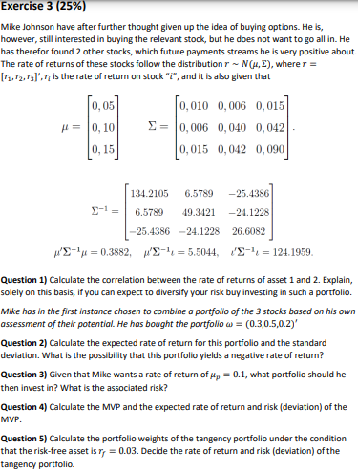
$$\left(\begin{matrix}1 & 1 & 1\end{matrix}\right)·\left(\begin{matrix}134,2105 & 6,5789 & -25,4386 \\ 6,5789 & 49,3421 & -24,1228 \\ -25,4386 & -24,1228 & 26,6082\end{matrix}\right)·\left(\begin{aligned}0,05 \\ 0,1 \\ 0,15\end{aligned}\right)≈5,5044$$
1)
$$ρ_{12}=\frac{σ_{12}}{σ_{1}·σ_{2}}=\frac{0,006}{\sqrt{0,010}·\sqrt{0,040}}≈0,3$$
Since the correlation is not far from 1, they assets don’t affect each other to a big degree. Hence, we can diversify some risk away.
2)
$$\overline{r}=\left(\begin{matrix}0,3 & 0,5 & 0,2\end{matrix}\right)·\left(\begin{aligned}0,05 \\ 0,1 \\ 0,15\end{aligned}\right)=0,095$$
$$σ_{p}^{2}=\left(\begin{matrix}0,3 & 0,5 & 0,2\end{matrix}\right)·\left(\begin{matrix}0,010 & 0,006 & 0,015 \\ 0,006 & 0,040 & 0,042 \\ 0,015 & 0,042 & 0,090\end{matrix}\right)·\left(\begin{aligned}0,3 \\ 0,5 \\ 0,2\end{aligned}\right)=0,0265$$
$$σ_{p}=\sqrt{0,0265}≈0,16279$$
$$P\left(w·r<0\right)$$
Since, $r∼N\left(μ,Σ\right)$ and $w$ is a constant, we have that $w·r∼N\left(w·μ,w^{2}·Σ\right)$. Since it is not a standard normal distribution, we calculate the value of the cdf using excel. Here we let $\overline{r}$ determine the concrete value of the mean and $σ_{p}$ determine the concrete value of the standard deviation. This gives us the following value:
Hence there is 27,9766% chance of getting negative return.
3)
If he invests all in asset two, that it is $w={\left(\begin{matrix}0 & 1 & 0\end{matrix}\right)}^{T}$, He gets an expected return of
$$\left(\begin{matrix}0 & 1 & 0\end{matrix}\right)·\left(\begin{aligned}0,05 \\ 0,1 \\ 0,15\end{aligned}\right)=0,1$$
The risk associated would be $σ_{2}=\sqrt{0,040}=0,2$
4)
$$w_{MVP}=\frac{1}{a}Σ^{-1}·l$$
$$w_{MVP}=\frac{1}{124,1959}·\left(\begin{matrix}134,2105 & 6,5789 & -25,4386 \\ 6,5789 & 49,3421 & -24,1228 \\ -25,4386 & -24,1228 & 26,6082\end{matrix}\right)·\left(\begin{aligned}1 \\ 1 \\ 1\end{aligned}\right)≈\left(\begin{matrix}0,92878 \\ 0,25603 \\ -0,18481\end{matrix}\right)$$
$${\overline{r}}_{MVP}=\frac{b}{a}=\frac{5,5044}{124,1959}≈0,04432$$
$$σ_{MVP}^{2}=\frac{1}{a}=\frac{1}{124,1959}≈0,0080518$$
$$σ_{MVP}=\sqrt{0,0081}=0,09$$

5)
$$w_{tan}=\frac{Σ^{-1}·{\overline{r}}^{e}}{l^{T}·Σ^{-1}·{\overline{r}}^{e}}$$
$${\overline{r}}^{e}=r-r_{f}=\left(\begin{aligned}0,05 \\ 0,10 \\ 0,15\end{aligned}\right)-0,03≈\left(\begin{matrix}0,02 \\ 0,07 \\ 0,12\end{matrix}\right)$$
$$w_{tan}=\frac{\left(\begin{matrix}134,2105 & 6,5789 & -25,4386 \\ 6,5789 & 49,3421 & -24,1228 \\ -25,4386 & -24,1228 & 26,6082\end{matrix}\right)·\left(\begin{matrix}0,02 \\ 0,07 \\ 0,12\end{matrix}\right)}{\left(\begin{matrix}1 & 1 & 1\end{matrix}\right)·\left(\begin{matrix}134,2105 & 6,5789 & -25,4386 \\ 6,5789 & 49,3421 & -24,1228 \\ -25,4386 & -24,1228 & 26,6082\end{matrix}\right)·\left(\begin{matrix}0,02 \\ 0,07 \\ 0,12\end{matrix}\right)}≈\left(\begin{matrix}0,051786 \\ 0,38841 \\ 0,5598\end{matrix}\right)$$
$${\overline{r}}_{tan}=\left(\begin{matrix}0,0518 & 0,3884 & 0,5598\end{matrix}\right)·\left(\begin{aligned}0,05 \\ 0,10 \\ 0,15\end{aligned}\right)=0,1254$$
$$σ_{tan}^{2}=\left(\begin{matrix}0,0518 & 0,3884 & 0,5598\end{matrix}\right)·\left(\begin{matrix}0,010 & 0,006 & 0,015 \\ 0,006 & 0,040 & 0,042 \\ 0,015 & 0,042 & 0,090\end{matrix}\right)·\left(\begin{aligned}0,0518 \\ 0,3884 \\ 0,5598\end{aligned}\right)≈0,05364$$
$$σ_{tan}=\sqrt{0,0536}≈0,23152$$
6.
The capital market line is given by:
$${\overline{r}}_{p}=r_{f}+\frac{{\overline{r}}_{M}-r_{f}}{σ_{M}}·σ_{p}$$
Where $M$ is the market portfolio. Assuming CAPM holds the market portfolio is equal to the tangency portfolio.
$${\overline{r}}_{p}=0,03+\frac{0,1254-0,03}{0,2315}·σ_{p}≈0,4121·σ_{p}+0,03$$
It is drawn graphically below.
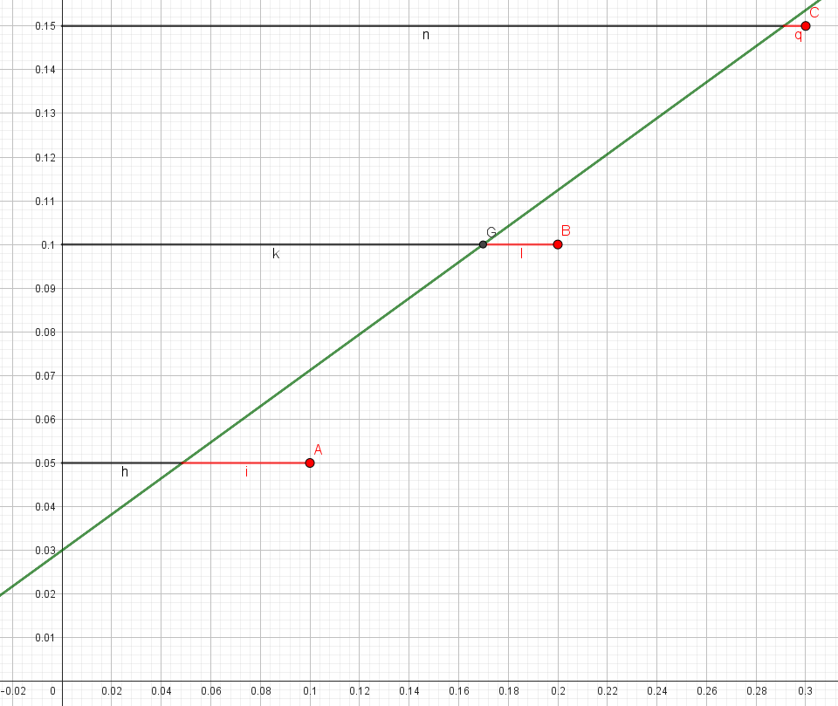
Here the points A, B, and C refer to asset 1, asset 2, and asset 3 respectively. The green graph is the capital market line. The black line refers to the systematic risk for each asset and the red line refers to the idiosyncratic risk.

Exercise 4:
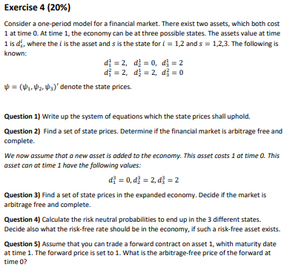
1)
We know that the state prices must uphold the following equation:
$$P=D·ψ⇔\left(\begin{aligned}1 \\ 1\end{aligned}\right)=\left(\begin{matrix}2 & 0 & 2 \\ 2 & 2 & 0\end{matrix}\right)·\left(\begin{aligned}ψ_{1} \\ ψ_{2} \\ ψ_{3}\end{aligned}\right)$$
$$2ψ_{1}+2ψ_{3}=1$$
$$2ψ_{1}+2ψ_{2}=1$$
2)
We let $ψ_{1}=ψ_{2}=ψ_{3}=\frac{1}{4}$. Then the left side is equal to:
$$2·\frac{1}{4}+2·\frac{1}{4}=1$$
$$2·\frac{1}{4}+2·\frac{1}{4}=1$$
Since $ψ≫0$ the market is free of arbitrage.
The system of equations can also be solved by letting $ψ_{1}=\frac{1}{2},ψ_{2}=ψ_{3}=0$. Since there exists at least 2 sets of state prices that solves the equations, the market is not complete.
3)
We update the matrix $D$.
$$P=D·ψ⇔\left(\begin{aligned}1 \\ 1 \\ 1\end{aligned}\right)=\left(\begin{matrix}2 & 0 & 2 \\ 2 & 2 & 0 \\ 0 & 2 & 2\end{matrix}\right)·\left(\begin{aligned}ψ_{1} \\ ψ_{2} \\ ψ_{3}\end{aligned}\right)$$
$$D^{-1}={\left(\begin{matrix}2 & 0 & 2 \\ 2 & 2 & 0 \\ 0 & 2 & 2\end{matrix}\right)}^{-1}=\left(\begin{matrix}0,25 & 0,25 & -0,25 \\ -0,25 & 0,25 & 0,25 \\ 0,25 & -0,25 & 0,25\end{matrix}\right)$$
$$ψ=D^{-1}·P={\left(\begin{matrix}2 & 0 & 2 \\ 2 & 2 & 0 \\ 0 & 2 & 2\end{matrix}\right)}^{-1}·\left(\begin{aligned}1 \\ 1 \\ 1\end{aligned}\right)=\left(\begin{matrix}0,25 \\ 0,25 \\ 0,25\end{matrix}\right)$$
Since $D$ is invertible, it has full rank. Therefore the state prices are unique and hence, the market is complete.
4)
The risk-neutral probabilities are given by:
$$q_{s}=\frac{ψ_{s}}{\sum_{s=1}^{S}{ψ_{s}}}$$
Since all three state prices are equal, so is the risk-neutral probabilities.
$$q_{1}=q_{2}=q_{3}=\frac{0,25}{3·0,25}≈0,33333$$
The risk-free rate solves the following equation:
$$ψ_{0}=\frac{1}{1+r_{f}}$$
$$0,75=\frac{1}{1+r_{f}}$$
$⇕$ Ligningen løses for r_f vha. WordMat.
$$r_{f}=0,33333$$
Since the risk-free rate has return of one third, which is absurdly high, it is fair to assume it does not exist.
5)
We know the formula for forward price is given by:
$$F_{0,T}=\frac{S\left(0\right)}{d_{0,T}}$$
Since both $F_{0,T}$ and $S\left(0\right)$ is equal to 1, we must have that the discount factor is equal to 1.
The price of the forward is given by: $P_{0}=d_{0,T}·E^{Q}\left[f\left(S\left(T\right)\right)\right]$
The payoff function depends on whether we buy it or sell it.
$$f\left(S\left(T\right)\right)=S\left(T\right)-F_{0,T} \left(if we buy\right)$$
$$f\left(S\left(T\right)\right)=F_{0,T}-S\left(T\right) \left(if we sell\right)$$
It is clear to see that the price will be equal in the two cases, just with different signs.
$$P_{0}=\left(0,33·\left(2-1\right)+0,33·\left(2-1\right)+0,33·\left(0-1\right)\right)=0,33$$
$$P_{0}=\frac{1}{1+0,3333}·\left(0,33·\left(2-1\right)+0,33·\left(2-1\right)+0,33·\left(0-1\right)\right)≈0,24750619$$

Reeksamen 2015:

Exercise 1:
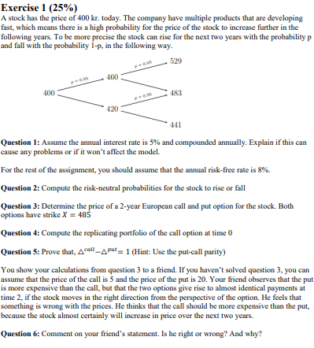
$$u=\frac{460}{400}=1,15$$
$$d=\frac{420}{400}=1,05$$
Since it has not been specified, we assume that the interest is discretely compounded. In that case the discount is defined by:
$$d_{t,t+Δt}=\frac{1}{1+r}⇔{\left(d_{t,t+Δt}\right)}^{-1}=1+r=1,05$$
Since $\frac{1}{d_{t,t+Δt}}=d$ there exists arbitrage which can cause problems.
$$q=\frac{\frac{1}{d_{t,Δt}}-d}{u-d}$$
$$q=\frac{1+0,08-1,05}{1,15-1,05}≈0,3$$
$$1-q=1-0,3=0,7$$

$$P_{0}=d_{0,T}·E^{Q}\left(f\left(S\left(T\right)\right)\right]$$
$$f\left(S\left(T\right)\right)=\max\left(S\left(T\right)-K;0\right)$$
$$P_{0}=\frac{1}{{\left(1+0,08\right)}^{2}}·\left({0,3}^{2}·\max\left(529-485;0\right)+2·0,3·0,7·\max\left(483-485;0\right)+{0,7}^{2}·\max\left(441-485;0\right)\right)≈3,3951$$
For the put price the payoff function is instead $f\left(S\left(T\right)\right)=\max\left(K-S\left(T\right);0\right)$
$$P_{0}=\frac{1}{{\left(1+0,08\right)}^{2}}·\left({0,3}^{2}·\max\left(485-529;0\right)+2·0,3·0,7·\max\left(485-483;0\right)+{0,7}^{2}·\max\left(485-441;0\right)\right)≈19,204$$
The amount we invest in the underlying:
$$x=\frac{C_{u}-C_{d}}{\left(u-d\right)·S_{0}}$$
$$b=d_{t,Δt}·\frac{u·C_{d}-d·C_{u}}{\left(u-d\right)}$$
Since these counts for a single-period model and we have a two-period model, we need to find $C_{u}$ and $C_{d}$ recursively.
$$C_{u}=\frac{1}{1+r}·\left(q·C_{uu}+\left(1-q\right)·C_{ud}\right)=\frac{1}{1+0,08}·\left(0,3·44+0,7·0\right)≈12,2222$$
$$C_{d}=\frac{1}{1+r}·\left(q·C_{ud}+\left(1-q\right)·C_{dd}\right)=\frac{1}{1+0,08}·\left(0,3·0+0,7·0\right) =0$$
$$x=\frac{12,222}{\left(1,15-1,05\right)·400}≈0,3056$$
$$b=\frac{1}{{\left(1+0,08\right)}^{2}}·\frac{1,15·0-1,05·12,2222}{\left(1,15-1,05\right)}≈-110,025$$

$$C_{t}-P_{t}+d_{t,T}·K=S\left(t\right)$$
We define $g\left(t\right)=C_{t}-P_{t}+d_{t,T}·K$
Now we take the partial differential with $S$ to find the deltas.
$$\frac{∂}{∂S}\left(C_{t}-P_{t}+d_{t,T}·K\right)=\frac{∂}{∂S}S\left(t\right)⇒ΔC_{t}-ΔP_{t}=1$$
He is wrong. It is true that the call- and put option gives almost identical payoffs at maturity. But the call option only gives a positive payment in one case, where the put gives a positive payoff in two cases. And the chance of going down (which is beneficial for the put option) is more than double of going up. So it makes perfect sense that the put option is more expensive than the call option.
$$\frac{1}{1+}$$

$$δ$$

Exercise 2:
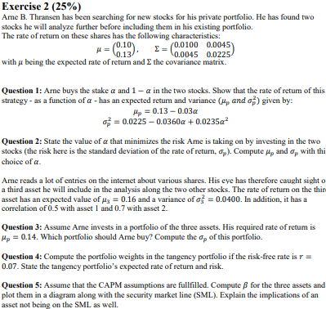
$$μ_{P}=w^{T}·μ=\left(\begin{matrix}α & \left(1-α\right)\end{matrix} \right)·\left(\begin{aligned}0,10 \\ 0,13\end{aligned}\right)=-0,03·α+0,13$$
$$σ_{p}^{2}=w^{T}·Σ·w=\left(\begin{matrix}α & \left(1-α\right)\end{matrix} \right)·\left(\begin{matrix}0,0100 & 0,0045 \\ 0,0045 & 0,0225\end{matrix}\right)·\left(\begin{aligned}α \\ \left(1-α\right)\end{aligned}\right)=0,0235·α^{2}-0,036·α+0,0225$$
$$\left(\begin{matrix}α & \left(1-α\right)\end{matrix} \right)·\left(\begin{matrix}0,0100 & 0,0045 \\ 0,0045 & 0,0225\end{matrix}\right)=\left(\begin{matrix}α·0,01+\left(1-α\right)·0,0045 & α·0,0045+\left(1-α\right)·0,0225\end{matrix}\right)$$
$$σ_{p}^{2}=α\left(α·0,01+\left(1-α\right)·0,0045\right)+\left(1-α\right)·\left(α·0,0045+\left(1-α\right)·0,0225\right)$$
Since we want to find the value of $α$ that minimizes risk, we take the derivative of $σ_{p}^{2}$with respect to $α$ and set it equal to zero.
$$\frac{∂σ_{p}^{2}}{∂α}=0⇒2·0,0235α-0,036=0$$
$⇕$ Ligningen løses for α vha. WordMat.
$$α=0,765957$$
Hence, $α=0,7660$
$$μ_{P}=w^{T}·μ=\left(\begin{matrix}0,7660 & \left(1-0,7660\right)\end{matrix} \right)·\left(\begin{aligned}0,10 \\ 0,13\end{aligned}\right)=0,10702$$
$$σ_{p}^{2}=w^{T}·Σ·w=\left(\begin{matrix}0,7660 & \left(1-0,7660\right)\end{matrix} \right)·\left(\begin{matrix}0,0100 & 0,0045 \\ 0,0045 & 0,0225\end{matrix}\right)·\left(\begin{aligned}0,7660 \\ \left(1-0,7660\right)\end{aligned}\right)≈0,00871277$$
$$σ_{p}=\sqrt{0,009}≈0,0948683$$
$$0,15·0,10+b·0,13+c·0,16=0,14$$
$$0,15+b+c=1$$
$⇕$ Ligningssystemet løses for b,c vha. WordMat's 'Løs Ligninger' funktion,
$$b=0,366667 ∧ c=0,483333$$
$$ρ_{13}=\frac{σ_{13}}{σ_{1}·σ_{3}}⇒σ_{13}=ρ_{13}·σ_{1}·σ_{3}=0,5·\sqrt{0,0100}·\sqrt{0,0400}≈0,01$$
$$ρ_{23}=0,7·\sqrt{0,0225}·\sqrt{0,0400}=0,021$$
$$σ_{p}^{2}=\left(\begin{matrix}0,15 & 0,3667 & 0,4833\end{matrix}\right)·\left(\begin{matrix}0,0100 & 0,0045 & 0,01 \\ 0,0045 & 0,0225 & 0,021 \\ 0,01 & 0,021 & 0,0400\end{matrix}\right)·\left(\begin{aligned}0,15 \\ 0,3667 \\ 0,4833\end{aligned}\right)≈0,0219821$$
$$σ_{p}=\sqrt{0,0212}≈0,145602$$

$$w_{tan}=\frac{Σ^{-1}·{\overline{r}}^{e}}{l^{T}·Σ^{-1}·{\overline{r}}^{e}}$$
$${\overline{r}}^{e}=r-r_{f}=\left(\begin{aligned}0,10 \\ 0,13 \\ 0,16\end{aligned}\right)-0,07=\left(\begin{matrix}0,03 \\ 0,06 \\ 0,09\end{matrix}\right)$$
$$w_{tan}=\frac{{\left(\begin{matrix}0,0100 & 0,0045 & 0,01 \\ 0,0045 & 0,0225 & 0,021 \\ 0,01 & 0,021 & 0,0400\end{matrix}\right)}^{-1}·\left(\begin{matrix}0,03 \\ 0,06 \\ 0,09\end{matrix}\right)}{\left(\begin{matrix}1 & 1 & 1\end{matrix}\right)·{\left(\begin{matrix}0,0100 & 0,0045 & 0,01 \\ 0,0045 & 0,0225 & 0,021 \\ 0,01 & 0,021 & 0,0400\end{matrix}\right)}^{-1}·\left(\begin{matrix}0,03 \\ 0,06 \\ 0,09\end{matrix}\right)}≈\left(\begin{matrix}0,306306 \\ 0,324324 \\ 0,369369\end{matrix}\right)$$
$${\overline{r}}_{tan}=\left(\begin{matrix}0,3063 & 0,3243 & 0,3694\end{matrix}\right)·\left(\begin{aligned}0,10 \\ 0,13 \\ 0,16\end{aligned}\right)≈0,131893$$
$$σ_{tan}^{2}=\left(\begin{matrix}0,3063 & 0,3243 & 0,3694\end{matrix}\right)·\left(\begin{matrix}0,0100 & 0,0045 & 0,01 \\ 0,0045 & 0,0225 & 0,021 \\ 0,01 & 0,021 & 0,0400\end{matrix}\right)·\left(\begin{matrix}0,3063 \\ 0,3243 \\ 0,3694\end{matrix}\right)≈0,0169512$$
$$σ_{tan}=\sqrt{0,0170}≈0,130384$$
Assuming CAPM holds, $w_{tan}=w_{M}.$
$${\overline{r}}_{i}-r_{f}=β_{i}·\left({\overline{r}}_{M}-r_{f}\right)⇒β_{i}=\frac{{\overline{r}}_{i}-r_{f}}{{\overline{r}}_{M}-r_{f}}$$
$$β_{1}=\frac{0,10-0,07}{0,1319-0,07}≈0,484653$$
SML: ${\overline{r}}_{i}=0,07+β_{i}·\left(0,1319-0,07\right)≈0,0619·β_{i}+0,07$
$$β_{2}=\frac{0,13-0,07}{0,1319-0,07}≈0,969305$$
$$β_{3}=\frac{0,16-0,07}{0,1319-0,07}≈1,45396$$
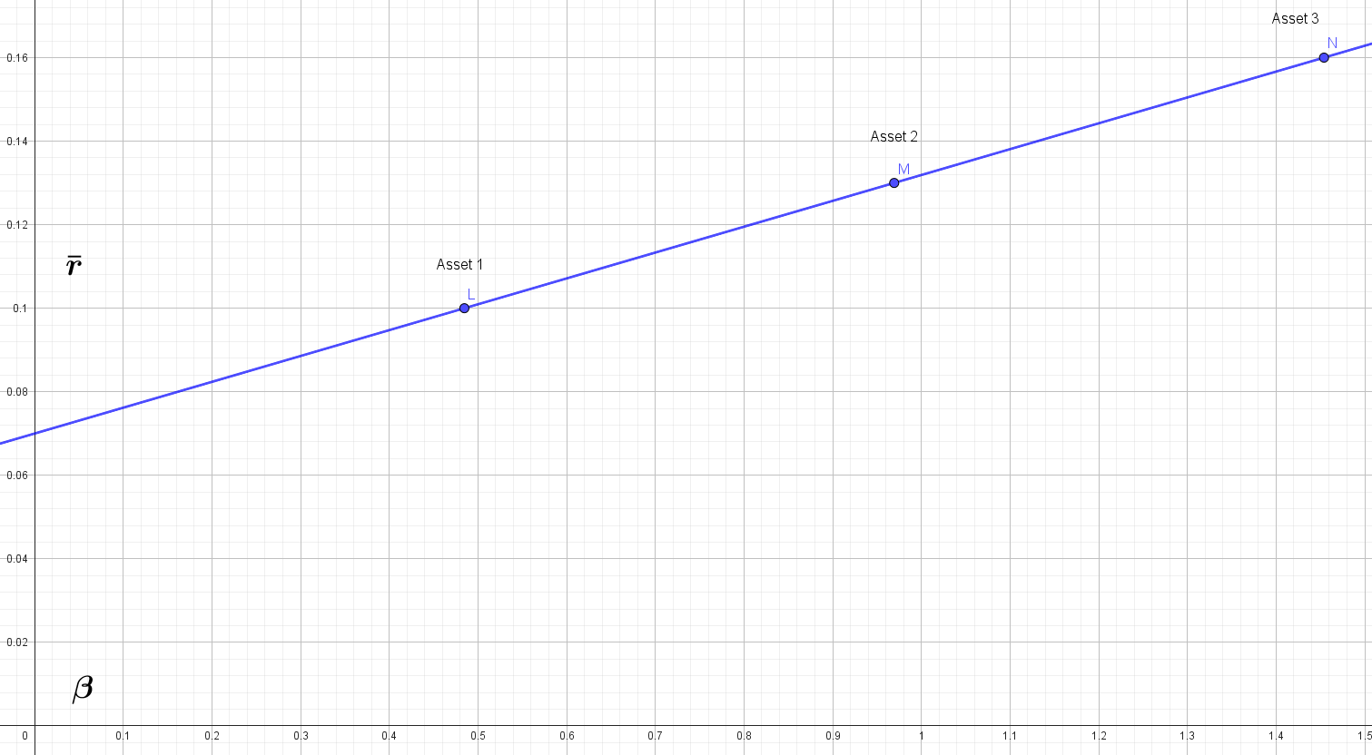

Exercise 3:
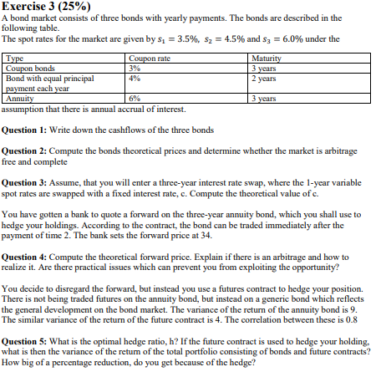
We first find the annual payment of the annuity:
$$A=\frac{c·{\left(1+c\right)}^{n}·P}{{\left(1+c\right)}^{n}-1}=\frac{0,06·{\left(1+0,06\right)}^{3}·100}{{\left(1+0,06\right)}^{3}-1}≈37,411$$
For the second bond, it pays out:
$$t=1:50+100·0,04=54$$
$$t=2:50+50·0,04=52$$
The payment matrix becomes:
$$B=\left(\begin{matrix}3 & 3 & 103 \\ 54 & 52 & 0 \\ 37,411 & 37,411 & 37,411\end{matrix}\right)$$
We find the three prices by discounting the cash flows using spot rates. We $P_{i}$ be the price of the $i$’th bond where $i=1,2,3$ and follows the order in the table above.
$$P_{1}=\frac{3}{1+0,035}+\frac{3}{{\left(1+0,045\right)}^{2}}+\frac{103}{{\left(1+0,06\right)}^{3}}≈92,1265$$
$$P_{2}=\frac{54}{1+0,035}+\frac{52}{{\left(1+0,045\right)}^{2}}+0≈99,7919$$
$$P_{3}=\frac{37,411}{1+0,035}+\frac{37,411}{{\left(1+0,045\right)}^{2}}+\frac{37,411}{{\left(1+0,06\right)}^{3}}≈101,815$$
We find the discount factors.
$$P=B·d⇒d=B^{-1}·P={\left(\begin{matrix}3 & 3 & 103 \\ 54 & 52 & 0 \\ 37,411 & 37,411 & 37,411\end{matrix}\right)}^{-1}·\left(\begin{aligned}92,1265 \\ 99,7919 \\ 101,815\end{aligned}\right)≈\left(\begin{matrix}0,96638 \\ 0,915526 \\ 0,839619\end{matrix}\right)$$
Since the vector of discount factors $d≫0$ there is no arbitrage. Since the payment matrix is invertible, it has full rank, and the discount factors are unique. Hence, the market is complete.

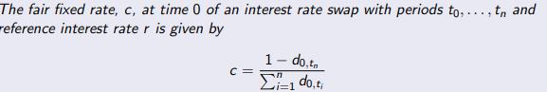
We note that $n=3$.
$$c=\frac{1-0,8396}{0,9664+0,9155+0,8396}≈0,0589381$$
So, the interest rate would be 0,0589.
We use the formula for forward price including cost of carry.
$$F_{0,T}=\frac{S\left(0\right)}{d_{0,T}}-\sum_{k=0}^{M}{\frac{c_{k}}{d_{k,T}}}$$
$$\frac{101,815}{0,9155}-37,411·\frac{0,9664}{0,9155}-37,411·\frac{0,9155}{0,9155}≈34,3105$$
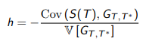
$$Cov\left(S\left(T\right),G_{T,T^{*}}\right)=ρ·\sqrt{V\left(S\left(T\right)\right)}·\sqrt{V\left(G_{T,T^{*}}\right)}=0,8·\sqrt{9}·\sqrt{4} ≈4,8$$
$$h=-\frac{4,8}{4}=-1,2$$
$$V\left(portfolio\right)=9+{\left(-1,2\right)}^{2}·4+2·\left(-1,2\right)·4,8=3,24$$
Change in variance:
$$\frac{3,24-9}{9}=-0,64$$
Hence, we have reduced the variance by 64%.

Exercise 4:
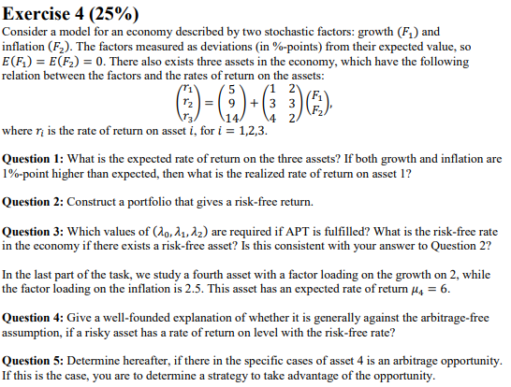
$${\overline{r}}_{i}=a_{i}+b_{1i}·{\overline{F}}_{1}+b_{2i}{\overline{F}}_{2i}$$
Since $E\left[F_{1}\right]=E\left[F_{2}\right]=0$, we have that ${\overline{r}}_{i}=a_{i}$
$$\overline{r}=\left(\begin{aligned}{\overline{r}}_{1} \\ {\overline{r}}_{2} \\ {\overline{r}}_{3}\end{aligned}\right)=\left(\begin{aligned}5 \\ 9 \\ 14\end{aligned}\right)$$
Now we assume $E\left[F_{1}\right]=E\left[F_{2}\right]=1$.
$$\overline{r}=\left(\begin{aligned}5 \\ 9 \\ 14\end{aligned}\right)+\left(\begin{matrix}1 & 2 \\ 3 & 3 \\ 4 & 2\end{matrix}\right)·\left(\begin{aligned}1 \\ 1\end{aligned}\right)=\left(\begin{matrix}8 \\ 15 \\ 20\end{matrix}\right)$$
$$r_{p}=w_{1}·r_{1}+w_{2}·r_{2}+\left(1-w_{1}-w_{2}\right)·r_{3}$$
$$w_{1}·\left(5+F_{1}+2·F_{2}\right)+w_{2}·\left(9+3F_{1}+3F_{2}\right)+\left(1-w_{1}-w_{2}\right)· \\ \left(14+4F_{1}+2F_{2}\right)$$
$$5w_{1}+9w_{2}+14\left(1-w_{1}-w_{2}\right)+F_{1}·(w_{1}+3w_{2}+4·\left(1-w_{1}-w_{2}\right)+F_{2}·(2w_{1}+3w_{2}+2·\left(1-w_{1}-w_{2}\right)$$
We now assume that:
$$a=5w_{1}+9w_{2}+14\left(1-w_{1}-w_{2}\right)$$
$$b_{1}=(w_{1}+3w_{2}+4·\left(1-w_{1}-w_{2}\right)$$
$$b_{2}=(2w_{1}+3w_{2}+2·\left(1-w_{1}-w_{2}\right)$$
$b_{i}$ is called factor loadings and they determine the sensitivity of the return of the asset in relation to $f_{1}$ and $f_{2}$. Therefore, we want to set those equal to 0. Hence we can solve for the portfolio weights.
$$\left(w_{1}+3w_{2}+4·\left(1-w_{1}-w_{2}\right)\right)=0$$
$$\left(2w_{1}+3w_{2}+2·\left(1-w_{1}-w_{2}\right)\right)=0$$
$⇕$ Ligningssystemet løses for w_1,w_2 vha. WordMat's 'Løs Ligninger' funktion,
$$w_{1}=2 ∧ w_{2}=-2$$
Since they are 3 assets and they have to sum to 1, we have that:
$$w_{3}=1-2+2=1$$
The portfolio is then:
$$w={\left(\begin{matrix}2 & -2 & 1\end{matrix}\right)}^{T}$$

$$\left(\begin{matrix}1 & 1 & 1 \\ - & b_{1}^{T} & - \\ - & b_{2}^{T} & -\end{matrix}\right)·\left(\begin{aligned}w_{1} \\ w_{2} \\ w_{3}\end{aligned}\right)=\left(\begin{aligned}1 \\ 0 \\ 0\end{aligned}\right)$$
$$\left(\begin{matrix}1 & 1 & 1 \\ 1 & 3 & 4 \\ 2 & 3 & 2\end{matrix}\right)·\left(\begin{aligned}a \\ b \\ c\end{aligned}\right)=\left(\begin{matrix}c+b+a \\ 4·c+3·b+a \\ 2·c+3·b+2·a\end{matrix}\right)=\left(\begin{aligned}1 \\ 0 \\ 0\end{aligned}\right)$$
$*$ Første række er kravet om at vægtene skal summe til 1. Anden række er vores $b_{1i }$’er og tredje række er $b_{2i}$’er.
$$a+b+c=1$$
$$a+3b+4c=0$$
$$2a+3b+2c=0$$
$⇕$ Ligningssystemet løses for a,b,c vha. WordMat's 'Løs Ligninger' funktion,
$$a=2 ∧ b=-2 ∧ c=1$$
$$Risk-free return: 2·5-2·9+14=6$$
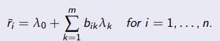
We write this in matrix form:
$$\overline{r}=\left(\begin{aligned}{\overline{r}}_{1} \\ {\overline{r}}_{2} \\ {\overline{r}}_{3}\end{aligned}\right)=\left(\begin{matrix}1 & 1 & 2 \\ 1 & 3 & 3 \\ 1 & 4 & 2\end{matrix}\right)·\left(\begin{aligned}λ_{0} \\ λ_{1} \\ λ_{2}\end{aligned}\right)⇒\left(\begin{aligned}λ_{0} \\ λ_{1} \\ λ_{2}\end{aligned}\right)={\left(\begin{matrix}1 & 1 & 2 \\ 1 & 3 & 3 \\ 1 & 4 & 2\end{matrix}\right)}^{-1}·\left(\begin{aligned}5 \\ 9 \\ 14\end{aligned}\right)≈\left(\begin{matrix}6 \\ 3 \\ -2\end{matrix}\right)$$
We know from slides that $r_{f}=λ_{0}=6$. Since the risk-free return on the portfolio was also 6, it is consistent.
It is generally not against the arbitrage-free assumption. Under the assumption of no arbitrage, the following equation must be true.
$${\overline{r}}_{i}=r_{f}+b_{1i}λ_{1}+b_{2i}λ_{2}$$
This can still be true if the factor loadings are zero or if they are perfectly negative correlated depending on the $λ's$.
We calculate the right side of the equation in the prior question.
$$6+2·3+2,5·\left(-2\right)=7≠6$$
Hence the is an arbitrage opportunity. We see that the asset should have an expected return on 7% and not 6%. Hence, we buy the asset and short the market.
 | $$t=0$$ | $$t=1$$
Asset | 1 | 0,07
market | -1 | -0,06
Total | 0 | 0,01
In each period we gain $1\%$ of the amount we buy and sell of the asset and market respectively.

Eksamen 2016

Exercise 1:
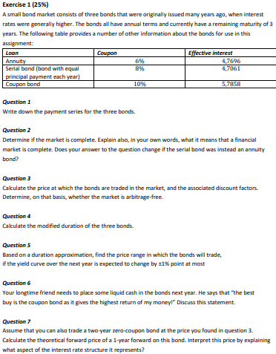
Annuity:
$$A=\frac{c·{\left(1+c\right)}^{n}·P}{{\left(1+c\right)}^{n}-1}=\frac{0,06·{\left(1+0,06\right)}^{3}·100}{{\left(1+0,06\right)}^{3}-1}≈37,411$$
Serial bond:
$$t=1:\frac{100}{3}+100·0,08≈41,3333$$
$$t=2:\frac{100}{3}+\left(100-\frac{100}{3}\right)·0,08≈38,6667$$
$$t=3:\frac{100}{3}+\left(100-\frac{200}{3}\right)·0,08=36$$
$$B=\left(\begin{matrix}37,411 & 37,411 & 37,411 \\ 41,3333 & 38,6667 & 36 \\ 10 & 10 & 110\end{matrix}\right)$$
We check whether the payment matrix is invrtible.
$$B^{-1}={\left(\begin{matrix}37,411 & 37,411 & 37,411 \\ 41,3333 & 38,6667 & 36 \\ 10 & 10 & 110\end{matrix}\right)}^{-1}≈\left(\begin{matrix}-0,39027 & 0,375009 & 0,0100004 \\ 0,419673 & -0,375009 & -0,0200004 \\ -0,00267301 & 0 & 0,01\end{matrix}\right)$$
It is invertible. Hence, the market is complete. Completeness means that all possible payment streams of a portfolio can be constructed from the existing assets in the market.
$$A^{'}=\frac{0,08·{\left(1+0,08\right)}^{3}·100}{{\left(1+0,08\right)}^{3}-1}≈38,8034$$
$$B=\left(\begin{matrix}37,411 & 37,411 & 37,411 \\ 38,8034 & 38,8034 & 38,8034 \\ 10 & 10 & 110\end{matrix}\right)$$
We can quickly notice that the first and second row are not linearly independent. Hence the matrix is not invertible at has not full rank. Hence, the market is now not complete.
Effective interest rate $r'$
$$r^{'}={\left(1+\frac{r}{m}\right)}^{m}-1=1+r-1 since m=1$$
$$P_{A}=\frac{37,411}{1+0,047696}+\frac{37,411}{{\left(1+0,047696\right)}^{2}}+\frac{37,411}{{\left(1+0,047696\right)}^{3}}≈102,321$$
$$P_{SB}=\frac{41,3333}{1+0,047061}+\frac{38,6667}{{\left(1+0,047061\right)}^{2}}+\frac{36}{{\left(1+0,047061\right)}^{3}}≈106,105$$
$$P_{B}=\frac{10}{\left(1+0,057858\right)}+\frac{10}{{\left(1+0,057858\right)}^{2}}+\frac{110}{{\left(1+0,057858\right)}^{3}}≈111,309$$
$$P=B·d⇒d=B^{-1}·P={\left(\begin{matrix}37,411 & 37,411 & 37,411 \\ 41,3333 & 38,6667 & 36 \\ 10 & 10 & 110\end{matrix}\right)}^{-1}·\left(\begin{aligned}102,321 \\ 106,105 \\ 111,309\end{aligned}\right)≈\left(\begin{matrix}0,970718 \\ 0,924748 \\ 0,839585\end{matrix}\right)$$
Since $d≫0$, the market is free of arbitrage.
$$D_{M}·\left(1+\frac{λ}{m}\right)=D_{Mac}⇒D_{M}=D_{Mac}·\frac{1}{1+\frac{λ}{m}}=\frac{1}{1+\frac{λ}{m}}·\frac{\sum_{k=1}^{n}{\frac{k}{m}·\frac{c_{k}}{{\left(1+\frac{λ}{m}\right)}^{k}}}}{P}$$
$$D_{M,A}=\frac{1}{1+0,047696}·\frac{\frac{37,411}{1+0,047696}+2·\frac{37,411}{{\left(1+0,047696\right)}^{2}}+3·\frac{37,411}{{\left(1+0,047696\right)}^{3}}}{102,321}≈1,87931$$
$$D_{M,SB}=\frac{1}{1+0,047061}·\frac{\frac{41,3333}{1+0,047061}+2·\frac{38,6667}{{\left(1+0,047061\right)}^{2}}+3·\frac{36}{{\left(1+0,047061\right)}^{3}}}{106,105}≈1,83707$$
$$D_{M,B}=\frac{1}{1+0,057858}·\frac{\frac{10}{1+0,057858}+2·\frac{10}{{\left(1+0,057858\right)}^{2}}+3·\frac{110}{{\left(1+0,057858\right)}^{3}}}{111,309}≈2,59948$$

The change in price when yield changes is given by:
$$ΔP=-D_{M}·P·Δλ$$

For the annuity bond:
$$ΔP=\left(-1,8793·102,321·0,01\right)≈-1,922919$$
$$ΔP=\left(-1,8793·102,321·\left(-0,01\right)\right)≈1,922919$$
$$P_{new}∈\left[102,321-1,9229;102,321+1,9229\right]=\left[100,3981;104,2439\right]$$
For the serial bond:
$$ΔP=\left[-1,8370·106,105·0,01;-1,8370·106,105·\left(-0,01\right)\right]≈\left[-1,949149;1,949149\right]$$
$$P_{new}∈\left[106,105-1,9491;106,105+1,9491\right]=\left[104,1559;108,0541\right]$$
For the coupon bond:
$$ΔP=\left[-2,5995·111,309·0,01;-2,5995·111,309·\left(-0,01\right)\right]≈\left[-2,893477;2,893477\right]$$
$$P_{new}∈\left[111,309-2,8935;111,309+2,8935\right]=\left[108,4155;114,2025\right]$$
It is true that the return on the coupon bond is bigger than the others. But there is also a downside, that is you must wait longer to get your money. With the coupon bond you only get paid the coupons until maturity where you also receive the face value. The others bond pays out the return more equally over the years. So, it depends on one’s preferences when it comes to importance of getting money now or later.
$$F_{0,T}=\frac{S\left(0\right)}{d_{0,T}}$$
$$F_{0,1}=\frac{111,309}{0,970718}$$

Exercise 2:
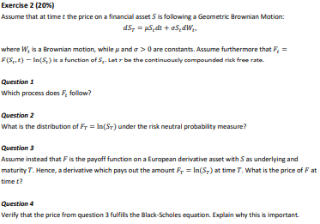
We use ito’s lemma:
$$dF_{t}=\left(\frac{∂F_{t}}{∂S_{t}}·a+\frac{∂F_{t}}{∂t}+\frac{1}{2}·\frac{∂^{2}F_{t}}{∂S_{t}^{2}}b^{2}\right)dt+\frac{∂F_{t}}{∂S_{t}}·b·dW_{t}$$
$$=\left(\frac{1}{S_{t}}·μ·S_{t}+0+\frac{1}{2}·\left(-\frac{1}{S_{t}^{2}}\right)·σ^{2}·S_{t}^{2}\right)dt+\frac{1}{S_{t}}σS_{t}dW_{t}$$
$$dF_{t}=\left(μ-\frac{1}{2}σ^{2}\right)dt+σdW_{t}$$
$$\ln{S_{t}}{Q \atop ∼} N\left(\ln\left(S_{t}\right)+\left(r-\frac{1}{2}σ^{2}\right)·\left(T-t\right),σ^{2}\left(T-t\right)\right)$$
$$\overset{̰}{a}$$
$$P_{0}=d_{0,T}·E^{Q}\left[f\left(S\left(T\right)\right)\right]$$
$$e^{-r·\left(T-t\right)}·E^{Q}\left[F_{T}\right]$$
$$=e^{-r·\left(T-t\right)}·E^{Q}\left[\ln\left(S_{T}\right)\right]=e^{-r·\left(T-t\right)}·\left(\ln\left(S_{t}\right)+\left(r-\frac{1}{2}σ^{2}\right)·\left(T-t\right)\right)$$

$$\frac{∂F_{t}}{∂t}+r·S_{t}·\frac{∂F_{t}}{∂S}+\frac{1}{2}σ^{2}S_{t}^{2}·\frac{∂^{2}F_{t}}{∂S^{2}}-r·F_{t}$$
$$\frac{∂F_{t}}{∂t}=e^{-r\left(T-t\right)}·r·\left(\ln\left(S_{t}\right)+\left(r-\frac{1}{2}σ^{2}\right)·\left(T-t\right)\right)+e^{-r·\left(T-t\right)}·\left(0+\left(r-\frac{1}{2}σ^{2}\right)\left(-1\right)\right)$$
$$=e^{-r\left(T-t\right)}·r·\left(\ln\left(S_{t}\right)+\left(r-\frac{1}{2}σ^{2}\right)·\left(T-t\right)\right)-e^{-r·\left(T-t\right)}·\left(r-\frac{1}{2}σ^{2}\right)$$
$$\frac{∂F_{t}}{∂S_{t}}=e^{-r·\left(T-t\right)}·\left(\frac{1}{S_{t}}+0\right)⇒r·S_{t}·\frac{∂F_{t}}{∂S_{t}}=r·e^{-r·\left(T-t\right)}$$
$$\frac{∂^{2}F_{t}}{∂S_{t}}=-\frac{1}{S_{t}^{2}}e^{-r·\left(T-t\right)}⇒\frac{1}{2}σ^{2}·S_{t}^{2}·\frac{∂^{2}F_{t}}{∂S_{t}^{2}}=-\frac{1}{2}σ^{2}e^{-r·\left(T-t\right)}$$

$$e^{-r\left(T-t\right)}·r·\left(\ln\left(S_{t}\right)+\left(r-\frac{1}{2}σ^{2}\right)·\left(T-t\right)\right)-e^{-r·\left(T-t\right)}·\left(r-\frac{1}{2}σ^{2}\right)+r·e^{-r·\left(T-t\right)}-\frac{1}{2}σ^{2}e^{-r·\left(T-t\right)}-r·e^{-r·\left(T-t\right)}·\left(\ln\left(S_{t}\right)+\left(r-\frac{1}{2}σ^{2}\right)·\left(T-t\right)\right)=0$$
$$F_{T}=e^{-r·\left(T-T\right)}·\left(\ln\left(S_{T}\right)+\left(r-\frac{1}{2}σ^{2}\right)·\left(T-T\right)\right)=1·\left(\ln\left(S_{T}\right)+0\right)=\ln\left(S_{T}\right)$$
If it didn’t fulfill the Black-Scholes equation, there would be arbitrage.

Exercise 3:
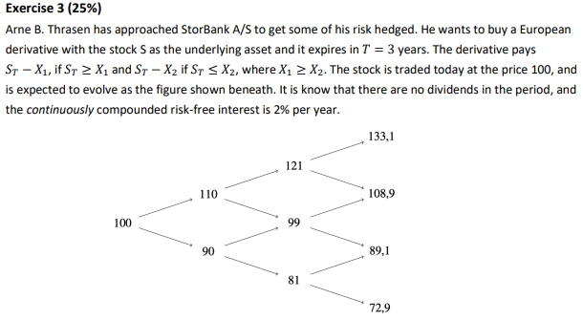
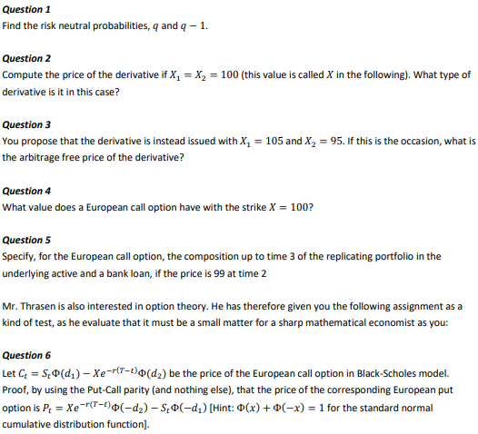
$$u=\frac{110}{100}=1,1$$
$$d=\frac{90}{100}=0,9$$
$$q=\frac{\frac{1}{d_{0,T}}-d}{u-d}$$
$*$ For a one-period model. Since $u$ and $d$ remains constant each period, it still works.
$$q=\frac{e^{0,02}-0,9}{1,1-0,9}≈0,6010067$$
$$P_{0}=d_{0,T}·E^{Q}\left[f\left(S\left(T\right)\right)\right]$$
Where $f\left(S\left(T\right)\right)$ is the payoff function which is equal to $S\left(T\right)-X_{1}=S\left(T\right)-X_{2}$.
We write in vector form.
$$e^{-3·0,02}·\left(\left(\begin{matrix}{0,6010}^{3} & 3·{0,6010}^{2}·0,399 & 3·0,6010·{0,399}^{2} & {0,399}^{3}\end{matrix}\right)·\left(\begin{aligned}\left(133,1-100\right) \\ \left(108,9-100\right) \\ \left(89,1-100\right) \\ \left(72,9-100\right)\end{aligned}\right)\right)≈5,823153$$
$$P_{0}=e^{-3·0,02}·\left({0,6010}^{3}·\left(133,1-100\right)+3·{0,6010}^{2}·\left(1-0,6010\right)·\left(108,9-100\right)+3·0,6010·(1-0,06\right)$$
We can consider the derivative as a forward. $F_{0,T}=100·e^{3·0,02}≈106,1837$.
$$V_{0}=\left(106,1837-100\right)·e^{-3·0,02}≈5,823589$$
$$\frac{1}{d_{0,Δt}}=e^{0,02}≈1,020201$$
Since $d<\frac{1}{d_{0,Δt}}<u$, there is no arbitrage. The price is:
$$e^{-3·0,02}·\left(\left(\begin{matrix}{0,6010}^{3} & 3·{0,6010}^{2}·0,399 & 3·0,6010·{0,399}^{2} & {0,399}^{3}\end{matrix}\right)·\left(\begin{aligned}\left(133,1-105\right) \\ \left(108,9-105\right) \\ \left(89,1-95\right) \\ \left(72,9-95\right)\end{aligned}\right)\right)≈4,415785$$
$$e^{-3·0,02}·\left(\left(\begin{matrix}{0,6010}^{3} & 3·{0,6010}^{2}·0,399 & 3·0,6010·{0,399}^{2} & {0,399}^{3}\end{matrix}\right)·\left(\begin{aligned}\max\left(\left(133,1-100\right);0\right) \\ \max\left(\left(108,9-100\right);0\right) \\ \max\left(\left(89,1-100\right);0\right) \\ \max\left(\left(72,9-100\right);0\right)\end{aligned}\right)\right)≈10,39086$$
We construct a portfolio consisting of the underlying and the risk-free asset.
The amount we invest in the underlying.
$$x=\frac{C_{u}-C_{d}}{u-d}=\frac{\max\left(99·1,1-100;0\right)-\max\left(99·0,9-100;0\right)}{\left(1,1-0,9\right)·99}≈0,4494949$$
$$\frac{1,1·\max\left(99·0,9-100;0\right)-0,9·\max\left(99·1,1-100;0\right)}{e^{0,02}·\left(1,1-0,9\right)}≈-39,257$$
We buy 0,4495 units of the underlying and take a loan in the bank of -39,257.
Put-call parity.
$$C_{t}-P_{t}+d_{t,T}K=S\left(t\right)⇔P\left(t\right)=C_{t}-S\left(t\right)+d_{t,T}K$$
$$=S\left(t\right)ϕ\left(d_{1}\right)-K·e^{-r·\left(T-t\right)}ϕ\left(d_{2}\right)-S\left(t\right)+e^{-r·\left(T-t\right)}K$$
$$-S\left(t\right)\left(1-ϕ\left(d_{1}\right)\right)+Ke^{-r·\left(T-t\right)}\left(1-ϕ\left(d_{2}\right)\right)=K·e^{-r·\left(T-t\right)}ϕ\left(-d_{2}\right)-S\left(t\right)ϕ\left(-d_{1}\right)$$

Exercise 4:
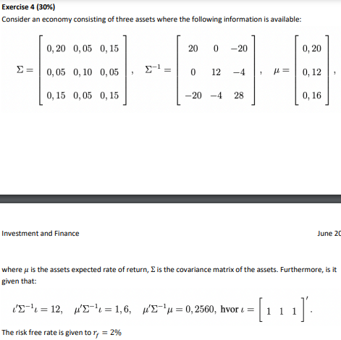
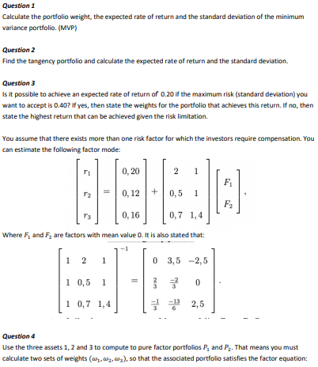
$$w_{MVP}=\frac{1}{a}·Σ^{-1}1$$
$$w_{MVP}=\frac{1}{12}·\left(\begin{matrix}20 & 0 & -20 \\ 0 & 12 & -4 \\ -20 & -4 & 28\end{matrix}\right)·\left(\begin{aligned}1 \\ 1 \\ 1\end{aligned}\right)≈\left(\begin{matrix}0 \\ 0,6666667 \\ 0,3333333\end{matrix}\right)$$
$${\overline{r}}_{MVP}=\frac{b}{a}=\frac{1,6}{12}≈0,1333333$$
$$σ_{MVP}^{2}=\frac{1}{a}=\frac{1}{12}≈0,08333333$$
$$σ_{MVP}=\sqrt{0,0833}≈0,2886174$$

$$w_{tan}=\frac{Σ^{-1}·{\overline{r}}^{e}}{1^{T}·Σ^{-1}·{\overline{r}}^{e}}$$
$${\overline{r}}^{e}=\left(\begin{aligned}0,20 \\ 0,12 \\ 0,16\end{aligned}\right)-0,02≈\left(\begin{matrix}0,18 \\ 0,1 \\ 0,14\end{matrix}\right)$$
$$w_{tan}=\frac{\left(\begin{matrix}20 & 0 & -20 \\ 0 & 12 & -4 \\ -20 & -4 & 28\end{matrix}\right)·\left(\begin{aligned}0,18 \\ 0,1 \\ 0,14\end{aligned}\right)}{\left(\begin{matrix}1 & 1 & 1\end{matrix}\right)·\left(\begin{matrix}20 & 0 & -20 \\ 0 & 12 & -4 \\ -20 & -4 & 28\end{matrix}\right)·\left(\begin{aligned}0,18 \\ 0,1 \\ 0,14\end{aligned}\right)}≈\left(\begin{matrix}0,5882353 \\ 0,4705882 \\ -0,05882353\end{matrix}\right)$$
$${\overline{r}}_{tan}=\left(\begin{matrix}0,5882 & 0,4706 & -0,0588\end{matrix}\right)·\left(\begin{aligned}0,20 \\ 0,12 \\ 0,16\end{aligned}\right)=0,164704$$
$$σ_{tan}^{2}=\left(\begin{matrix}0,5882 & 0,4706 & -0,0588\end{matrix}\right)·\left(\begin{matrix}0,20 & 0,05 & 0,15 \\ 0,05 & 0,10 & 0,05 \\ 0,15 & 0,05 & 0,15\end{matrix}\right)·\left(\begin{aligned}0,5882 \\ 0,4706 \\ -0,0588\end{aligned}\right)≈0,1063986$$
$$σ_{tan}=\sqrt{0,1064}≈0,3261901$$

$$\overline{r}=r_{f}+\frac{{\overline{r}}_{tan}-r_{f}}{σ_{tan}}=0,02+\frac{0,1647-0,02}{0,3262}σ≈0,4435929·σ+0,02$$
$$0,20=0,4436·σ+0,02$$
$⇕$ Ligningen løses for σ vha. WordMat.
$$σ=0,405771$$
We see that it is not possible. However, we cand find the maximum return using the CAPM.
$${\overline{r}}_{max}=0,4436·0,40+0,02=0,19744$$

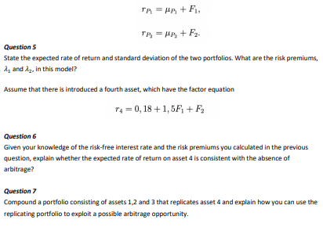
Since ${\overline{r}}_{p}=μ_{p}$ we must have for $w_{p_{1}}$ that $w_{p_{1}}·b_{1}=1$ and $w_{p_{1}}·b_{2}=0$
$$a+b+c=1$$
$$2a++0,5b+0,7c=1$$
$$a+b+1,4c=0$$
$⇕$ Ligningssystemet løses for a,b,c vha. WordMat's 'Løs Ligninger' funktion,
$$a=0,6666667 ∧ b=2,833333 ∧ c=-2,5$$
For the other portfolio we must have that $w_{p_{1}}·b_{1}=0$ and $w_{p_{1}}·b_{2}=1$
$$a+b+c=1$$
$$2a+0,5b+0,7c=0$$
$$a+b+1,4c=1$$
$⇕$ Ligningssystemet løses for a,b,c vha. WordMat's 'Løs Ligninger' funktion,
$$a=-0,3333333 ∧ b=1,333333 ∧ c=0$$

$${\overline{r}}_{p_{1}}=0,6667·0,2+2,8333·0,12+\left(-2,5\right)·0,16≈0,073336$$
$$σ_{p_{1}}^{2}=\left(\begin{matrix}0,6667 & 2,8333 & -2,5\end{matrix}\right)·\left(\begin{matrix}0,20 & 0,05 & 0,15 \\ 0,05 & 0,10 & 0,05 \\ 0,15 & 0,05 & 0,15\end{matrix}\right)·\left(\begin{aligned}0,6667 \\ 2,8333 \\ -2,5\end{aligned}\right)≈0,8097028$$
$$σ_{p_{1}}=\sqrt{0,8097}≈0,8998333$$
$${\overline{r}}_{p_{2}}=\left(-\frac{1}{3}\right)·0,20+\frac{4}{3}·0,12≈0,09333333$$
$$σ_{p_{2}}^{2}=\left(\begin{matrix}\left(-\frac{1}{3}\right) & \frac{4}{3} & 0\end{matrix}\right)·\left(\begin{matrix}0,20 & 0,05 & 0,15 \\ 0,05 & 0,10 & 0,05 \\ 0,15 & 0,05 & 0,15\end{matrix}\right)·\left(\begin{aligned}\left(-\frac{1}{3}\right) \\ \frac{4}{3} \\ 0\end{aligned}\right)≈0,1555556$$
$$σ_{p_{2}}=\sqrt{0,15556}≈0,394411$$
$$A=\left(\begin{matrix}1 & 2 & 1 \\ 1 & 0,5 & 1 \\ 1 & 0,7 & 1,4\end{matrix}\right)$$
$$\overline{r}=\left(\begin{aligned}{\overline{r}}_{1} \\ {\overline{r}}_{2} \\ {\overline{r}}_{3}\end{aligned}\right)=A·λ⇒λ=A^{-1}·r={\left(\begin{matrix}1 & 2 & 1 \\ 1 & 0,5 & 1 \\ 1 & 0,7 & 1,4\end{matrix}\right)}^{-1}·\left(\begin{aligned}0,20 \\ 0,12 \\ 0,16\end{aligned}\right)≈\left(\begin{matrix}0,02 \\ 0,05333333 \\ 0,07333333\end{matrix}\right)$$
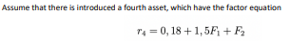
$${\overline{r}}_{4}=a+b_{1}·{\overline{F}}_{1}+b_{2}·{\overline{F}}_{2}=a=0,18$$
Given the risk premiums, the expected return should be:
$$\overline{r}=λ_{0}+b_{1}·λ_{1}+b_{2}λ_{2}$$
$$\overline{r}=0,02+1,5·0,0533+0,0733≈0,17325≠0,18$$
Under the assumption of no arbitrage, the two formulas for calculating expected return should have given the same result. Hence, there is arbitrage.
We must have that the weights sum to 1, the factor loading for the first factor sum to 1,5 and the factor loadings for the second factor sums to 1.
$$a+b+c=1$$
$$2a+0,5b+0,7c=1,5$$
$$a+b+1,4c=1$$
$⇕$ Ligningssystemet løses for a,b,c vha. WordMat's 'Løs Ligninger' funktion,
$$a=0,6666667 ∧ b=0,3333333 ∧ c=0$$
$$\frac{2}{3}·0,2+\frac{1}{3}·0,12≈0,1733333$$
We can buy the asset and short the market portfolio. This will give a positive net return of $0,18-0,1733≈0,0067$.

Reeksamen 2016

Exercise 1:
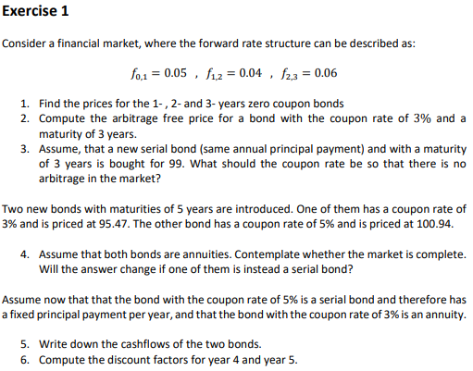
$$B=\left(\begin{matrix}100 & 0 & 0 \\ 0 & 100 & 0 \\ 0 & 0 & 100\end{matrix}\right)$$
$${\left(1+0,05\right)}^{1}=\frac{\left(1+s_{1}\right)}{1}$$
$⇕$ Ligningen løses for s_1 vha. WordMat.
$$s_{1}=0,05$$
$${\left(1+0,04\right)}^{1}=\frac{{\left(1+s_{2}\right)}^{2}}{1+0,05}$$
$⇕$ Ligningen løses for s_2 vha. WordMat.
$$s_{2}=-2,044988 ∨ s_{2}=0,04498804$$
$$\left(1+0,06\right)=\frac{{\left(1+s_{3}\right)}^{3}}{{\left(1+0,0450\right)}^{2}}$$
$⇕$ Ligningen løses for s_3 vha. WordMat.
$$s_{3}=0,04997627$$
$$P_{1}=\frac{100}{1+0,05}≈95,2381$$
$$P_{2}=\frac{100}{{\left(1+0,0450\right)}^{2}}≈91,573$$
$$P_{3}=\frac{100}{{\left(1+0,0500\right)}^{3}}≈86,38376$$
$$P_{CB}=\frac{3}{1+0,05}+\frac{3}{{\left(1+0,0450\right)}^{2}}+\frac{103}{{\left(1+0,0500\right)}^{3}}≈94,57961$$

$$\frac{\frac{100}{3}+100·c}{1+0,0500}+\frac{\frac{100}{3}+\left(100-\frac{100}{3}\right)·c}{{\left(1+0,0450\right)}^{2}}+\frac{\frac{100}{3}+\left(100-\frac{200}{3}\right)·c}{{\left(1+0,0500\right)}^{3}}=99$$
$⇕$ Ligningen løses for c vha. WordMat.
$$c=0,04287331$$
$$A_{1}=\frac{0,03·{\left(1+0,03\right)}^{5}·100}{{\left(1+0,03\right)}^{5}-1}≈21,83546$$
$$A_{2}=\frac{0,05·{\left(1+0,05\right)}^{5}·100,94}{{\left(1+0,05\right)}^{5}-1}≈23,3146$$
$$\frac{0,05·{\left(1+0,05\right)}^{5}·100}{{\left(1+0,05\right)}^{5}-1}≈23,09748$$

$$B=\left(\begin{matrix}100 & 0 & 0 & 0 & 0 \\ 0 & 100 & 0 & 0 & 0 \\ 0 & 0 & 100 & 0 & 0 \\ 21,8355 & 21,8355 & 21,8355 & 21,8355 & 21,8355 \\ 23,3146 & 23,3146 & 23,3146 & 23,3146 & 23,3146\end{matrix}\right)$$
The two last rows are not linearly independent. This means the matrix doesn’t have full rank, which means the market is not complete. If we change one of the bonds two a serial bond, the rows will become linearly independent, which means the matrix would have full rank and the market would be complete.
The cash flows for the first is showed in the second to last row of the B matrix.
Serial bond:
$$t=1:\frac{100}{5}+100·0,05=25$$
$$t=2:\frac{100}{5}+\left(100-\frac{100}{5}\right)·0,05=24$$
$$t=3:\frac{100}{5}+\left(100-\frac{200}{5}\right)·0,05=23$$
$$t=4:\frac{100}{5}+\left(100-\frac{300}{5}\right)·0,05=22$$
$$t=5:\frac{100}{5}+\left(100-\frac{400}{5}\right)·0,05=21$$

$$95,47=\frac{21,8355}{1+0,0500}+\frac{21,8355}{{\left(1+0,0450\right)}^{2}}+\frac{21,8355}{{\left(1+0,0500\right)}^{3}}+21,8355·x+21,8355·y$$
$$100,94=\frac{25}{1+0,0500}+\frac{24}{{\left(1+0,0450\right)}^{2}}+\frac{23}{{\left(1+0,0500\right)}^{3}}+22·x+21·y$$
$⇕$ Ligningssystemet løses for x,y vha. WordMat's 'Løs Ligninger' funktion,
$$x=0,8386159 ∧ y=0,8016735$$

Exercise 2:
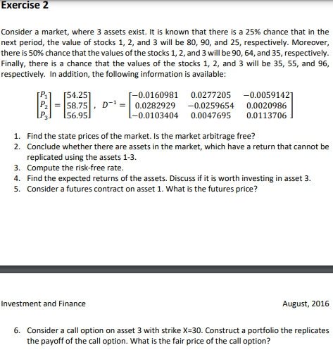
$$P=D·ψ⇒ψ=D^{-1}·P⇒ψ={\left(\begin{matrix}80 & 90 & 35 \\ 90 & 64 & 55 \\ 25 & 35 & 96\end{matrix}\right)}^{-1}·\left(\begin{aligned}54,25 \\ 58,75 \\ 56,95\end{aligned}\right)≈\left(\begin{matrix}0,2 \\ 0,25 \\ 0,45\end{matrix}\right)$$
Since $ψ≫0$, there is no arbitrage.
Since the matrix $D$ is invertible, it has full rank which means the market is complete. When a market is complete it means that all possible cash flows of a portfolio can be constructed from the assets in the market. Hence, all returns on the asset can be constructed by replication.
$$ψ_{0}=\sum_{s=1}^{S}{ψ_{s}}=1=\frac{1}{1+r_{f}}$$
$$r_{f}=\frac{1}{0,2+0,25+0,45}-1≈0,1111111$$
Possible returns:
$$V_{1,i}=\left(\begin{aligned}80 \\ 90 \\ 25\end{aligned}\right)-\left(\begin{aligned}54,25 \\ 58,75 \\ 56,95\end{aligned}\right)≈\left(\begin{matrix}25,75 \\ 31,25 \\ -31,95\end{matrix}\right)$$
$$V_{2,i}=\left(\begin{aligned}90 \\ 64 \\ 35\end{aligned}\right)-\left(\begin{aligned}54,25 \\ 58,75 \\ 56,95\end{aligned}\right)≈\left(\begin{matrix}35,75 \\ 5,25 \\ -21,95\end{matrix}\right)$$
$$V_{3,i}=\left(\begin{aligned}35 \\ 55 \\ 96\end{aligned}\right)-\left(\begin{aligned}54,25 \\ 58,75 \\ 56,95\end{aligned}\right)=\left(\begin{matrix}-19,25 \\ -3,75 \\ 39,05\end{matrix}\right)$$
$$0,25·\left(\begin{matrix}25,75 \\ 31,25 \\ -31,95\end{matrix}\right)+0,5·\left(\begin{matrix}35,75 \\ 5,25 \\ -21,95\end{matrix}\right)+0,25·\left(\begin{matrix}-19,25 \\ -3,75 \\ 39,05\end{matrix}\right)=\left(\begin{matrix}19,5 \\ 9,5 \\ -9,2\end{matrix}\right)$$
It is not worth investing in asset 3.

$$q=\left(\begin{aligned}\frac{0,2}{0,2+0,25+0,45} \\ \frac{0,25}{0,2+0,25+0,45} \\ \frac{0,45}{0,2+0,25+0,45}\end{aligned}\right)≈\left(\begin{matrix}0,2222222 \\ 0,2777778 \\ 0,5\end{matrix}\right)$$
Futures price is given by:
$$G_{0,T}=E^{Q}\left[S\left(T\right)\right]$$
$$G_{0,T}=\left(\begin{matrix}0,2222 & 0,2778 & 0,5\end{matrix}\right)·\left(\begin{aligned}80 \\ 90 \\ 35\end{aligned}\right)=60,278$$
Payoffs for the call option:
$$C_{1}=\max\left(25-30;0\right)=0$$
$$C_{2}=\max\left(35-30;0\right)=5$$
$$C_{3}=\max\left(96-30;0\right)=66$$
Replicating:
$$D=\left(\begin{matrix}80 & 90 & 35 \\ 90 & 64 & 55 \\ 25 & 35 & 96\end{matrix}\right)=\left(\begin{matrix}d_{1}^{1} & d_{2}^{1} & d_{3}^{1} \\ d_{2}^{1} & d_{2}^{2} & d_{2}^{3} \\ d_{3}^{1} & d_{3}^{2} & d_{3}^{2}\end{matrix}\right)$$
Let $d_{s}^{i}$ denote the value at time $t=1$ of asset $i$ in state $s$. The following must be fulfilled:
$$D^{T}·\left(\begin{aligned}w_{1} \\ w_{2} \\ w_{3}\end{aligned}\right)=\left(\begin{aligned}C_{1} \\ C_{2} \\ C_{3}\end{aligned}\right)$$
$$a·80+b·90+c·25=0$$
$$a·90+b·64+c·35=5$$
$$a·35+b·55+c·96=66$$
$⇕$ Ligningssystemet løses for a,b,c vha. WordMat's 'Løs Ligninger' funktion,
$$a=-0,2517361 ∧ b=0,008680556 ∧ c=0,7743056$$
$$C_{0}=d_{0,T}·E^{Q}\left[max⁡(\left(S\left(T\right)-K;0\right)\right]=\frac{1}{1+0,1111}·\left(0,2222·0+0,2778·5+0,5·66\right)≈30,95041$$

Exercise 3:
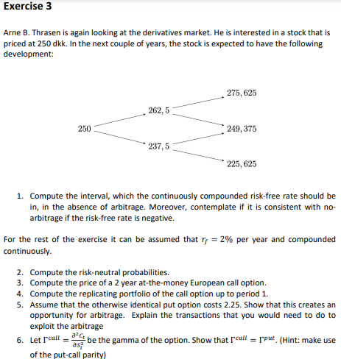
$$u=\frac{262,5}{250}=1,05$$
$$d=\frac{237,5}{250}=0,95$$
For there to be no arbitrage, we must have that:
$$d<\frac{1}{d_{t,t+Δt}}<u$$
Since the risk-free rate is continuously compounded, we know that:
$$\frac{1}{d_{t,t+Δt}}=e^{r_{f}}$$
So, we must have that:
$$\ln\left(d\right)=\ln\left(0,95\right)=-0,0512<r_{f}<\ln\left(u\right)=\ln\left(1,05\right)≈0,04879016$$
This gives us that:
$$r_{f}∈\left(-0,0512;0,0488\right)$$
$$q=\frac{\frac{1}{d_{0,t+Δt}}-d}{u-d}=\frac{e^{0,02}-0,95}{1,05-0,95}≈0,7020134$$
$$1-q=1-0,7020≈0,298$$

We use the general pricing formula for a derivative.
$$P_{0}=d_{0,T}·E^{Q}\left[f\left(S\left(T\right)\right)\right]$$
Here the payoff function $f\left(S\left(T\right)\right)=\max\left(S\left(T\right)-K;0\right)$
$$C_{0}=e^{-0,02·2}\left(\left(\begin{matrix}{0,7020}^{2} & 2·0,7020·\left(1-0,7020\right) & {\left(1-0,7020\right)}^{2}\end{matrix}\right)·\left(\begin{aligned}275,625-250 \\ 0 \\ 0\end{aligned}\right)\right)≈12,13295$$
We replicate the portfolio by investing in the underlying asset and the risk-free asset.
The amount we invest in the underlying:
$$C_{u}=d_{t,t+Δt}·\left(q·C_{uu}+\left(1-q\right)·C_{ud}\right)$$
$$C_{u}=e^{-0,02}·\left(0,7020·\left(275,625-250\right)+\left(1-0,7020\right)·0\right)≈17,63255$$
$$C_{d}=d_{t,t+Δt}·\left(q·C_{ud}+\left(1-q\right)·C_{dd}\right)$$
$$C_{d}=e^{-0,02}·\left(0,7020·0+\left(1-0,7020\right)·0\right)=0$$
$$x=\frac{C_{u}-C_{d}}{\left(u-d\right)·S\left(0\right)}=\frac{17,6326-0}{\left(1,05-0,95\right)·250}≈0,705304$$
The amount we invest in the risk-free asset:
$$B=d_{0,T}·\left(\frac{u·C_{d}-d·C_{u}}{u-d}\right)$$
$$=e^{-0,02}·\left(\frac{1,05·0-0,95·17,6326}{1,05-0,95}\right)≈-164,1928$$
We invest 0,7053 units in the underlying and borrow -164,1928 at the risk-free rate.
We use put-call parity.
$$C_{t}-P_{t}+d_{t,T}·K=S\left(t\right)⇒P_{t}=C_{t}+d_{t,T}·K-S\left(t\right)$$
Set $t=0$
$$P_{0}=12,1326+e^{-0,02·2}·250-250≈2,32996≠2,25$$
The arbitrage-free price is higher which means the put is priced too cheap. We could use the put-call parity. We buy the put and sell the call on the one side and buy the underlying and take a bank loan.
$$C_{t}-P_{t}=S\left(t\right)-d_{t,T}·K$$
Short Call | $$12,1326$$
Buy Put | $$-2,25$$
Buy Underlying | $$-250$$
Bank loan | $$e^{-0,02·2}·250≈240,1974$$
Total | $$12,1326-2,25-250+240,1974≈0,08$$
We see here that we have a net gain.
$$C_{t}-P_{t}+d_{t,T}·K=S\left(t\right)$$
$$⇓$$
$$\frac{∂}{∂S_{t}}\left(C_{t}-P_{t}+d_{t,T}·K\right)=\frac{∂}{∂S_{t}}S\left(t\right)⇒Δ^{call}-Δ^{put}=1$$
$$⇓$$
$$\frac{∂}{∂S_{t}}\left(Δ^{call}-Δ^{put}\right)=\frac{∂}{∂S_{t}}1⇒Γ^{call}-Γ^{put}=0⇒Γ^{call}=Γ^{put}$$

Exercise 4:
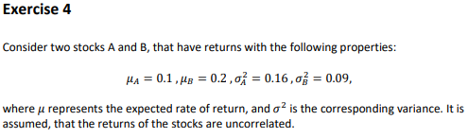
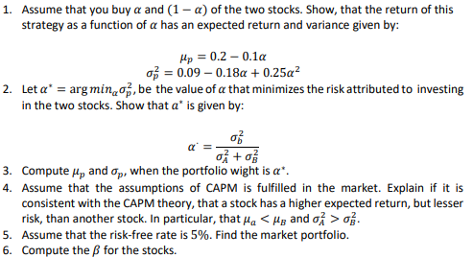
$$μ_{p}=0,1·α+0,2·\left(1-α\right)=0,1α+0,2-0,2α=0,2-0,1α$$
$$σ_{p}^{2}=\left(\begin{matrix}α & 1-α\end{matrix}\right)·\left(\begin{matrix}0,16 & 0 \\ 0 & 0,09\end{matrix}\right)·\left(\begin{aligned}α \\ 1-α\end{aligned}\right)$$
$$=0,16α^{2}+0,09·{\left(1-α\right)}^{2}=0,16α^{2}+0,09·α^{2}+0,09-0,18α=0,25α^{2}-0,18α+0,09$$
$$\frac{∂σ_{p}^{2}}{∂α}=0⇒0,5α-0,18=0⇒0,5α=0,18⇒α=\frac{0,18}{0,5}=\frac{0,09}{0,25}=\frac{σ_{B}^{2}}{σ_{A}^{2}+σ_{B}^{2}}$$
$$μ_{p}\left(α^{*}\right)=0,2-0,1·\frac{0,18}{0,5}=0,164$$
$$σ_{p}^{2}\left(α^{*}\right)=0,25·{\left(\frac{0,18}{0,5}\right)}^{2}-0,18·\frac{0,18}{0,5}+0,09=0,0576$$
$$σ_{p}\left(α^{*}\right)=\sqrt{0,0576}=0,24$$
It can be consistent. According to CAPM the risk of an asset consists of systematic risk and idiosyncratic risk. The idiosyncratic risk can be diversified away, the systematic risk can’t. So, an asset can have higher return and less risk than a different asset. The expected return only correlates with the systematic risk. So, it depends on how well the assets are diversified.

Assuming CAPM is fulfilled, the market portfolio is equal to the tangency portfolio.
$$w_{M}=w_{tan}=\frac{Σ^{-1}·{\overline{r}}^{e}}{1^{T}·Σ^{-1}·{\overline{r}}^{e}}$$
$${\overline{r}}^{e}=\overline{r}-r_{f}=\left(\begin{aligned}0,1 \\ 0,2\end{aligned}\right)-0,05≈\left(\begin{matrix}0,05 \\ 0,15\end{matrix}\right)$$
$$w_{M}=\frac{{\left(\begin{matrix}0,16 & 0 \\ 0 & 0,09\end{matrix}\right)}^{-1}·\left(\begin{aligned}0,05 \\ 0,15\end{aligned}\right)}{\left(\begin{matrix}1 & 1\end{matrix}\right)·{\left(\begin{matrix}0,16 & 0 \\ 0 & 0,09\end{matrix}\right)}^{-1}·\left(\begin{aligned}0,05 \\ 0,15\end{aligned}\right)}≈\left(\begin{matrix}0,1578947 \\ 0,8421053\end{matrix}\right)$$
$${\overline{r}}_{M}=0,1·0,1579+0,2·0,8421=0,18421$$
SML:
$${\overline{r}}_{i}-r_{f}=β_{i}·\left({\overline{r}}_{M}-r_{f}\right)⇒β=\frac{{\overline{r}}_{i}-r_{f}}{{\overline{r}}_{M}-r_{f}}$$
$$β_{1}=\frac{0,1-0,05}{0,1842-0,05}≈0,3725782$$
$$β_{2}=\frac{0,2-0,05}{0,1842-0,05}≈1,117735$$

Eksamen 2017:

Exercise 1:
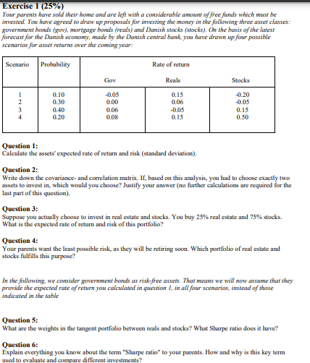
$$\overline{r}=\sum_{i=1}^{4}{p_{i}}·r_{i}$$
$$σ^{2}=E\left[{\left(r-\overline{r}\right)}^{2}\right]=E\left[r^{2}+{\overline{r}}^{2}-2·r·\overline{r}\right]$$
$${\overline{r}}_{Gov}=\left(\begin{matrix}0,1 & 0,3 & 0,4 & 0,2\end{matrix}\right)·\left(\begin{aligned}\left(-0,05\right) \\ 0 \\ 0,06 \\ 0,08\end{aligned}\right)=0,035$$
$$σ_{Gov}^{2}=E\left[r^{2}\right]+{0,035}^{2}-2·0,035·E\left[r\right]$$
$$σ_{Gov}^{2}=\left(\begin{matrix}0,1 & 0,3 & 0,4 & 0,2\end{matrix}\right)·\left(\begin{aligned}{\left(-0,05\right)}^{2} \\ 0^{2} \\ {0,06}^{2} \\ {0,08}^{2}\end{aligned}\right)+{0,035}^{2}-2·0,035·0,035≈0,001745$$
$$σ_{Gov}=\sqrt{0,0018}≈0,04242641$$
$${\overline{r}}_{Reals}=\left(\begin{matrix}0,1 & 0,3 & 0,4 & 0,2\end{matrix}\right)·\left(\begin{aligned}0,15 \\ 0,06 \\ \left(-0,05\right) \\ 0,15\end{aligned}\right)=0,043$$
$$σ_{Reals}^{2}=\left(\begin{matrix}0,1 & 0,3 & 0,4 & 0,2\end{matrix}\right)·\left(\begin{aligned}{0,15}^{2} \\ {0,06}^{2} \\ {\left(-0,05\right)}^{2} \\ {0,15}^{2}\end{aligned}\right)+{0,043}^{2}-2·{0,043}^{2}≈0,006981$$
$$σ_{Reals}=\sqrt{0,0070}≈0,083666$$
$${\overline{r}}_{Stocks}=\left(\begin{matrix}0,1 & 0,3 & 0,4 & 0,2\end{matrix}\right)·\left(\begin{aligned}\left(-0,2\right) \\ \left(-0,05\right) \\ 0,15 \\ 0,5\end{aligned}\right)=0,125$$
$$σ_{Stocks}^{2}=\left(\begin{matrix}0,1 & 0,3 & 0,4 & 0,2\end{matrix}\right)·\left(\begin{aligned}{\left(-0,2\right)}^{2} \\ {\left(-0,05\right)}^{2} \\ {0,15}^{2} \\ {0,5}^{2}\end{aligned}\right)+{0,125}^{2}-2·{0,125}^{2}=0,048125$$
$$σ_{Stocks}=\sqrt{0,0481}≈0,2193171$$
$$σ_{p}^{2}=\left(\begin{matrix}0,1 & 0,3 & 0,4 & 0,2\end{matrix}\right)·\left(\begin{matrix}{\left(-0,05\right)}^{2} & {0,15}^{2} & {\left(-0,2\right)}^{2} \\ 0^{2} & {0,06}^{2} & {\left(-0,05\right)}^{2} \\ {0,06}^{2} & {\left(-0,05\right)}^{2} & {0,15}^{2} \\ {0,08}^{2} & {0,15}^{2} & {0,5}^{2}\end{matrix}\right)-\left(\begin{matrix}{0,035}^{2} & {0,043}^{2} & {0,125}^{2}\end{matrix}\right)≈\left(\begin{matrix}0,001745 & 0,006981 & 0,048125\end{matrix}\right)$$
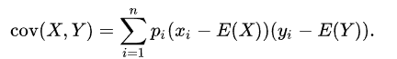
$$Cov\left(r_{Gov},r_{Reals}\right)=\left(\begin{matrix}0,1·\left(\left(-0,05\right)-0,035\right) & 0,3·\left(0-0,035\right) & 0,4·\left(0,06-0,035\right) & 0,2·\left(0,08-0,035\right)\end{matrix}\right)·\left(\begin{aligned}0,15-0,043 \\ 0,06-0,043 \\ \left(-0,05\right)-0,043 \\ 0,15-0,043\end{aligned}\right)=-0,001055$$
$$\left(\begin{matrix}0,1·\left(\left(-0,05\right)-0,035\right) & 0,3·\left(0-0,035\right) & 0,4·\left(0,06-0,035\right) & 0,2·\left(0,08-0,035\right)\end{matrix}\right)≈\left(\begin{matrix}-0,0085 & -0,0105 & 0,01 & 0,009\end{matrix}\right)$$
$$Cov\left(r_{Gov},r_{Stocks}\right)=\left(\begin{matrix}0,1·\left(\left(-0,05\right)-0,035\right) & 0,3·\left(0-0,035\right) & 0,4·\left(0,06-0,035\right) & 0,2·\left(0,08-0,035\right)\end{matrix}\right)·\left(\begin{aligned}\left(-0,2\right)-0,125 \\ \left(-0,05\right)-0,125 \\ 0,15-0,125 \\ 0,5-0,125\end{aligned}\right)=0,008225$$
$$Cov\left(r_{Reals},r_{Stocks}\right)=\left(\begin{matrix}0,1·\left(0,15-0,043\right) & 0,3·\left(0,06-0,043\right) & 0,4·\left(\left(-0,05\right)-0,043\right) & 0,2·\left(0,15-0,043\right)\end{matrix}\right)·\left(\begin{aligned}\left(-0,2\right)-0,125 \\ \left(-0,05\right)-0,125 \\ 0,15-0,125 \\ 0,5-0,125\end{aligned}\right)=0,002725$$
$$Σ=\left(\begin{matrix}0,001745 & -0,001055 & 0,008225 \\ -0,001055 & 0,006981 & 0,002725 \\ 0,008225 & 0,002725 & 0,048125\end{matrix}\right)$$
Since the portfolio variance depends positively on the covariance, we can reduce the risk the most by investing in asset 1 and 2. But the best portfolio to invest in depends on a person’s preferences in relation to risk and return.

$$ρ_{ij}=\frac{σ_{ij}}{σ_{i}·σ_{j}}$$
$$ρ_{Gov,Reals}=\frac{-0,001055}{\sqrt{0,001745}·\sqrt{0,006981}}≈-0,3022706$$
$$ρ_{Gov,Stocks}=\frac{0,008225}{\sqrt{0,001745}·\sqrt{0,048125}}≈0,8975379$$
$$ρ_{Reals,Stocks}=\frac{0,002725}{\sqrt{0,006981}·\sqrt{0,048125}}≈0,1486696$$
$$ρ=\left(\begin{matrix}1 & -0,3023 & 0,8975 \\ -0,3023 & 1 & 0,1487 \\ 0,8975 & 0,1487 & 1\end{matrix}\right)$$

$$\overline{r}=\left(\begin{matrix}0,25 & 0,75\end{matrix}\right)·\left(\begin{aligned}0,043 \\ 0,125\end{aligned}\right)=0,1045$$
$$σ_{p}^{2}=\left(\begin{matrix}0,25 & 0,75\end{matrix}\right)·\left(\begin{matrix}0,006981 & 0,002725 \\ 0,002725 & 0,048125\end{matrix}\right)·\left(\begin{aligned}0,25 \\ 0,75\end{aligned}\right)≈0,0285285$$
$$σ_{p}=\sqrt{0,0285}≈0,1688194$$
$$a=\left(\begin{matrix}1 & 1\end{matrix}\right)·{\left(\begin{matrix}0,006981 & 0,002725 \\ 0,002725 & 0,048125\end{matrix}\right)}^{-1}·\left(\begin{aligned}1 \\ 1\end{aligned}\right) ≈151,1437$$
$$w_{MVP}=\frac{1}{151,1437}·{\left(\begin{matrix}0,006981 & 0,002725 \\ 0,002725 & 0,048125\end{matrix}\right)}^{-1}·\left(\begin{aligned}1 \\ 1\end{aligned}\right)≈\left(\begin{matrix}0,9142904 \\ 0,08570969\end{matrix}\right)$$

$$w_{tan}=\frac{Σ^{-1}·{\overline{r}}^{e}}{1^{T}·Σ^{-1}·{\overline{r}}^{e}}$$
$${\overline{r}}^{e}=\left(\begin{aligned}0,043 \\ 0,125\end{aligned}\right)-0,035≈\left(\begin{matrix}0,008 \\ 0,09\end{matrix}\right)$$
$$w_{tan}=\frac{{\left(\begin{matrix}0,006981 & 0,002725 \\ 0,002725 & 0,048125\end{matrix}\right)}^{-1}·\left(\begin{aligned}0,008 \\ 0,09\end{aligned}\right)}{\left(\begin{matrix}1 & 1\end{matrix}\right)·{\left(\begin{matrix}0,006981 & 0,002725 \\ 0,002725 & 0,048125\end{matrix}\right)}^{-1}·\left(\begin{aligned}0,008 \\ 0,09\end{aligned}\right)}≈\left(\begin{matrix}0,1872722 \\ 0,8127278\end{matrix}\right)$$
$${\overline{r}}_{tan}=0,1873·0,043+0,8127·0,125=0,1096414$$
$$σ_{tan}^{2}=\left(\begin{matrix}0,1873 & 0,8127\end{matrix}\right)·\left(\begin{matrix}0,006981 & 0,002725 \\ 0,002725 & 0,048125\end{matrix}\right)·\left(\begin{aligned}0,1873 \\ 0,8127\end{aligned}\right)≈0,03286016$$
$$σ_{tan}=\sqrt{0,0329}≈0,1813836$$
$$Sharpe ratio:\frac{{\overline{r}}_{tan}-r_{f}}{σ_{tan}}=\frac{0,1096-0,035}{0,1814}≈0,4112459$$
Sharpe ratio defines the expected excess return on the portfolio relative to the risk of the portfolio. This means that the higher sharpe ratio your portfolio has, the more you get compensated for taking on risk. It can also be interpreted as the slope of the capital market line.

Exercise 2:
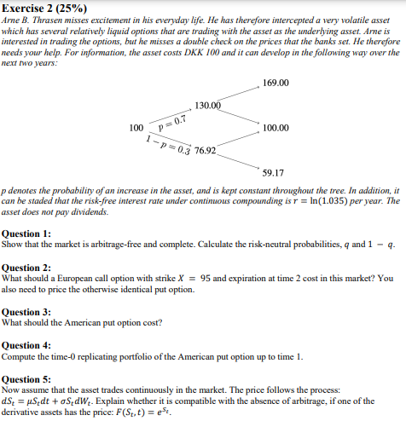
$$u=\frac{130}{100}=1,3$$
$$d=\frac{76,92}{100}=0,7692$$
The market is free of arbitrage and complete if and only if the following is fulfilled:
$$d<\frac{1}{d_{t,t+Δt}}<u$$
$$\frac{1}{d_{t,t+Δt}}=e^{r}=e^{\ln\left(1,035\right)}=1,035$$
Since $0,7692<1,035<1,3$, the market is free of arbitrage and complete.
$$q=\frac{\frac{1}{d_{t,t+Δt}}-d}{u-d}=\frac{e^{\ln\left(1,035\right)}-0,7692}{1,3-0,7692}≈0,5007536$$
$$1-q=1-0,5010=0,499$$
$$C_{0}=d_{0,T}·E^{Q}\left[\max\left(S\left(T\right)-K;0\right)\right]$$
$$C_{0}=e^{-2·\ln\left(1,035\right)}·\left(\left(\begin{matrix}{0,5008}^{2} & 2·0,5008·\left(1-0,5008\right) & {\left(1-0,5008\right)}^{2}\end{matrix}\right)·\left(\begin{aligned}169-95 \\ 100-95 \\ 0\end{aligned}\right)\right)≈19,65903$$
Put-call parity:
$$C_{0}-P_{0}+d_{0,T}·K=S\left(0\right)⇒P_{0}=C_{0}+d_{0,T}·K-S\left(0\right)$$
$$P_{0}=19,65903+e^{-2·\ln\left(1,035\right)}·95-100≈8,342547$$
$$P_{u}=d_{t,t+Δt}·\left(q·P_{uu}+\left(1-q\right)·P_{ud}\right)$$
$$P_{u}=e^{-\ln\left(1,035\right)}·\left(0,5010·\max\left(95-169;0\right)+0,499·\max\left(95-100;0\right)\right)=0$$
$$P_{d}=d_{t,t+Δt}·\left(q·P_{ud}+\left(1-q\right)·P_{dd}\right)$$
Since the price go up, we would not exercise here.
$$P_{d}=e^{-\ln\left(1,035\right)}·\left(0,5008·\max\left(95-100;0\right)+0,4992·\max\left(95-59,17;0\right)\right)≈17,28148$$
$$1-0,5008=0,4992$$
Payoff if we exercise here:
$$\max\left(95-76,92;0\right)=18,08>17,2746$$
$$P_{0}^{a}=e^{-\ln\left(1,035\right)}·\left(0,5008·0+\left(1-0,5008\right)·18,08\right)≈8,720325$$
We invest in the underlying and the risk-free asset.
The amount we invest in the underlying:
$$x=\frac{P_{u}-P_{d}}{\left(u-d\right)·S\left(0\right)}=\frac{0-18,08}{\left(1,3-0,7692\right)·100}≈-0,3406179$$
The amount we invest in the risk-free asset:
$$B=d_{t,t+Δt}·\frac{u·P_{d}-d·P_{u}}{u-d}=e^{-\ln\left(1,035\right)}·\frac{1,3·18,08-0,7692·0}{1,3-0,7692}≈42,78293$$
We short $0,3406$ units of the underlying and invest 42,7829 at the risk-free rate.
We check whether it fulfills the Black-Scholes equation.
$$\frac{∂F\left(S_{t},t\right)}{∂t}=0$$
$$\frac{∂F\left(S_{t},t\right)}{∂S_{t}}=e^{S_{t}}⇒r·S_{t}·\frac{∂F\left(S_{t},t\right)}{∂S_{t}}=r·S_{t}·e^{S_{t}}$$
$$\frac{∂^{2}F\left(S_{t},t\right)}{∂S_{t}^{2}}=e^{S_{t}}⇒\frac{1}{2}σ^{2}·S_{t}^{2}·\frac{∂^{2}F\left(S_{t},t\right)}{∂S_{t}^{2}}=\frac{1}{2}σ^{2}S_{t}^{2}·e^{S_{t}}$$
$$0+r·S_{t}·e^{S_{t}}+\frac{1}{2}σ^{2}S_{t}^{2}·e^{S_{t}}-r·e^{S_{t}}=e^{S_{t}}·\left(r·S_{t}+\frac{1}{2}σ^{2}S_{t}^{2}-r\right)≠0$$

Exercise 3:
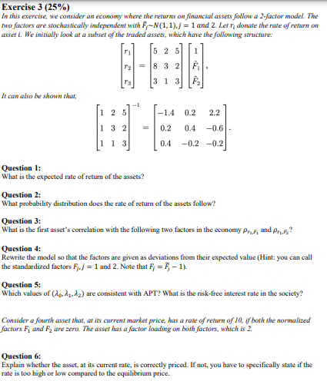
$${\overline{r}}_{i}=a_{i}+b_{1i}·\overline{F_{1}}+b_{2i}·{\overline{F}}_{2}$$
$$E\left[r\right]=$$
$$\overline{r}=\left(\begin{aligned}{\overline{r}}_{1} \\ {\overline{r}}_{2} \\ {\overline{r}}_{3}\end{aligned}\right)= =\left(\begin{matrix}12 \\ 13 \\ 7\end{matrix}\right)$$
$$σ^{2}=b_{1i}^{2}·σ_{F_{1}}^{2}+b_{2i}^{2}·σ_{F_{2}}^{2}=\left(\begin{aligned}σ_{1}^{2} \\ σ_{2}^{2} \\ σ_{3}^{2}\end{aligned}\right)=\left(\begin{matrix}2^{2} & 5^{2} \\ 3^{2} & 2^{2} \\ 1^{2} & 3^{2}\end{matrix}\right)·\left(\begin{aligned}1 \\ 1\end{aligned}\right)=\left(\begin{matrix}29 \\ 13 \\ 10\end{matrix}\right)$$
$$r_{1}∼N\left(12,29\right)$$
$$r_{2}∼N\left(13,13\right)$$
$$r_{3}∼N\left(7,10\right)$$
Remember that:
$$cov\left(r_{i},F_{1}\right)=b_{1i}·σ_{F_{1}}^{2}+b_{2i}·σ_{F_{1},F_{2}}$$
$$cov\left(r_{i},F_{2}\right)=b_{1i}·σ_{F_{1},F_{2}}+b_{2i}·σ_{F_{2}}^{2}$$
$$ρ_{r_{1},F_{1}}=\frac{Cov\left(r_{1},F_{1}\right)}{σ_{r_{1}}·σ_{F_{1}}}=\frac{b_{1i}·σ_{F_{1}}^{2}}{\sqrt{29}·1}=\frac{2}{\sqrt{29}}≈0,3713907$$
$$ρ_{r_{1},F_{2}}=\frac{Cov\left(r_{1},F_{2}\right)}{σ_{r_{1}}·σ_{F_{2}}}=\frac{5}{\sqrt{29}}≈0,9284767$$

We write the returns out without using a. We see that we need to add 5 in the
We assume we can use the same factor loadings, we will look at how much we need to change $a_{i}$ in order for the new relation be true.
$$2·\left(F_{1}-1\right)+5·\left(F_{2}-1\right)=5·F_{1}+2·F_{2}-7$$
From this we can see that $a_{1}^{'}=a_{1}+7=5+7=12$. Lets check if it is true:
$$r_{1}^{'}=12+2·\left(F-1\right)+5·\left(G-1\right)=5·G+2·F+5=r_{1}$$
Hence this works.
Second asset:
$$3·\left(F_{1}-1\right)+2·\left(F_{2}-1\right)=2·F_{1}+3·F_{2}-5$$
$$a_{2}^{'}=a_{2}+5=8+5=13$$
Third asset:
$$\left(F-1\right)+3·\left(G-1\right)=3·G+F-4$$
$$a_{3}^{'}=a_{3}+4=3+4=7$$

Lets check if it is true:
$${\overline{r}}^{'}=\left(\begin{aligned}{\overline{r}}_{1}^{'} \\ {\overline{r}}_{2}^{'} \\ {\overline{r}}_{3}^{'}\end{aligned}\right)=\left(\begin{matrix}12 & 2 & 5 \\ 13 & 3 & 2 \\ 7 & 1 & 3\end{matrix}\right)·\left(\begin{aligned}1 \\ \left(F_{1}-1\right) \\ \left(F_{2}-1\right)\end{aligned}\right)=\left(\begin{matrix}5·F_{2}+2·F_{1}+5 \\ 2·F_{2}+3·F_{1}+8 \\ 3·F_{2}+F_{1}+3\end{matrix}\right)=\overline{r}$$
So, all we need is to change the coefficients $a_{i}$.

We look at the relation:
$$\overline{r}=\left[1 B\right]·λ$$
Where $λ=\left(\begin{aligned}λ_{0} \\ λ_{1} \\ λ_{2}\end{aligned}\right)$.
Here the $1$ is a vector of 1’s and B is factor loading matrix.
$$\overline{r}=\left(\begin{aligned}12 \\ 13 \\ 10\end{aligned}\right)=\left(\begin{matrix}1 & 2 & 5 \\ 1 & 3 & 2 \\ 1 & 1 & 3\end{matrix}\right)·\left(\begin{aligned}λ_{0} \\ λ_{1} \\ λ_{2}\end{aligned}\right)⇒\left(\begin{aligned}λ_{0} \\ λ_{1} \\ λ_{2}\end{aligned}\right)={\left(\begin{matrix}1 & 2 & 5 \\ 1 & 3 & 2 \\ 1 & 1 & 3\end{matrix}\right)}^{-1}·\left(\begin{aligned}12 \\ 13 \\ 7\end{aligned}\right)=\left(\begin{matrix}\frac{6}{5} \\ \frac{17}{5} \\ \frac{4}{5}\end{matrix}\right)=\left(\begin{matrix}1,2 \\ 3,4 \\ 0,8\end{matrix}\right)$$

If it is priced correctly there should be no arbitrage. Pr. no arbitrage we must have that:
$${\overline{r}}_{4}=λ_{0}+b_{41}·λ_{1}+b_{42}·λ_{2}=1,2+2·3,4+2·0,8=9,6≠10$$
Since the expected return is higher than the return implied by no-arbitrage, the asset is priced too cheap.

Exercise 4:
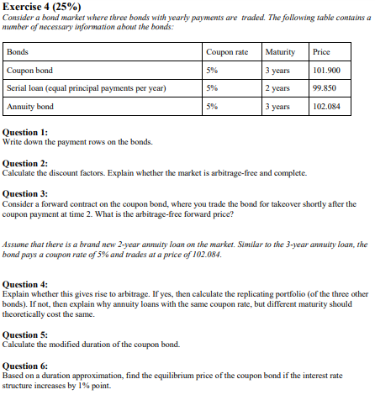
Annuity payment:
$$A=\frac{c·{\left(1+c\right)}^{n}·100}{{\left(1+c\right)}^{n}-1}=\frac{0,05·{\left(1+0,05\right)}^{3}·100}{{\left(1+0,05\right)}^{3}-1}≈36,72086$$
Serial bond:
$$t=1:50+100·0,05=55$$
$$t=2:50+50·0,05=52,5$$
$$B=\left(\begin{matrix}5 & 5 & 105 \\ 36,721 & 36,721 & 36,721 \\ 55 & 52,5 & 0\end{matrix}\right)$$
$$P=B·d⇒d=B^{-1}·P={\left(\begin{matrix}5 & 5 & 105 \\ 36,721 & 36,721 & 36,721 \\ 55 & 52,5 & 0\end{matrix}\right)}^{-1}·\left(\begin{aligned}101,9 \\ 102,084 \\ 99,85\end{aligned}\right)≈\left(\begin{matrix}0,04022818 \\ 1,859761 \\ 0,8800005\end{matrix}\right)$$
$$36,721·\left(0,04+1,8598+0,88\right)≈102,077$$

Since we take over the bond at time t=2, we miss out on two coupon payments. Hence we need to subtract cost of carry.
$$F_{0,2}=\frac{S\left(0\right)}{d_{0,T}}-C·\frac{d_{0,1}}{d_{0,T}}-C·\frac{d_{0,2}}{d_{0,T}}=\frac{101,9}{1,8598}-5·\frac{0,04}{1,8598}-5·\frac{1,8598}{1,8598} ≈49,6833$$

$$A^{'}=\frac{0,05·{\left(1+0,05\right)}^{2}·100}{{\left(1+0,05\right)}^{2}-1}≈53,78049$$
$$53,7805·0,04+53,7805·1,86≈102,183$$
We see that it is priced incorrectly, hence there is arbitrage.
$$\left(\begin{matrix}a & b & c\end{matrix}\right)·\left(\begin{matrix}5 & 5 & 105 \\ 36,721 & 36,721 & 36,721 \\ 55 & 52,5 & 0\end{matrix}\right)=\left(\begin{matrix}53,7805 & 53,7805 & 0\end{matrix}\right)$$
$$\left(\begin{matrix}a & b & c\end{matrix}\right)=\left(\begin{matrix}53,7805 & 53,7805 & 0\end{matrix}\right)·{\left(\begin{matrix}5 & 5 & 105 \\ 36,721 & 36,721 & 36,721 \\ 55 & 52,5 & 0\end{matrix}\right)}^{-1}≈\left(\begin{matrix}-0,537805 & 1,537799 & 0\end{matrix}\right)$$
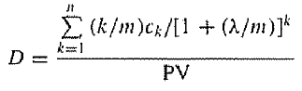
$$D_{Mac}=\frac{\frac{1·5}{\left(1+0,0431\right)}+\frac{2·5}{{\left(1+0,0431\right)}^{2}}+\frac{3·105}{{\left(1+0,0431\right)}^{3}}}{101,9}≈2,860929$$
$$D_{Mac}=\left(1+λ\right)D_{Mod}⇒D_{Mod}=\frac{D_{Mac}}{\left(1+λ\right)}=\frac{2,8609}{1+0,0431}≈2,74269$$
We start by finding the yield:
$$101,9=\frac{5}{1+λ}+\frac{5}{{\left(1+λ\right)}^{2}}+\frac{105}{{\left(1+λ\right)}^{3}}$$
$⇕$ Ligningen løses for λ vha. WordMat.
$$λ=0,04311289$$
$$ΔP=-D_{Mod}·P·Δλ$$
$$-2,7427·101,9·0,01≈-2,794811$$
$$P=101,9-2,7948≈99,1052$$

Reeksamen 2017:

Exercise 1:
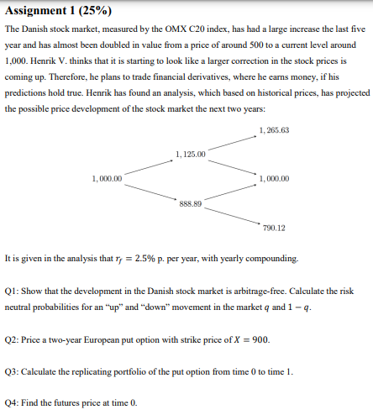
$$u=\frac{1125}{1000}=\frac{9}{8}=1,125$$
$$d=\frac{888,89}{1000}=0,88889$$
There is no arbitrage if and only if
$$d<\frac{1}{d_{t,Δt}}<u.$$
Since nothing is specified, we assume the risk-free rate is discretely compounded.
$$d_{t,Δt}=\frac{1}{1+0,025}⇒\frac{1}{d_{t,Δt}}=1+0,025=1,025$$
Since $0,8889<1,025<1,125$ there is no arbitrage.
$$q=\frac{\frac{1}{d_{t,Δt}}-d}{u-d}=\frac{1,025-0,8889}{1,125-0,8889}≈0,5764507$$
$$1-q=1-0,5765=0,4235$$
$$P_{0}=d_{0,T}·E^{Q}\left[f\left(S\left(T\right)\right)\right]$$
$$f\left(S\left(T\right)\right)=\max\left(K-S\left(T\right);0\right)$$

$$P_{0}=\frac{1}{{\left(1+0,025\right)}^{2}}·\left(\begin{matrix}{0,5765}^{2} & 2·0,5765·\left(1-0,5765\right) & {\left(1-0,5765\right)}^{2}\end{matrix}\right)·\left(\begin{aligned}\max\left(900-1265,63;0\right) \\ \max\left(900-1000;0\right) \\ \max\left(900-790,12;0\right)\end{aligned}\right)≈18,75762$$
We construct a portfolio of the underlying and the risk-free asset.
The amount we invest in the underlying:
$$x=\frac{P_{u}-P_{d}}{\left(u-d\right)·S\left(0\right)}$$
$$C_{u}=\frac{1}{d_{1,2}}·\left(q·C_{uu}+\left(1-q\right)·C_{ud}\right)$$
$$P_{u}=\frac{1}{1+0,025}·\left(0,5765·\max\left(900-1265,63;0\right)+\left(1-0,5765\right)·\max\left(900-1000;0\right)\right)=0$$
$$P_{d}=\frac{1}{1+0,025}·\left(0,5765·\max\left(900-1000;0\right)+\left(1-0,5765\right)·\max\left(900-790,12;0\right)\right)=45,3992$$
$$x=\frac{0-45,3992}{\left(1,125-0,8889\right)·1000}≈-0,192288$$
The amount we invest in the risk-free asset:
$$B=d_{0,T}·\frac{uP_{d}-dP_{u}}{u-d}=\frac{1}{1+0,025}·\frac{1,125·45,3992-0,8889·0}{1,125-0,8889}≈211,0478$$
$$G_{0,T}=E^{Q}\left[S\left(T\right)\right]={0,5765}^{2}·1265,63+2·0,5765·\left(1-0,5765\right)·1000+{\left(1-0,5765\right)}^{2}·790,12≈1050,64$$
$$F_{0,T}=\frac{1000}{{\left(1+0,025\right)}^{-2}}≈1050,625$$

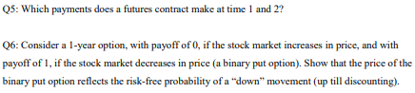
We start by looking at payments at time 1.
Denote $F_{1,T}^{u}$ the forward price at time 1 if we go up and likewise $F_{1,T}^{d}$ if we go down.
If we go up:
$$F_{1,T}^{u}=\frac{u·S\left(0\right)}{d_{1,T}}=\frac{1,125·1000}{{\left(1+0,025\right)}^{-1}}=1153,125$$
$$F_{1,T}^{d}=\frac{d·S\left(0\right)}{d_{1,T}}=\frac{0,8889·1000}{{\left(1+0,025\right)}^{-1}}=911,1225$$
With a futures contract if the value goes up or down after a period, then the difference is paid out.
Hence at time $t=1$, there is the following payments depending on if we go up or down.
$$If up:F_{1,T}^{u}-F_{0,T}=1153,125-1050,625=102,5$$
$$If down:F_{1,T}^{d}-F_{0,T}=933,9006-1050,625≈-116,7244$$
We can use the same pattern for time $t=2$. Here we note the fact that futures price at maturity is just equal to the spot price at maturity. Hence, there is the following payments:
$$If up twice:1265,63-1153,125≈112,505$$
$$If up and down:1000-1153,125=-153,125$$
$$If down and up:1000-911,1225≈88,8775$$
$$If down twice:790,12-911,1225≈-121,0025$$
$$P_{0}=\frac{1}{1+r_{f}}·E^{Q}\left[S\left(T\right)\right]=\frac{1}{1+r_{f}}·\left(0·q+\left(1-q\right)·1\right)=\frac{1}{1+r_{f}}·(1-q)$$
If $r_{f}$ is small enough then $\frac{1}{1+r_{f}}\left(1-q\right)∼1-q$.

Exercise 2:
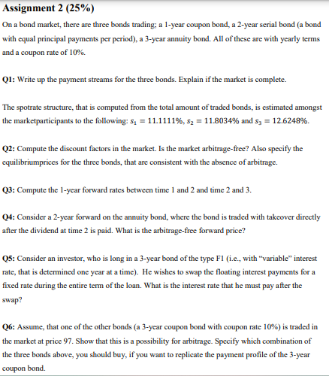
Serial bond:
$$t=1:\left(50+100·0,1\right)=60$$
$$t=2:\left(50+50·0,1\right)=55$$
Annuity bond:
$$A=\frac{0,1·{\left(1+0,1\right)}^{3}·100}{{\left(1+0,1\right)}^{3}-1}≈40,21148$$
The payment matrix:
$$B=\left(\begin{matrix}105 & 0 & 0 \\ 60 & 55 & 0 \\ 40,2115 & 40,2115 & 40,2115\end{matrix}\right)$$
Since the matrix has $Rang\left(B\right)=3$ the matrix is also invertible. This means that the vector d that solve the equation
$$P=B·d$$
will be unique. Hence, the market is complete.
$$d_{k}=\frac{1}{{\left(1+s_{k}\right)}^{k}}$$
$$d=\left(\begin{aligned}\frac{1}{1+0,1111} \\ \frac{1}{{\left(1+0,1180\right)}^{2}} \\ \frac{1}{{\left(1+0,1263\right)}^{3}}\end{aligned}\right)≈\left(\begin{matrix}0,900009 \\ 0,8000486 \\ 0,6999028\end{matrix}\right)$$
Since $d≫0$, there is no arbitrage.
$$P=B·d=\left(\begin{matrix}105 & 0 & 0 \\ 60 & 55 & 0 \\ 40,2115 & 40,2115 & 40,2115\end{matrix}\right)·\left(\begin{matrix}0,900009 \\ 0,8000486 \\ 0,6999028\end{matrix}\right)≈\left(\begin{matrix}94,50095 \\ 98,00321 \\ 96,50601\end{matrix}\right)$$
$$f_{ij}={\left(\frac{{\left(1+s_{j}\right)}^{j}}{{\left(1+s_{i}\right)}^{i}}\right)}^{\frac{1}{j-i}}-1$$
$$f_{12}=\frac{{\left(1+0,1180\right)}^{2}}{1+0,1111}-1≈0,1249428$$
$$f_{23}=\frac{{\left(1+0,1263\right)}^{3}}{{\left(1+0,1180\right)}^{2}}-1≈0,1430853$$
Since we receive it after the second dividend has been paid out, we must include cost of carry in the price.
$$F_{0,T}=\frac{P}{d_{0,T}}-A·\left(\frac{d_{0,1}}{d_{0,T}}+\frac{d_{0,2}}{d_{0,T}}\right)=\frac{96,5060}{0,8}-40,2115\left(\frac{0,9}{0,8}+\frac{0,9}{0,9}\right)≈35,18306$$
$$c=\frac{1-d_{0,t_{n}}}{\sum_{i=1}^{n}{d_{0,t_{i}}}}=\frac{1-0,6999}{0,8+0,9+0,6999}≈0,1250469$$
$$B=\left(\begin{matrix}10 & 10 & 110\end{matrix}\right)$$
$$P=B·d=\left(\begin{matrix}10 & 10 & 110\end{matrix}\right)·\left(\begin{matrix}0,900009 \\ 0,8000486 \\ 0,6999028\end{matrix}\right)≈93,98988$$
It is priced to expensive so there is an arbitrage. We want to construct a portfolio consisting of the current assets in the market such that the payment stream equals that of the new bond.
$$\left(\begin{matrix}w_{CB} & w_{SB} & w_{A}\end{matrix}\right)·\left(\begin{matrix}105 & 0 & 0 \\ 60 & 55 & 0 \\ 40,2115 & 40,2115 & 40,2115\end{matrix}\right)=\left(\begin{matrix}10 & 10 & 110\end{matrix}\right)$$
$$⇒\left(\begin{matrix}w_{CB} & w_{SB} & w_{A}\end{matrix}\right)=\left(\begin{matrix}10 & 10 & 110\end{matrix}\right)·{\left(\begin{matrix}105 & 0 & 0 \\ 60 & 55 & 0 \\ 40,2115 & 40,2115 & 40,2115\end{matrix}\right)}^{-1}≈\left(\begin{matrix}0,08658009 & -1,818182 & 2,735536\end{matrix}\right)$$

Exercise 3:
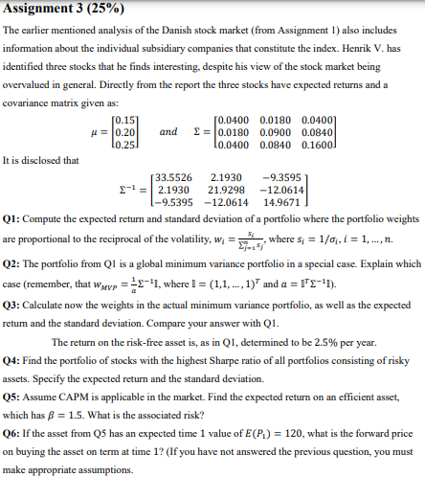≈0,1926136
$$w^{T}=\left(\begin{matrix}\frac{{0,04}^{-\frac{1}{2}}}{{0,04}^{-\frac{1}{2}}+{0,09}^{-\frac{1}{2}}+{0,16}^{-\frac{1}{2}}} & \frac{{0,09}^{-\frac{1}{2}}}{{0,04}^{-\frac{1}{2}}+{0,09}^{-\frac{1}{2}}+{0,16}^{-\frac{1}{2}}} & \frac{{0,16}^{-\frac{1}{2}}}{{0,04}^{-\frac{1}{2}}+{0,09}^{-\frac{1}{2}}+{0,16}^{-\frac{1}{2}}}\end{matrix}\right)≈\left(\begin{matrix}0,4615385 & 0,3076923 & 0,2307692\end{matrix}\right)$$
We claim that it is the case where the assets are uncorrelated.
$$w_{MVP}=\frac{1}{a}·Σ^{-1}·1$$
$$a=1^{T}·Σ^{-1}·1=\left(\begin{matrix}1 & 1 & 1\end{matrix}\right)·{\left(\begin{matrix}σ_{1}^{2} & 0 & 0 \\ 0 & σ_{2}^{2} & 0 \\ 0 & 0 & σ_{3}^{2}\end{matrix}\right)}^{-1}·\left(\begin{aligned}1 \\ 1 \\ 1\end{aligned}\right)=\frac{1}{σ_{1}^{2}}+\frac{1}{σ_{2}^{2}}+\frac{1}{σ_{3}^{2}}$$
$$=\sum_{i=1}^{n}{s_{i}}$$
$$w_{MVP}=\frac{1}{\sum_{i=1}^{n}{s_{i}}}·{\left(\begin{matrix}σ_{1}^{2} & 0 & 0 \\ 0 & σ_{2}^{2} & 0 \\ 0 & 0 & σ_{3}^{2}\end{matrix}\right)}^{-1}·\left(\begin{aligned}1 \\ 1 \\ 1\end{aligned}\right)=\frac{1}{\sum_{i=1}^{n}{s_{i}}}·\left(\begin{aligned}\frac{1}{σ_{1}^{2}} \\ \frac{1}{σ_{2}^{2}} \\ \frac{1}{σ_{3}^{2}}\end{aligned}\right)$$
$$⇒w_{MVP}=\left(\begin{aligned}\frac{\frac{1}{σ_{1}^{2}}}{\sum_{i=1}^{n}{s_{i}}} \\ \frac{\frac{1}{σ_{2}^{2}}}{\sum_{i=1}^{n}{s_{i}}} \\ \frac{\frac{1}{σ_{3}^{2}}}{\sum_{i=1}^{n}{s_{i}}}\end{aligned}\right)=\left(\begin{aligned}\frac{s_{1}}{\sum_{i=1}^{n}{s_{i}}} \\ \frac{s_{2}}{\sum_{i=1}^{n}{s_{i}}} \\ \frac{s_{3}}{\sum_{i=1}^{n}{s_{i}}}\end{aligned}\right)$$
This is the tangency portfolio.
$${\overline{r}}^{e}=\overline{r}-r_{f}=\left(\begin{aligned}0,15 \\ 0,2 \\ 0,25\end{aligned}\right)-0,025≈\left(\begin{matrix}0,125 \\ 0,175 \\ 0,225\end{matrix}\right)$$
$$w_{tan}=\frac{Σ^{-1}·{\overline{r}}^{e}}{1^{T}·Σ^{-1}·{\overline{r}}^{e}}$$
$$w_{tan}=\frac{{\left(\begin{matrix}0,04 & 0,018 & 0,04 \\ 0,018 & 0,09 & 0,084 \\ 0,04 & 0,084 & 0,16\end{matrix}\right)}^{-1}·\left(\begin{aligned}0,125 \\ 0,175 \\ 0,225\end{aligned}\right)}{\left(\begin{matrix}1 & 1 & 1\end{matrix}\right)·{\left(\begin{matrix}0,04 & 0,018 & 0,04 \\ 0,018 & 0,09 & 0,084 \\ 0,04 & 0,084 & 0,16\end{matrix}\right)}^{-1}·\left(\begin{aligned}0,125 \\ 0,175 \\ 0,225\end{aligned}\right)}≈\left(\begin{matrix}0,62442802 \\ 0,35902851 \\ 0,016543471\end{matrix}\right)$$
$${\overline{r}}_{tan}=\left(\begin{matrix}0,15 & 0,20 & 0,25\end{matrix}\right)· \left(\begin{matrix}0,6244 \\ 0,3590 \\ 0,0165\end{matrix}\right)≈0,169585$$
$$σ_{tan}^{2}=\left(\begin{matrix}0,6244 & 0,3590 & 0,0165\end{matrix}\right)· \left(\begin{matrix}0,04 & 0,018 & 0,04 \\ 0,018 & 0,09 & 0,084 \\ 0,04 & 0,084 & 0,16\end{matrix}\right)·\left(\begin{matrix}0,6244 \\ 0,3590 \\ 0,0165\end{matrix}\right)≈0,037126966$$
$$σ_{tan}=\sqrt{0,0371}≈0,1926136$$

We use the security market line. Since CAPM is assumed applicable, we note that the tangency portfolio is equal to the market portfolio.
$${\overline{r}}_{i}=r_{f}+β_{i}·\left({\overline{r}}_{M}-r_{f}\right)$$
$$\overline{r}=0,025+1,5·\left(0,1696-0,025\right)=0,2419$$
Now we use the capital market line to find the risk (standard deviation).
$$\overline{r}=r_{f}+\frac{{\overline{r}}_{M}-r_{f}}{σ_{M}}·σ⇒σ=\frac{\overline{(r}-r_{f})·σ_{M} }{{\overline{r}}_{M}-r_{f}}=\frac{\left(0,2419-0,025\right)·0,1926}{0,1696-0,025}=0,2889$$
We use the formula on page 187 in the book.
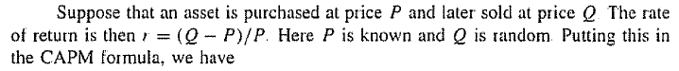
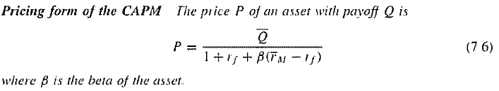
We note that $r_{f}+β\left({\overline{r}}_{M}-r_{f}\right)=\overline{r}$
Hence, we see that we can rewrite the formula as:
$$P_{0}=\frac{E\left(P_{1}\right)}{1+\overline{r}}=\frac{120}{1+0,2419}≈96,626137$$
Now we use the formula for forward price:
$$F_{0,T}=\frac{S\left(0\right)}{d_{0,T}}=\frac{96,6261}{{\left(1+0,025\right)}^{-1}}≈99,041752$$

Exercise 4:
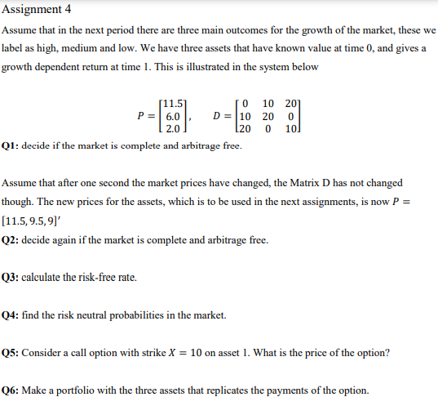
We know that:
$$P=D·ψ⇒ψ=D^{-1}·P$$
$$ψ={\left(\begin{matrix}0 & 10 & 20 \\ 10 & 20 & 0 \\ 20 & 0 & 10\end{matrix}\right)}^{-1}·\left(\begin{aligned}11,5 \\ 6 \\ 2\end{aligned}\right)≈\left(\begin{matrix}-0,1 \\ 0,35 \\ 0,4\end{matrix}\right)$$
Since $ψ_{1}$ is not strictly positive, the market is not free of arbitrage. Since the matrix $D$ is invertible and the $ψ$ that solves the equation $P=D·ψ$ is unique. Hence, the market is complete.
We do the same as in the previous question.
$$P=D·ψ⇒ψ=D^{-1}·P$$
$$ψ={\left(\begin{matrix}0 & 10 & 20 \\ 10 & 20 & 0 \\ 20 & 0 & 10\end{matrix}\right)}^{-1}·\left(\begin{aligned}11,5 \\ 9,5 \\ 9\end{aligned}\right)≈\left(\begin{matrix}0,25 \\ 0,35 \\ 0,4\end{matrix}\right)$$
Now we see that the state prices are strictly positive. Now there is no arbitrage. The market is still complete since we have not changed the matrix $D$.
We know that:
$$\sum_{s=1}^{S}{ψ_{s}}=ψ_{0}=\frac{1}{1+r_{f}}⇒r_{f}=\frac{1}{ψ_{0}}-1=\frac{1}{0,25+0,35+0,4}-1=0$$

$$q_{S}=\frac{ψ_{s}}{ψ_{0}}$$
Since $ψ_{0}=1⇒q_{s}=ψ_{s}$
$$q=\left(\begin{aligned}0,25 \\ 0,35 \\ 0,4\end{aligned}\right)$$
We us the general pricing formula for derivatives:
$$P_{0}=d_{0,T}·E^{Q}\left[f\left(S\left(T\right)\right)\right]$$
Here $f\left(S\left(T\right)\right)=\max\left(d^{1}-K;0\right)$
$$P_{0}=\frac{1}{1+0}·\left(0,25·\max\left(0-10;0\right)+0,35·\max\left(10-10;0\right)+0,4·\max\left(20-10;0\right)\right)=4$$
The possible payments of the option:
$$state 1:\max\left(0-10;0\right)=0$$
$$state 2:\max\left(10-10;0\right)=0$$
$$state 3:\max\left(20-10;0\right)=10$$
We construct a portfolio such that the weighted payoff in each state matches that of the call option.
$$x_{A}·0+x_{B}·10+x_{C}·20=0$$
$$x_{A}·10+x_{B}·20+x_{C}·0=0$$
$$x_{A}·20+x_{B}·0+x_{C}·10=10$$
$⇕$ Ligningssystemet løses for x_A,x_B,x_C vha. WordMat's 'Løs Ligninger' funktion,
$$x_{A}=\frac{4}{9} ∧ x_{B}=-\frac{2}{9} ∧ x_{C}=\frac{1}{9}$$

Eksamen 2019:

Exercise 1:
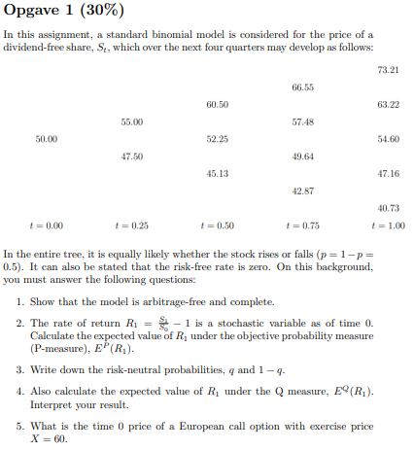
$$u=\frac{55}{50}=\frac{11}{10}=1,1$$
$$d=\frac{47,50}{50}=0,95$$
The model is free of arbitrage if and only if the following is true:
$$d<\frac{1}{d_{t,Δt}}<u$$
Since $r_{f}=0⇒d_{t,Δt}^{-1}=1$. Hence the inequality
$$0,95<1<1,1$$
is true and the market is free of arbitrage and complete.

$$E^{P}\left[R_{1}\right]={\frac{1}{2}}^{4}·\left(\frac{73,21}{50}-1\right)+{\frac{1}{2}}^{4}·\left(\frac{40,73}{50}-1\right)+4·{\frac{1}{2}}^{4}·\left(\frac{63,22}{50}-1\right)+6·{\frac{1}{2}}^{4}·\left(\frac{54,60}{50}-1\right)+4·{\frac{1}{2}}^{4}·\left(\frac{47,16}{50}-1\right)=0,103825$$
$${\frac{1}{2}}^{4}=\frac{1}{16}=0,0625$$
$$q=\frac{\frac{1}{d_{t,Δt}}-d}{u-d}=\frac{1-0,95}{1,1-0,95}≈0,33333333$$
$$1-q=1-0,3333≈0,6667$$
$$E^{Q}\left[R_{1}\right]={0,3333}^{4}·\left(\frac{73,21}{50}-1\right)+{0,6667}^{4}·\left(\frac{40,73}{50}-1\right)+4·{0,3333}^{3}·0,6667·\left(\frac{63,22}{50}-1\right)+6·{0,3333}^{2}·{0,6667}^{2}·\left(\frac{54,60}{50}-1\right)+4·\left(0,3333·{0,6667}^{3} \right)·\left(\frac{47,16}{50}-1\right)≈2,1982372·{10}^{-5}≈0,000$$
$$E^{Q}\left[R_{1}\right]=\sum_{k=0}^{4}{\left(\frac{4!}{k!·\left(4-k\right)!}·{\left(\frac{1}{3}\right)}^{k}·{\left(1-\frac{1}{3}\right)}^{4-k}·\left(\frac{50·{1,1}^{k}·{0,95}^{4-k}}{50}-1\right)\right)}=9,3675068·{10}^{-17}≈6,5919492·{10}^{-17}$$
Since there is no arbitrage the expected rate of return must be equal to the rate of return on the risk-free asset. Otherwise we could create an arbitrage strategy.
$$E^{Q}\left[C_{T}\right]={0,3333}^{4}·\left(\max\left(73,21-60;0\right)\right)+{0,6667}^{4}·\max\left(40,73-60;0\right)+4·{0,3333}^{3}·0,6667·\max\left(63,22-60;0\right)+6·{0,3333}^{2}·{0,6667}^{2}·\max\left(54,60-60;0\right)+4·\left(0,3333·{0,6667}^{3} \right)·\max\left(47,16-60;0\right)≈0,48096638$$
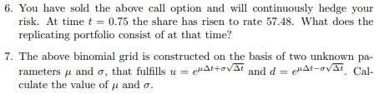
We assume that we currently are at $S\left(0,75\right)=57,48$
$$x=\frac{C_{u}-C_{d}}{\left(u-d\right)S\left(0\right)}$$
$$B=d_{t,Δt}·\frac{u·C_{d}-d·C_{u}}{\left(u-d\right)}$$
$$x=\frac{\max\left(57,48·1,1-60;0\right)-\max\left(57,48·0,95-60;0\right)}{\left(1,1-0,95\right)·57,48}≈0,37439109$$
$$B=1·\frac{1,1·\max\left(57,48·0,95-60;0\right)-0,95·\max\left(57,48·1,1-60;0\right)}{1,1-0,95}≈-20,444$$

Since the change in time pr. period is 0,25, we assume $Δt=0,25$
$$1,1=e^{μ·0,25+σ·\sqrt{0,25}}⇒\ln\left(1,1\right)=μ·0,25+σ·\sqrt{0,25}$$
$$0,95=e^{μ·0,25-σ·\sqrt{0,25}}⇒\ln\left(0,95\right)=μ·0,25-σ·\sqrt{0,25}$$
We have to equations with two unknowns. We can solve them to get the values of $μ$ and $σ.$
$$\ln\left(1,1\right)=μ·0,25+σ·\sqrt{0,25}$$
$$\ln\left(0,95\right)=μ·0,25-σ·\sqrt{0,25}$$
$⇕$ Ligningssystemet løses for μ,σ vha. WordMat's 'Løs Ligninger' funktion,
$$μ=0,088033771 ∧ σ=0,14660347$$

Exercise 2
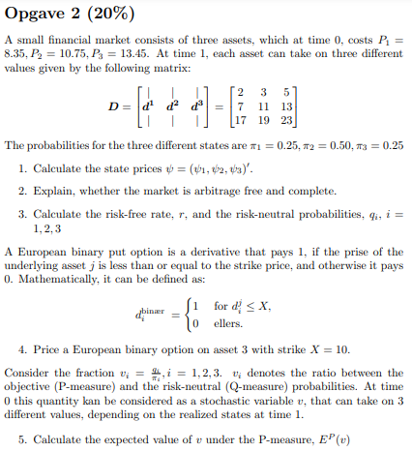
$$P=D·ψ⇒D^{-1}·P=ψ$$
Here we note that we need to transpose the matrix first.
$${\left(\begin{matrix}2 & 7 & 17 \\ 3 & 11 & 19 \\ 5 & 13 & 23\end{matrix}\right)}^{-1}·\left(\begin{aligned}8,35 \\ 10,75 \\ 13,45\end{aligned}\right)≈\left(\begin{matrix}0,4 \\ 0,35 \\ 0,3\end{matrix}\right)$$
Since the state prices are strictly positive, there is no arbitrage. Since the matrix $D^{T}$ is invertible, it has full rank, and which means that the state prices are unique. Hence, the market is complete.
$$q_{i}=\frac{ψ_{i}}{\sum_{i=1}^{n}{ψ_{i}}}$$
$$q=\left(\begin{aligned}q_{1} \\ q_{2} \\ q_{3}\end{aligned}\right)=\left(\begin{aligned}\frac{0,4}{0,4+0,35+0,3} \\ \frac{0,35}{0,4+0,35+0,3} \\ \frac{0,3}{0,4+0,35+0,3}\end{aligned}\right)≈\left(\begin{matrix}0,38095238 \\ 0,33333333 \\ 0,28571429\end{matrix}\right)$$
$$\sum_{i=1}^{n}{ψ_{i}}=ψ_{0}=\frac{1}{1+r_{f}}⇒0,4+0,35+0,3=\frac{1}{1+r_{f}}$$
$⇕$ Ligningen løses for r vha. WordMat.
$$r_{f}=-0,047619048$$

$$P_{0}=d_{0,T}·E^{Q}\left[d_{i}^{binær}\right]$$
$$P_{0}=\frac{1}{\left(1+\left(-0,0476\right)\right)}·\left(0,381·1+0,3333·0+0,2857·0\right)≈0,400042$$
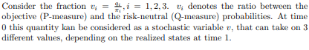
$$E^{P}\left[X\right]=\sum_{i∈I}{x_{i}·π_{i}}⇒ E^{P}\left[v\right]=\sum_{s=1}^{S}{\frac{q_{s}}{π_{i}}·π_{i}}=\sum_{s=1}^{S}{q_{s}}=\sum_{s=1}^{S}{\frac{ψ_{s}}{ψ_{0}}}=1$$

Exercise 3:
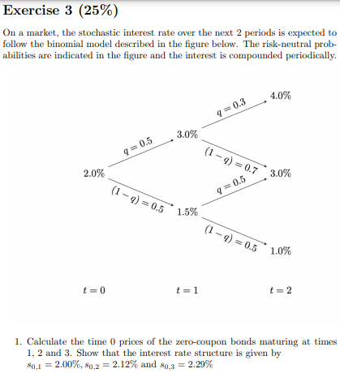
We calculate state prices.
$$ψ_{1,0}=\frac{0,5}{1+0,02}=ψ_{1,1}≈0,49019608$$
$$ψ_{2,0}=\frac{0,5}{1+0,015}·0,4902≈0,2414778$$
$$ψ_{2,1}=\frac{0,5}{1+0,015}·0,4902+\frac{0,5}{1+0,03}·0,4902≈0,479439$$
$$ψ_{2,2}=\frac{0,5}{1+0,03}·0,4902≈0,23796117$$
$$ψ_{3,0}=\frac{0,5}{1+0,01}·0,2415≈0,11955446$$
$$ψ_{3,1}=\frac{0,5}{1+0,01}·0,2415+\frac{0,5}{1+0,03}·0,4794≈0,3522729$$
$$ψ_{3,2}=\frac{0,5}{1+0,03}·0,4794+\frac{0,5}{1+0,04}·0,238≈0,34714152$$
$$ψ_{3,3}=\frac{0,5}{1+0,04}·0,238≈0,11442308$$

$$B_{0,T}=\sum_{s=1}^{T}{ψ_{T,s}}$$
$$B_{0,1}=2·0,4902=0,9804$$
$$B_{0,2}=0,2415+0,4794+0,238=0,9589$$
$$B_{0,3}=0,1196+0,3523+0,3471+0,1144=0,9334$$
$$s_{0,t}=B_{0,t}^{-\frac{1}{t}}-1$$
$$s_{0,1}={0,9804}^{-1}-1≈0,01999184$$
$$s_{0,2}={0,9589}^{-\frac{1}{2}}-1≈0,02120596$$
$$s_{0,3}={0,9334}^{-\frac{1}{3}}-1≈0,023239746$$
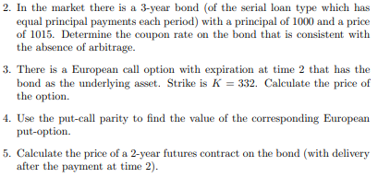
$$P=\sum_{k=1}^{n}{\frac{c_{k}}{{\left(1+s_{k}\right)}^{k}}}$$
$$1015=\frac{333,33+1000·c}{1+0,02}+\frac{333,33+1000·\frac{2}{3}·c}{{\left(1+0,0212\right)}^{2}}+\frac{333,33+1000·\frac{1}{3}·c}{{\left(1+0,0232\right)}^{3}}$$
$⇕$ Ligningen løses for c vha. WordMat.
$$c=0,029730924$$

Cash flows from a loan taker.
$$\left[333,33+1000·0,0297;333,33+1000·\frac{2}{3}·0,0297;333,33+1000·\frac{1}{3}·0,0297\right]≈\left[363,03;353,13;343,23\right]$$
Debt:
$$\left[1000-363,03;1000-363,03-353,13;1000-363,03-353,13-343,23\right]≈\left[636,97;283,84;0\right]$$
$$V_{2}\left(0\right)=\frac{1}{1+0,01}·343,23≈339,83168$$
$$V_{2}\left(1\right)=\frac{1}{1+0,03}·343,23≈333,23301$$
$$V_{2}\left(2\right)=\frac{1}{1+0,04}·343,23≈330,02885$$
$$C_{2}=\left(\begin{aligned}\max\left(339,8317-332;0\right) \\ \max\left(333,23301-332;0\right) \\ \max\left(330,0289-332;0\right)\end{aligned}\right)$$
$$C_{1}^{0}=\frac{1}{1+0,015}·\frac{1}{2}·\left(\max\left(339,8317-332;0\right)+\max\left(333,23301-332;0\right)\right)≈4,4653744$$
$$C_{1}^{1}=\frac{1}{1+0,03}·\left(0,3·\max\left(330,0289-332;0\right)+0,7·\max\left(333,23301-332;0\right)\right)≈0,83796796$$
$$C_{0}=\frac{1}{1+0,02}·\frac{1}{2}\left(4,4653744+0,83796796\right)≈2,5996776$$

$$\left[\frac{1000}{3}+1000·0,0297;\frac{1000}{3}+1000·\frac{2}{3}·0,0297;\frac{1000}{3}+1000·\frac{1}{3}·0,0297\right]$$
$$\left[\frac{1000}{3}+1000·0,0297;\frac{1000}{3}+1000·\frac{2}{3}·0,0297;\frac{1000}{3}+1000·\frac{1}{3}·0,0297\right]$$
$$\frac{1000}{3}+1000·\frac{1}{3}·0,0297≈343,23333$$

$$0,5·0,3·330+\left(0,5·0,7+0,5·0,5\right)·333,20388+{0,5}^{2}·339,80198≈334,37282$$

$$\frac{1015}{{\left(1+0,0212\right)}^{-2}}-363,03·\frac{{\left(1+0,020\right)}^{-1}}{{\left(1+0,0212\right)}^{-2}}-353,13≈334,1998$$

Exercise 4:
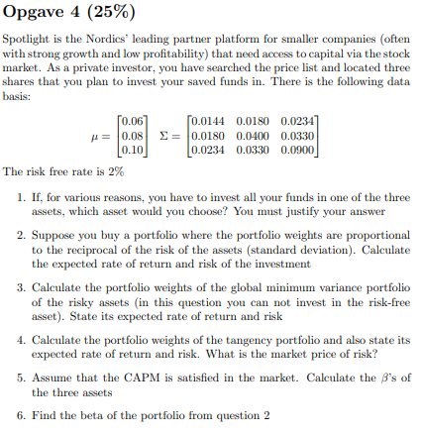
We look at the expected return/risk ratio of the three assets.
$$\frac{0,06}{{0,0144}^{\frac{1}{2}}}=0,5$$
$$\frac{0,08}{{0,04}^{\frac{1}{2}}}≈0,4$$
$$\frac{0,1}{{0,09}^{\frac{1}{2}}}≈0,33333333$$
Since asset 1 has the highest ratio, we are relatively better compensated for taking on risk. Hence, we would want to invest in the first asset.
$$w=\left(\begin{matrix}\frac{{0,0144}^{-\frac{1}{2}}}{8,3333+5+3,3333} & \frac{{0,04}^{-\frac{1}{2}}}{8,3333+5+3,3333} & \frac{{0,09}^{-\frac{1}{2}}}{8,3333+5+3,3333}\end{matrix}\right)≈\left(\begin{matrix}0,500002 & 0,3000012 & 0,2000008\end{matrix}\right)$$
$${\overline{r}}_{p}=\left(\begin{matrix}0,500002 & 0,3000012 & 0,2000008\end{matrix}\right)·\left(\begin{aligned}0,06 \\ 0,08 \\ 0,1\end{aligned}\right)=0,074000296$$
$$σ_{p}^{2}=\left(\begin{matrix}0,5 & 0,3 & 0,2\end{matrix}\right)·\left(\begin{matrix}0,0144 & 0,018 & 0,0234 \\ 0,018 & 0,04 & 0,033 \\ 0,0234 & 0,033 & 0,09\end{matrix}\right)·\left(\begin{aligned}0,5 \\ 0,3 \\ 0,2\end{aligned}\right)≈0,02484$$
$$σ_{p}=\sqrt{0,0248}≈0,15748016$$

$$w_{MVP}=\frac{1}{a}·Σ^{-1}·1$$
$$a=1^{T}·Σ^{-1}·1=\left(\begin{matrix}1 & 1 & 1\end{matrix}\right)·{\left(\begin{matrix}0,0144 & 0,018 & 0,0234 \\ 0,018 & 0,04 & 0,033 \\ 0,0234 & 0,033 & 0,09\end{matrix}\right)}^{-1}·\left(\begin{aligned}1 \\ 1 \\ 1\end{aligned}\right)≈79,396985$$
$$w_{MVP}=\frac{1}{79,397}·{\left(\begin{matrix}0,0144 & 0,018 & 0,0234 \\ 0,018 & 0,04 & 0,033 \\ 0,0234 & 0,033 & 0,09\end{matrix}\right)}^{-1}·\left(\begin{aligned}1 \\ 1 \\ 1\end{aligned}\right)≈\left(\begin{matrix}1,2904358 \\ -0,149789 \\ -0,14064695\end{matrix}\right)$$
$${\overline{r}}_{MVP}=\left(\begin{matrix}1,2904 & -0,1498 & -0,1406\end{matrix}\right)·\left(\begin{aligned}0,06 \\ 0,08 \\ 0,1\end{aligned}\right)≈0,05138$$
$$σ_{MVP}^{2}=\left(\begin{matrix}1,2904 & -0,1498 & -0,1406\end{matrix}\right)·\left(\begin{matrix}0,0144 & 0,018 & 0,0234 \\ 0,018 & 0,04 & 0,033 \\ 0,0234 & 0,033 & 0,09\end{matrix}\right)·\left(\begin{matrix}1,2904 \\ -0,1498 \\ -0,1406\end{matrix}\right)≈0,012594937$$
$$σ_{MVP}=\sqrt{0,0126}≈0,11224972$$
$${\overline{r}}^{e}=\left(\begin{aligned}0,06 \\ 0,08 \\ 0,1\end{aligned}\right)-0,02≈\left(\begin{matrix}0,04 \\ 0,06 \\ 0,08\end{matrix}\right)$$
$$w_{tan}=\frac{Σ^{-1}·{\overline{r}}^{e}}{1^{T}·Σ^{-1}·{\overline{r}}^{e}}$$
$$w_{tan}=\frac{{\left(\begin{matrix}0,0144 & 0,018 & 0,0234 \\ 0,018 & 0,04 & 0,033 \\ 0,0234 & 0,033 & 0,09\end{matrix}\right)}^{-1}·\left(\begin{matrix}0,04 \\ 0,06 \\ 0,08\end{matrix}\right)}{\left(\begin{matrix}1 & 1 & 1\end{matrix}\right)·{\left(\begin{matrix}0,0144 & 0,018 & 0,0234 \\ 0,018 & 0,04 & 0,033 \\ 0,0234 & 0,033 & 0,09\end{matrix}\right)}^{-1}·\left(\begin{matrix}0,04 \\ 0,06 \\ 0,08\end{matrix}\right)}≈\left(\begin{matrix}0,69139399 \\ 0,20775437 \\ 0,10085164\end{matrix}\right)$$
$${\overline{r}}_{tan}=\left(\begin{matrix}0,6914 & 0,2078 & 0,1009\end{matrix}\right)·\left(\begin{matrix}0,06 \\ 0,08 \\ 0,1\end{matrix}\right)≈0,068198$$
$$σ_{tan}^{2}=\left(\begin{matrix}0,6914 & 0,2078 & 0,1009\end{matrix}\right)·\left(\begin{matrix}0,0144 & 0,018 & 0,0234 \\ 0,018 & 0,04 & 0,033 \\ 0,0234 & 0,033 & 0,09\end{matrix}\right)·\left(\begin{matrix}0,6914 \\ 0,2078 \\ 0,1009\end{matrix}\right)≈0,019348118$$
$$σ_{tan}=\sqrt{0,0193}≈0,13892444$$
Price of risk is the slope of the CAPM market line. But we just use the tangency portfolio.
$$\frac{{\overline{r}}_{tan}-r_{f}}{σ_{tan}}=\frac{0,0682-0,02}{0,1389}≈0,34701224$$
If CAPM is satisfied, then ${\overline{r}}_{tan}={\overline{r}}_{M}$.
$${\overline{r}}_{i}=r_{f}+β_{i}·\left({\overline{r}}_{M}-r_{f}\right)⇒β_{i}=\frac{{\overline{r}}_{i}-r_{f}}{{\overline{r}}_{M}-r_{f}}$$

$$β=\left(\begin{aligned}β_{1} \\ β_{2} \\ β_{3}\end{aligned}\right)=\left(\begin{aligned}\frac{0,06-0,02}{0,0682-0,02} \\ \frac{0,08-0,02}{0,0682-0,02} \\ \frac{0,1-0,02}{0,0682-0,02}\end{aligned}\right)≈\left(\begin{matrix}0,82987552 \\ 1,2448133 \\ 1,659751\end{matrix}\right)$$
$$β_{p}=w^{T}·β=\left(\begin{matrix}0,50 & 0,30 & 0,20\end{matrix}\right)·\left(\begin{matrix}0,8299 \\ 1,2448 \\ 1,6598\end{matrix}\right)=1,12035$$

Eksamen 2020

Exercise 1:
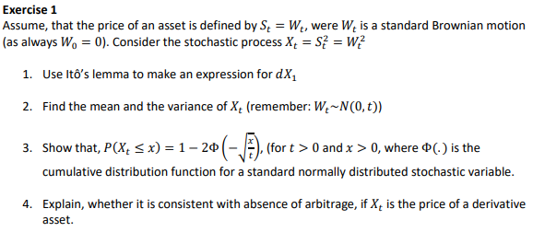
The standard Brownian motion is given by:
$$S_{t}=W_{t}$$
$$dS_{t}=dW_{t}$$

Let $f\left(t,S_{t}\right)=S_{t}^{2}$
$$df=\left(\frac{∂f}{∂t}+\frac{∂f}{∂S}·a\left(t,X_{t}\right)+\frac{1}{2}·b{\left(t,X_{t}\right)}^{2}·\frac{∂^{2}f}{∂X^{2}}\right)dt+\frac{∂f}{∂X_{t}}·b\left(t,X_{t}\right)dW_{t}$$
$$=\left(0+2S_{t}·0+\frac{1}{2}·2·1\right)dt+2S_{t}dW_{t}=dt+2W_{t}dW_{t}$$
$$Var\left(X_{t}\right)=E\left[X_{t}^{2}\right]-E{\left[X_{t}\right]}^{2}⇒E\left[X_{t}^{2}\right]=Var\left(X_{t}\right)+E{\left[X_{t}\right]}^{2}=t$$
Pdf af en normal fordeling:
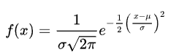
Lotus:
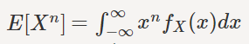
$$E\left[{\left(X_{t}^{2}\right)}^{2}\right]=E\left[X_{t}^{4}\right]=\int_{-∞}^{∞}{x^{4}·\frac{1}{t^{\frac{1}{2}}·\sqrt{2·π}}·e^{-\frac{1}{2}·{\left(\frac{x-0}{t^{\frac{1}{2}}}\right)}^{2}}dx}=3·t^{2}$$
$$Var\left(X_{t}^{2}\right)=E\left[{\left(X_{t}^{2}\right)}^{2}\right]-E{\left[X_{t}^{2}\right]}^{2}=3t^{2}-t^{2}=2t^{2}$$

Since $W_{t}∼N\left(μ,σ^{2}\right)$, then $W_{t}^{2}=\frac{X-μ}{σ}$ is standard normal distributed $\frac{W_{t}}{\sqrt{t}}∼N\left(0,1\right)$
$$P\left(W_{t}^{2}≤x\right)=P\left(-\sqrt{x}≤W_{t}≤\sqrt{x}\right)=P\left(-\frac{\sqrt{x}}{\sqrt{t}}≤\frac{W_{t}}{\sqrt{t}}≤\frac{\sqrt{x}}{\sqrt{t}}\right)$$
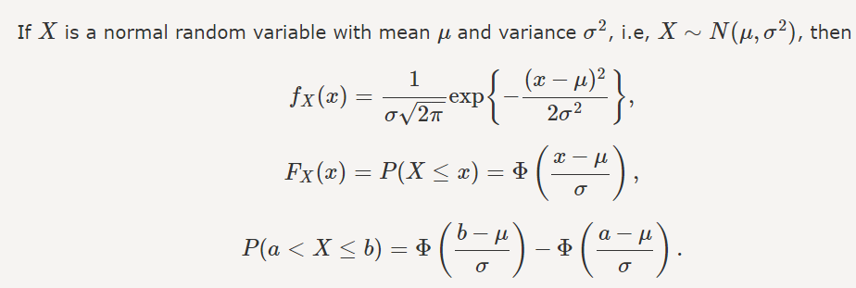
$$P\left(-\frac{\sqrt{x}}{\sqrt{t}}≤\frac{W_{t}}{\sqrt{t}}≤\frac{\sqrt{x}}{\sqrt{t}}\right)=Φ\left(\frac{\sqrt{x}}{\sqrt{t}}\right)-ϕ\left(-\frac{\sqrt{x}}{\sqrt{t}}\right)$$
For a standard normal distribution:
$$Φ\left(x\right)=1-ϕ\left(-x\right)$$
$$Φ\left(\frac{\sqrt{x}}{\sqrt{t}}\right)-ϕ\left(-\frac{\sqrt{x}}{\sqrt{t}}\right)=1-Φ\left(-\frac{\sqrt{x}}{\sqrt{t}}\right)-ϕ\left(-\frac{\sqrt{x}}{\sqrt{t}}\right)=1-2ϕ\left(-\frac{\sqrt{x}}{\sqrt{t}}\right)$$

Exercise 2:
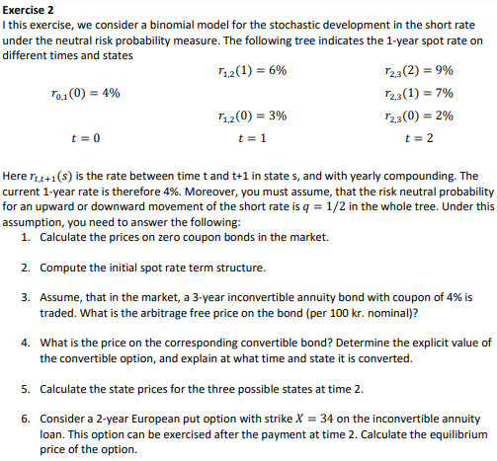
$$A=\frac{c·{\left(1+c\right)}^{n}·100}{{\left(1+c\right)}^{n}-1}$$
$$A=\frac{0,04·{\left(1+0,04\right)}^{3}·100}{{\left(1+0,04\right)}^{3}-1}≈36,034854$$
$$P=\frac{36,0349}{1+0,04}+\frac{36,0349}{{\left(1+0,04239\right)}^{2}}+\frac{36,0349}{{\left(1+0,048755\right)}^{3}}≈99,051925$$
$$\frac{36,0349}{1+x}+\frac{36,0349}{{\left(1+x\right)}^{2}}+\frac{36,0349}{{\left(1+x\right)}^{3}}=99,051925$$
$⇕$ Ligningen løses for x vha. WordMat.
$$x=0,04503606$$
Debt:
$$R_{0}=99,0519$$
$$R_{1}=99,0519·1,0450-36,0349≈67,474335$$
$$R_{2}=67,4743·1,0450-36,0349≈34,475744$$
$$R_{3}=34,4757·1,045-36,03490$$
$$V_{3}\left(0\right)=0=V_{3}\left(1\right)=0=V_{3}\left(2\right)=0=V_{3}\left(3\right)$$
$$V_{2}\left(0\right)=\frac{1}{1+0,02}·36,0349≈35,328333$$
$$V_{2}\left(1\right)=\frac{1}{1+0,07}·36,0349≈33,677477$$
$$V_{2}\left(2\right)=\frac{1}{1+0,09}·36,0349≈33,059541$$
We call the bond if $V_{t}\left(s\right)>R_{t}$
$$V_{1}\left(0\right)=\frac{1}{1+0,03}·\frac{1}{2}·\left(35,3283+33,6774\right)+\frac{36,0349}{1+0,03} ≈68,483252$$
$$V_{1}\left(1\right)=\frac{1}{1+0,06}·\frac{1}{2}·\left(33,6774+33,0595\right)+\frac{36,0349}{1+0,06}≈65,474858$$
We call at state 0.
$$V_{0}=\frac{1}{1+0,04}·\frac{1}{2}\left(65,4749+67,4743\right)+\frac{36,0349}{1+0,04}≈98,566827$$

$$ψ_{0,0}=1$$
$$ψ_{1,0}=ψ_{1,1}=\frac{0,5}{1+0,04}≈0,48076923$$
$$ψ_{2,0}=\frac{0,5}{1+0,03}·0,4808≈0,23339806$$
$$ψ_{2,1}=\frac{0,5}{1+0,03}·0,4808+\frac{0,5}{1+0,06}·0,4808≈0,46019051$$
$$ψ_{2,2}=\frac{0,5}{1+0,06}·0,4808≈0,22679245$$
$$P_{callable}=P_{non-callable}-P_{option}$$
$$⇒P_{option}=P_{non-callable}-P_{callable}=99,0519-98,5669≈0,485$$

Exercise 3:
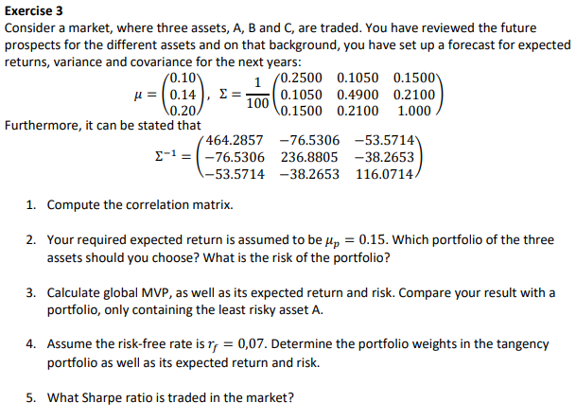
$$ρ_{ab}=\frac{σ_{ab}}{σ_{a}·σ_{b}}$$
$$ρ_{AB}=\frac{\frac{0,105}{100}}{\sqrt{\frac{0,25}{100}}·\sqrt{\frac{0,49}{100}}}=0,3$$
$$ρ_{AC}=\frac{\frac{0,15}{100}}{\sqrt{\frac{0,25}{100}}·\sqrt{\frac{1}{100}}}≈0,3$$
$$ρ_{BC}=\frac{\frac{0,21}{100}}{\sqrt{\frac{0,49}{100}}·\sqrt{\frac{1}{100}}}=0,3$$
$$ρ=\left(\begin{matrix}1 & 0,3 & 0,3 \\ 0,3 & 1 & 0,3 \\ 0,3 & 0,3 & 1\end{matrix}\right)$$
$$w=\frac{a·{\overline{r}}_{p}-b}{d}·Σ^{-1}·\overline{r}+\frac{c-{\overline{r}}_{p}·b}{d}·Σ^{-1}·1$$
$$a=1^{T}·Σ^{-1}·1=\left(\begin{matrix}1 & 1 & 1\end{matrix}\right)·\left(\begin{matrix}464,2857 & -76,5306 & -53,5714 \\ -76,5306 & 236,8805 & -38,2653 \\ -53,5714 & -38,2653 & 116,0714\end{matrix}\right)·\left(\begin{aligned}1 \\ 1 \\ 1\end{aligned}\right)≈480,503$$
$$b=1^{T}·Σ^{-1}·\overline{r}=\left(\begin{matrix}1 & 1 & 1\end{matrix}\right)·\left(\begin{matrix}464,2857 & -76,5306 & -53,5714 \\ -76,5306 & 236,8805 & -38,2653 \\ -53,5714 & -38,2653 & 116,0714\end{matrix}\right)·\left(\begin{aligned}0,1 \\ 0,14 \\ 0,2\end{aligned}\right)=55,357154$$
$$c={\overline{r}}^{T}·Σ^{-1}·\overline{r}=\left(\begin{matrix}0,1 & 0,14 & 0,2\end{matrix}\right)·\left(\begin{matrix}464,2857 & -76,5306 & -53,5714 \\ -76,5306 & 236,8805 & -38,2653 \\ -53,5714 & -38,2653 & 116,0714\end{matrix}\right)·\left(\begin{aligned}0,1 \\ 0,14 \\ 0,2\end{aligned}\right)≈7,5000012$$
$$d=ac-b^{2}=480,503·7,5-{55,3572}^{2}≈539,35291$$
$$w=\frac{480,503·0,15-55,3572}{539,3529}·\left(\begin{matrix}464,2857 & -76,5306 & -53,5714 \\ -76,5306 & 236,8805 & -38,2653 \\ -53,5714 & -38,2653 & 116,0714\end{matrix}\right)·\left(\begin{aligned}0,1 \\ 0,14 \\ 0,2\end{aligned}\right)+\frac{7,5-0,15·55,3572}{539,3529}·\left(\begin{matrix}464,2857 & -76,5306 & -53,5714 \\ -76,5306 & 236,8805 & -38,2653 \\ -53,5714 & -38,2653 & 116,0714\end{matrix}\right)·\left(\begin{aligned}1 \\ 1 \\ 1\end{aligned}\right)≈\left(\begin{matrix}0,27702273 \\ 0,37162228 \\ 0,35135358\end{matrix}\right)$$
$$σ_{p}^{2}=\left(\begin{matrix}0,2770 & 0,3716 & 0,3514\end{matrix}\right)·{\left(\begin{matrix}464,2857 & -76,5306 & -53,5714 \\ -76,5306 & 236,8805 & -38,2653 \\ -53,5714 & -38,2653 & 116,0714\end{matrix}\right)}^{-1}·\left(\begin{aligned}0,2770 \\ 0,3716 \\ 0,3514\end{aligned}\right)≈0,0031598761$$
$$σ_{p}=\sqrt{0,0032}≈0,056568542$$
$$w_{MVP}=\frac{1}{a}·Σ^{-1}·1=\frac{1}{480,53}·\left(\begin{matrix}464,2857 & -76,5306 & -53,5714 \\ -76,5306 & 236,8805 & -38,2653 \\ -53,5714 & -38,2653 & 116,0714\end{matrix}\right)·\left(\begin{aligned}1 \\ 1 \\ 1\end{aligned}\right)≈\left(\begin{matrix}0,69544815 \\ 0,25406239 \\ 0,050433272\end{matrix}\right)$$
$${\overline{r}}_{MVP}=\frac{b}{a}=\frac{55,3572}{480,53}≈0,1152003$$
$$σ_{MVP}=\frac{1}{a}⇒σ_{MVP}=a^{-\frac{1}{2}}={480,53}^{-\frac{1}{2}}≈0,045618368$$
$${\overline{r}}_{A}=0,1,σ_{A}=\sqrt{\frac{0,25}{100}} =0,05$$
We see that we get a higher return and lower risk by constructing a portfolio compared to just investing in one asset. This illustrates the effect of diversification.

$${\overline{r}}^{e}=\overline{r}-r_{f}=\left(\begin{aligned}0,1 \\ 0,14 \\ 0,2\end{aligned}\right)-0,07=\left(\begin{matrix}0,03 \\ 0,07 \\ 0,13\end{matrix}\right)$$
$$w_{tan}=\frac{Σ^{-1}·{\overline{r}}^{e}}{1^{T}·Σ^{-1}·{\overline{r}}^{e}}=\frac{\left(\begin{matrix}464,2857 & -76,5306 & -53,5714 \\ -76,5306 & 236,8805 & -38,2653 \\ -53,5714 & -38,2653 & 116,0714\end{matrix}\right)·\left(\begin{aligned}0,03 \\ 0,07 \\ 0,13\end{aligned}\right)}{\left(\begin{matrix}1 & 1 & 1\end{matrix}\right)·\left(\begin{matrix}464,2857 & -76,5306 & -53,5714 \\ -76,5306 & 236,8805 & -38,2653 \\ -53,5714 & -38,2653 & 116,0714\end{matrix}\right)·\left(\begin{aligned}0,03 \\ 0,07 \\ 0,13\end{aligned}\right)}≈\left(\begin{matrix}0,073987255 \\ 0,42865537 \\ 0,49735737\end{matrix}\right)$$
$${\overline{r}}_{tan}=0,074·0,1+0,4287·0,14+0,4974·0,2≈0,166898$$
$$σ_{tan}=\left(\begin{matrix}0,074 & 0,4287 & 0,4974\end{matrix}\right)·{\left(\begin{matrix}464,2857 & -76,5306 & -53,5714 \\ -76,5306 & 236,8805 & -38,2653 \\ -53,5714 & -38,2653 & 116,0714\end{matrix}\right)}^{-1}·\left(\begin{aligned}0,074 \\ 0,4287 \\ 0,4974\end{aligned}\right)≈0,0044609289$$
$$σ_{tan}=\sqrt{0,0045}≈0,067082039$$
$$Sharpe-ratio:\frac{{\overline{r}}_{tan}-r_{f} }{σ_{tan}}=\frac{0,1669-0,07}{0,0671}≈1,4441133$$

Exercise 4:
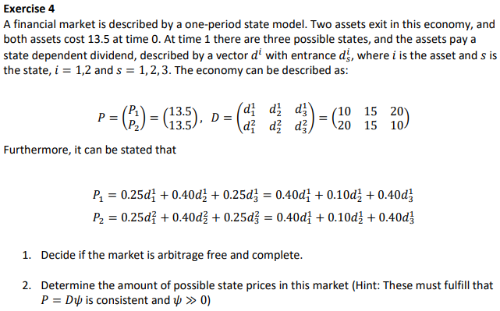
We can see that the state prices $ψ=\left(\begin{aligned}0,25 \\ 0,40 \\ 0,25\end{aligned}\right)$ solves the equation $P=D·ψ$. Since the state prices are strictly positive, the market is free of arbitrage. The market is only complete if the state prices are unique. But we see that the state prices $ψ^{'}=\left(\begin{aligned}0,4 \\ 0,1 \\ 0,4\end{aligned}\right)$ also solves the equation $P=D·ψ$. Hence the market is not complete. Since the matrix $D$ does not have full rank, it is not complete.
We look at the totalmatrix $\left(D|P\right)$ and set it on reduced row echelon form.
$$\left(D|P\right)∼\left(\begin{matrix}1 & 0 & -1 \\ 0 & 1 & 2\end{matrix} | \begin{aligned}0 \\ 0,9\end{aligned}\right)$$
$$ψ_{1}-ψ_{3}=0⇒ψ_{1}=ψ_{3}$$
$$ψ_{2}+2ψ_{3}=0,9$$
Since $ψ_{2}>0⇒2ψ_{3}<0,9⇒ψ_{3}=ψ_{1}<0,45$. Likewise, we must have that $ψ_{1},ψ_{3}>0⇒ψ_{2}<0,9$.
Hence, we get that amount of state prices are $ψ_{1}∈\left(0;0,45\right)$, $ψ_{2}∈\left(0;0,9\right)$, $ψ_{3}∈\left(0;0,45\right)$.
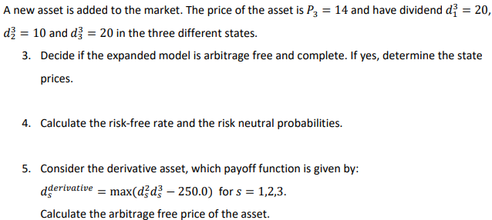
$$P=20·0,25+10·0,40+20·0,25=14$$
The same state prices works with the new asset. It is arbitrage free. Sine the matrix $D$ now has full rank, the market is also complete.
$$\sum_{s=1}^{S}{ψ_{s}}=ψ_{0}=\frac{1}{1+r_{f}}$$
$$ψ_{0}=2·0,25+0,4=\frac{1}{1+r_{f}}$$
$⇕$ Ligningen løses for r vha. WordMat.
$$r=0,11111111$$
$$q_{s}=\frac{ψ_{s}}{ψ_{0}}$$
$$q=\left(\begin{aligned}\frac{0,25}{0,9} \\ \frac{0,4}{0,9} \\ \frac{0,25}{0,9}\end{aligned}\right)≈\left(\begin{matrix}0,27777778 \\ 0,44444444 \\ 0,27777778\end{matrix}\right)$$

$$P_{0}=d_{0,T}·E^{Q}\left[f\left(S\left(T\right)\right)\right]$$
$$P_{0}=\frac{1}{1+0,1111}·\left(0,2778·\max\left(20·20-250;0\right)+0,4444·\max\left(15·10-250;0\right)+0,2778·\max\left(10·20-250;0\right)\right)≈37,503375$$

Reeksamen 2020:

Exercise 1:
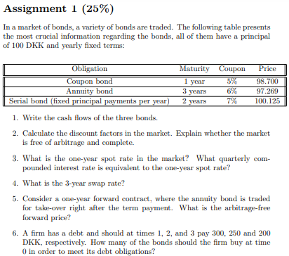
Annuity:
$$A=\frac{c·{\left(1+c\right)}^{n}·100}{{\left(1+c\right)}^{n}-1}=\frac{0,06·{\left(1+0,06\right)}^{3}·100}{{\left(1+0,06\right)}^{3}-1}≈37,410981$$
Serial bond:
$$t=1:\frac{100}{2}+100·0,07=57$$
$$t=2:\frac{100}{2}+\frac{100}{2}·0,07=53,5$$
$$B=\left(\begin{matrix}105 & 0 & 0 \\ 37,411 & 37,411 & 37,411 \\ 57 & 53,5 & 0\end{matrix}\right)$$
We know that $P=B·d⇒d=B^{-1}·P$. If the matrix $B$ is invertible, we can easily find the discount factors.
$$d={\left(\begin{matrix}105 & 0 & 0 \\ 37,411 & 37,411 & 37,411 \\ 57 & 53,5 & 0\end{matrix}\right)}^{-1}·\left(\begin{aligned}98,7 \\ 97,269 \\ 100,125\end{aligned}\right)≈\left(\begin{matrix}0,94 \\ 0,87 \\ 0,79001069\end{matrix}\right)$$
Since $d≫0$ the market is free of arbitrage.

$$d_{k}=\frac{1}{{\left(1+s_{k}\right)}^{k}}$$
$$0,94=\frac{1}{1+s}$$
$⇕$ Ligningen løses for s vha. WordMat.
$$s=0,063829787$$
$$\left(1+0,0638\right)={\left(1+\frac{r}{4}\right)}^{4}$$
$⇕$ Ligningen løses for r vha. WordMat.
$$r=-8,062328 ∨ r=0,062328015$$
$$c=\frac{1-d_{0,t_{n}}}{\sum_{i=1}^{n}{d_{0,t_{i}}}}$$
$n=3$.
$$c=\frac{1-0,79}{0,94+0,87+0,79}≈0,080769231$$
Since we take over after the first term payment has been made, we must include cost of carry which in this case needs to be subtracted.
$$F_{0,T}=\frac{S\left(0\right)}{d_{0,T}}-\sum_{k=1}^{T}{\frac{c_{k}}{d_{k,T}}}$$
Here we note that $d_{0,k}·d_{k,T}=d_{0,T}⇒d_{k,T}=\frac{d_{0,T}}{d_{0,k}}$
$$F_{0,1}=\frac{97,269}{0,94}-37,411·1≈66,06666$$

We need to invest enough of the respective assets such that their cashflows equal the debt.
At time 1:
$$x_{ZCB}·105+x_{Annui}·37,411+x_{SB}·57=300$$
At time 2:
$$x_{ZCB}·0+x_{Annui}·37,411+x_{SB}·53,5=250$$
At time 3:
$$x_{ZCB}·0+x_{Annui}·37,411+x_{SB}·0=200$$
From the third equation:
$$x_{Annui}=\frac{200}{37,411}≈5,3460212$$
From the second equation:
$$x_{SB}=\frac{250-37,411·5,3460}{53,5}≈0,93459428$$
From the first equation:
$$x_{ZCB}=\frac{300-37,411·5,3460-0,9346·57}{105}≈0,44503423$$

Exercise 2:
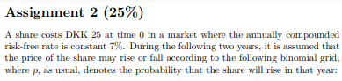
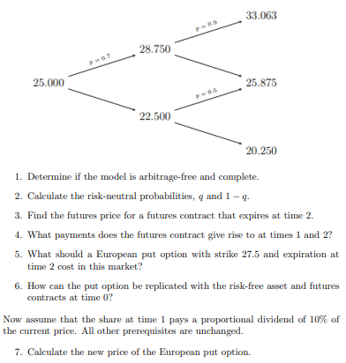
The model is free of arbitrage and complete if and only if the following inequality is true:
$$d<\frac{1}{d_{t,Δt}}<u$$
$$u=\frac{28,75}{25}=1,15$$
$$d=\frac{22,5}{25}=0,9$$
$$\frac{1}{d_{t,Δt}}=1+r=1,07$$
Since $0,9<1,07<1,15$ the model is free of arbitrage and complete.
$$q=\frac{\frac{1}{d_{t,Δt}}-d }{u-d}=\frac{1,07-0,9}{1,15-0,9}≈0,68$$
$$1-q=1-0,68=0,32$$
$$G_{0,T}=E^{Q}\left[S\left(T\right)\right]={0,68}^{2}·33,063+2·0,68·0,32·25,875+{0,32}^{2}·20,25≈28,622731$$
$$G_{1,2}^{u}=0,68·33,063+0,32·25,875≈30,76284$$
$$G_{1,2}^{d}=0,68·25,875+0,32·20,25≈24,075$$
Payment if we go up:
$$G_{1,2}^{u}-G_{0,2}=30,7628-28,6227≈2,1401$$
Payment if we go down:
$$G_{1,2}^{d}-G_{0,2}=24,075-28,6227≈-4,5477$$
Now we look at the second period.
Here we note that $G_{2,2}^{s}={\left(S\left(T\right)\right)}^{s}$ for all states $s$. Here ${\left(S\left(T\right)\right)}^{s}$ is the price at maturity in state s.
Payment if we go up twice:
$$G_{2,2}^{u}-G_{1,2}^{u}=33,063-30,7628≈2,3002$$
Payment if we go up, then down:
$$G_{2,2}^{ud}-G_{1,2}^{u}=25,875-30,7628≈-4,8878$$
Payment if we go down then up:
$$G_{2,2}^{ud}-G_{1,2}^{d}=25,875-24,075≈1,8$$
Payment if we go down twice:
$$G_{2,2}^{dd}-G_{1,2}^{d}=20,25-24,075≈-3,825$$
Payoff function for an European put option:
$$f\left(S\left(T\right)\right)=\max\left(K-S\left(T\right);0\right)$$
$$P_{0}=d_{0,T}·E^{Q}\left[f\left(S\left(T\right)\right)\right]$$
$$=\frac{1}{{\left(1+0,07\right)}^{2}}·\left(\begin{matrix}{0,68}^{2} & 2·0,68·0,32 & {0,32}^{2}\end{matrix} \right)·\left(\begin{aligned}\max\left(27,5-33,063;0\right) \\ \max\left(27,5-25,875;0\right) \\ \max\left(27,5-20,25;0\right)\end{aligned}\right)≈1,2661368$$
We start by looking at the value of the put option at time 1:
$$P_{1}=\left(\begin{aligned}P_{1}^{u} \\ P_{1}^{d}\end{aligned}\right)=\left(\begin{aligned}\frac{1}{1,07}·\left(0,68·\max\left(27,5-33,063;0\right)+0,32·\max\left(27,5-25,875;0\right)\right) \\ \frac{1}{1,07}·\left(0,68·\max\left(27,5-25,875;0\right)+0,32·\max\left(27,5-20,25;0\right)\right)\end{aligned}\right)≈\left(\begin{matrix}0,48598131 \\ 3,2009346\end{matrix}\right)$$

The payments of the futures at that time:
$$G_{1,2}=\left(\begin{aligned}2,1401 \\ -4,5477\end{aligned}\right)$$
We construct a portfolio such that the value in each state at time $t=1$ is equal to the value of the put option in the same states.
$$x·G_{1,2}^{u}+d_{tΔt}^{-1}·B=P_{1}^{u}$$
$$x·G_{1,2}^{d}+d_{tΔt}^{-1}·B=P_{1}^{d}$$
$$\left(\begin{matrix}2,1401 & 1,07 \\ -4,5477 & 1,07\end{matrix}\right)·\left(\begin{aligned}x \\ B\end{aligned}\right)=\left(\begin{aligned}0,486 \\ 3,201\end{aligned}\right)⇒\left(\begin{aligned}x \\ B\end{aligned}\right)={\left(\begin{matrix}2,1401 & 1,07 \\ -4,5477 & 1,07\end{matrix}\right)}^{-1}·\left(\begin{aligned}0,486 \\ 3,201\end{aligned}\right)≈\left(\begin{matrix}-0,4059631 \\ 1,2661697\end{matrix}\right)$$
We let $δ=0,1$. Then the price at each state is just $S\left(t\right)·\left(1-0,1\right)$
Time 1:
$$S{\left(1\right)}^{u}=25·1,15·0,9≈25,875$$
$$S{\left(1\right)}^{d}=25·{0,9}^{2}=20,25$$
$$S{\left(2\right)}^{uu}=25,875·1,15≈29,75625$$
$$S{\left(2\right)}^{ud}=25,875·0,9=23,2875$$

$$S{\left(2\right)}^{dd}=20,25·0,9=18,225$$
$$\left(\begin{aligned}\max\left(27,5-29,75625;0\right) \\ \max\left(27,5-23,2875;0\right) \\ \max\left(27,5-18,225;0\right)\end{aligned}\right)≈\left(\begin{matrix}0 \\ 4,2125 \\ 9,275\end{matrix}\right)$$
$$C_{0}=\frac{1}{{\left(1+0,07\right)}^{2}}·\left(\begin{matrix}{0,68}^{2} & 2·0,68·0,32 & {0,32}^{2}\end{matrix} \right)·\left(\begin{matrix}0 \\ 4,2125 \\ 9,275\end{matrix}\right)≈2,4308149$$

Exercise 3:
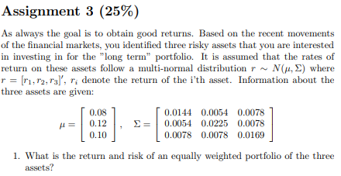
$${\overline{r}}_{p}=\left(\begin{matrix}\frac{1}{3} & \frac{1}{3} & \frac{1}{3}\end{matrix}\right)·\left(\begin{aligned}0,08 \\ 0,12 \\ 0,1\end{aligned}\right)≈0,1$$
$$σ_{p}^{2}=\left(\begin{matrix}\frac{1}{3} & \frac{1}{3} & \frac{1}{3}\end{matrix}\right)·\left(\begin{matrix}0,0144 & 0,0054 & 0,0078 \\ 0,0054 & 0,0225 & 0,0078 \\ 0,0078 & 0,0078 & 0,0169\end{matrix}\right)·\left(\begin{aligned}\frac{1}{3} \\ \frac{1}{3} \\ \frac{1}{3}\end{aligned}\right)≈0,010644444$$
$$σ_{p}=\sqrt{0,0106}≈0,1029563$$
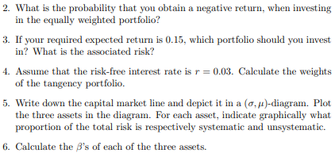
The probability of yielding a negative return is given by:
$$P\left(w·r<0\right)=P\left(w·r≤0\right)$$
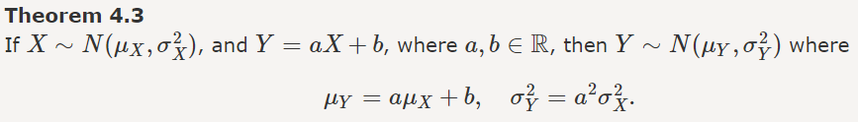
Hence we note that $w·r∼N\left(0,1;0,0106\right)$. We calculate the value in excel. Here it is worth noting that one shall plug in the standard deviation in excel, not the variance.
In Excel: NORMAL.FORDELING(0; 0,1; 0,1030; SAND)
Hence, there is 16,5806% chance of a negative return.

Exercise 4:
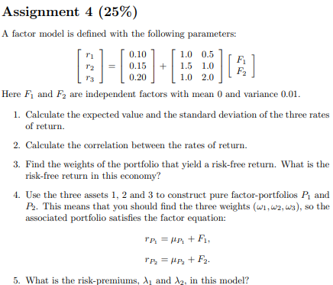
$${\overline{r}}_{i}=a_{i}+b_{1i}·\overline{F_{1}}+b_{2i}·\overline{F_{2}}$$
$$\overline{r}=\left(\begin{aligned}{\overline{r}}_{1} \\ {\overline{r}}_{2} \\ {\overline{r}}_{3}\end{aligned}\right)=\left(\begin{aligned}0,1 \\ 0,15 \\ 0,2\end{aligned}\right)+\left(\begin{matrix}1 & 0,5 \\ 1,5 & 1 \\ 1 & 2\end{matrix}\right)·\left(\begin{aligned}0 \\ 0\end{aligned}\right)=\left(\begin{matrix}0,1 \\ 0,15 \\ 0,2\end{matrix}\right)$$
$$σ_{i}=b_{1i}^{2}+σ_{F_{1}}^{2}+2·b_{1i}·b_{2i}·Cov\left(F_{1},F_{2}\right)+b_{2i}·σ_{F_{2}}^{2}$$
Since $F_{1},F_{2}$ are independent, $Cov\left(F_{1},F_{2}\right)=0$.
$$σ^{2}=\left(\begin{aligned}σ_{1}^{2} \\ σ_{2}^{2} \\ σ_{3}^{2}\end{aligned}\right)=\left(\begin{matrix}1^{2} & {0,5}^{2} \\ {1,5}^{2} & 1^{2} \\ 1^{2} & 2^{2}\end{matrix}\right)·\left(\begin{aligned}0,01 \\ 0,01\end{aligned}\right)=\left(\begin{matrix}0,0125 \\ 0,0325 \\ 0,05\end{matrix}\right)$$
$$σ=\left(\begin{matrix}{0,0125}^{\frac{1}{2}} \\ {0,0325}^{\frac{1}{2}} \\ {0,05}^{\frac{1}{2}}\end{matrix}\right)≈\left(\begin{matrix}0,1118034 \\ 0,18027756 \\ 0,2236068\end{matrix}\right)$$
Covariance:
$$ρ=\frac{Cov\left(r_{i},r_{j}\right)}{σ_{r_{i}}·σ_{r_{j}}}$$
$$Cov\left(r_{1},r_{2}\right)=1·1,5·0,01+0,5·1·0,01=0,2$$
$$ρ_{12}=\frac{0,02}{0,1118·0,1803}≈0,99218456$$
$$Cov\left(r_{1},r_{3}\right)=1·1·0,01+0,5·2·0,01=0,02$$
$$ρ_{13}=\frac{0,02}{0,1118·0,2236}≈0,80004864$$
$$Cov\left(r_{2},r_{3}\right)=1,5·1·0,01+1·2·0,01=0,035$$
$$ρ_{23}=\frac{0,035}{0,1803·0,2236}≈0,86816149$$
We must have that the weighted sum of both factor loadings be equal to zero.
$$x+y+z=1$$
$$x+1,5·y+z=0$$
$$0,5x+y+2·z=0$$
$⇕$ Ligningssystemet løses for x,y,z vha. WordMat's 'Løs Ligninger' funktion,
$$x=\frac{8}{3} ∧ y=-2 ∧ z=\frac{1}{3}$$
$$\overline{r}=\frac{8}{3}·0,1-2·0,15+\frac{1}{3}·0,2≈0,033333333$$

We know we must construct the first portfolio such that factor loadings on the first factor loading is equal to 1 and the second is equal to zero.

$$x+y+z=1$$
$$x+1,5·y+z=1$$
$$0,5x+y+2·z=0$$
$⇕$ Ligningssystemet løses for x,y,z vha. WordMat's 'Løs Ligninger' funktion,
$$x=\frac{4}{3} ∧ y=0 ∧ z=-\frac{1}{3}$$

We know we must construct the first portfolio such that factor loadings on the first factor loading is equal to 0 and the second is equal to 1.
$$x+y+z=1$$
$$x+1,5·y+z=0$$
$$0,5x+y+2·z=1$$
$⇕$ Ligningssystemet løses for x,y,z vha. WordMat's 'Løs Ligninger' funktion,
$$x=2 ∧ y=-2 ∧ z=1$$
We set up the matrix $\left[1 B\right].$ Here $1$ is a vector of one’s and B is the factorloadings matrix.
$$\overline{r}=\left[1 B\right]·λ$$
Here $λ$ is a vector of the risk- premiums.
$$\overline{r}=\left(\begin{matrix}0,1 \\ 0,15 \\ 0,2\end{matrix}\right)=\left(\begin{matrix}1 & 1 & 0,5 \\ 1 & 1,5 & 1 \\ 1 & 1 & 2\end{matrix}\right)·\left(\begin{aligned}λ_{0} \\ λ_{1} \\ λ_{2}\end{aligned}\right)⇒\left(\begin{aligned}λ_{0} \\ λ_{1} \\ λ_{2}\end{aligned}\right)={\left(\begin{matrix}1 & 1 & 0,5 \\ 1 & 1,5 & 1 \\ 1 & 1 & 2\end{matrix}\right)}^{-1}\left(\begin{matrix}0,1 \\ 0,15 \\ 0,2\end{matrix}\right)≈\left(\begin{matrix}0,033333333 \\ 0,033333333 \\ 0,066666667\end{matrix}\right)$$

Eksamen 2022:
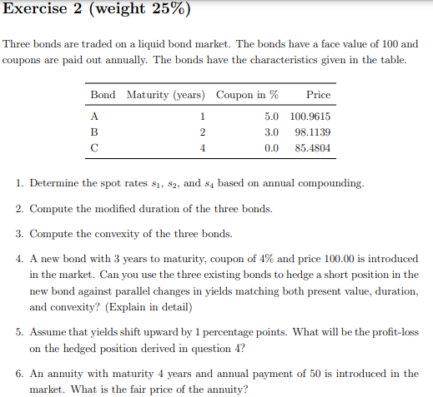
We determine the spots by calculating cash flows:
$$P=\sum_{k=1}^{n}{\frac{c_{k}}{{\left(1+s_{k}\right)}^{k}}}$$
Here $c_{k}$ is the payment the bond makes at time k.
$$P_{A}=100,9615=\frac{105}{1+s_{1}}$$
$⇕$ Ligningen løses for s vha. WordMat.
$$s_{1}=0,0400004$$
$$P_{B}=98,1139=\frac{3}{1,04}+\frac{103}{{\left(1+s_{2}\right)}^{2}}$$
$⇕$ Ligningen løses for a vha. WordMat.
$$s_{2}=-2,04 ∨ s_{2}=0,04000003$$
Spot rate for zero coupon bonds (ZCB).
$$s_{t}=m·\left({\left(\frac{F}{P}\right)}^{\frac{1}{m·t}}-1\right)$$
$$s_{4}=1·\left({\left(\frac{100}{85,4804}\right)}^{\frac{1}{1·4}}-1\right)≈0,04000006$$
Hence the spot rates are all equal to 0,0400. We have flat spot rate term structure.
Since we have flat spot rate term structure, the spot rate is equal to the yield.
Bond A can be seen as a zero coupon bond with face value of 105. Hence, we have two ZCB’s. We then use following formula for modified duration:
$$D_{Mod}=\frac{T}{\left(1+\frac{λ}{m}\right)}$$
$$D_{Mod}^{A}=\frac{1}{\left(1+0,04\right)}≈0,9615385$$
For the non ZCB we use the following formula:
$$D_{Mod}=D_{Mac}·{\left(1+\frac{λ}{m}\right)}^{-1}=\frac{\sum_{k=1}^{n}{\frac{k}{m}}·\frac{c_{k}}{{\left(1+\frac{λ}{m}\right)}^{k}}}{P}·{\left(1+\frac{λ}{m}\right)}^{-1}$$
$$D_{Mod}^{B}=\frac{\frac{3}{\left(1+0,04\right)}+\frac{2·103}{{\left(1+0,04\right)}^{2}}}{98,1139}·{\left(1+0,04\right)}^{-1}≈1,894807$$
$$D_{Mod}^{C}=\frac{4}{1+0,04}≈3,846154$$
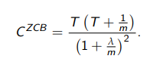
$$C^{ZCB}=\frac{T·\left(T+\frac{1}{m}\right)}{{\left(1+\frac{λ}{m}\right)}^{2}}$$
$$C^{A}=\frac{1·\left(1+1\right)}{{\left(1+0,04\right)}^{2}}≈1,849112$$
Convexity for non ZCB’s:
$$C=\frac{1}{P·{\left(1+\frac{λ}{m}\right)}^{2}}·\sum_{k=1}^{n}{\frac{k·\left(k+1\right)}{m^{2}}·\frac{c_{k}}{{\left(1+\frac{λ}{m}\right)}^{k}}}$$
$$C^{B}=\frac{1}{98,1139·{\left(1+0,04\right)}^{2}}·\left(1·\left(1+1\right)·\frac{3}{1+0,04}+2·\left(2+1\right)·\frac{103}{{\left(1+0,04\right)}^{2}}\right)≈5,438607$$
$$C^{C}=\frac{4·\left(4+1\right)}{{\left(1+0,04\right)}^{2}}≈18,49112$$
We need to construct a portfolio consisting of the three current assets that match the present value, duration and convexity of the new bond. First, we calculate the duration and convexity of the new bond.
$$D_{Mod}^{D}=\frac{\frac{1·4}{1+0,04}+\frac{2·4}{{\left(1+0,04\right)}^{2}}+3·\frac{104}{{\left(1+0,04\right)}^{3}}}{100}·{\left(1+0,04\right)}^{-1}≈2,775091$$
$$C^{D}=\frac{1}{100·{\left(1+0,04\right)}^{2}}·\left(1·\left(1+1\right)·\frac{4}{1+0,04}+2·\left(2+1\right)·\frac{4}{{\left(1+0,04\right)}^{2}}+3·\left(3+1\right)·\frac{104}{{\left(1+0,04\right)}^{3}}\right)≈10,53392$$
We can now construct three equations with three unknowns. The present value of future cash flows is how we define the price of an asset. Hence the present value is equal to the price.
$$P_{A}·x_{A}+P_{B}·x_{B}+P_{C}·x_{C}=P_{D}$$
$$P_{A}·D_{Mod}^{A}+P_{B}·D_{Mod}^{B}+P_{C}·D_{Mod}^{C}=P_{D}·D_{Mod}^{D}$$
$$P_{A}·C^{A}+P_{B}·C^{B}+P_{C}·C^{C}=P_{D}·C^{D}$$
Inserting the numbers.
$$100,9615·a+98,1139·b+85,4804·c=100$$
$$\frac{100,9615}{100}·0,9615·a+\frac{98,1139}{100}·1,8948·b+\frac{85,4804}{100}·3,8462·c=2,7751$$
$$\frac{100,9615}{100}·1,8491·a+\frac{98,1139}{100}·5,4386·b+\frac{85,4804}{100}·18,4911·c=10,5339$$
$⇕$ Ligningssystemet løses for a,b,c vha. WordMat's 'Løs Ligninger' funktion,
$$a=-0,2959842 ∧ b=1,009684 ∧ c=0,3605387$$
Hence, we need to short $-0,2960$ of the first asset, 1,0100 of the second asset and 0,3605 of the third asset.

We find the new prices of the assets after the change in yield.
$$P_{A}^{'}=\frac{105}{1+0,05}=100$$
$$P_{B}^{'}=\frac{3}{1+0,05}+\frac{103}{{\left(1+0,05\right)}^{2}}≈96,28118$$
$$P_{C}^{'}=\frac{100}{{\left(1+0,05\right)}^{4}}≈82,27025$$
We find the price of the portfolio:
$$100,9615·a+98,1139·b+85,4804·c=100$$
$$\frac{100,9615}{100}·0,9615·a+\frac{98,1139}{100}·1,8948·b+\frac{85,4804}{100}·3,8462·c=2,7751$$
$$\frac{100,9615}{100}·1,8491·a+\frac{98,1139}{100}·5,4386·b+\frac{85,4804}{100}·18,4911·c=10,5339$$

$$ΔP=-D_{Mod}·P·Δλ$$
$$\left(\begin{matrix}-0,2960 & 1,0097 & 0,3605\end{matrix}\right)·\left(\begin{aligned}100,9615+\left(-0,9615·100,9615·0,01\right)+100 \\ 98,1139 \\ 85,4804\end{aligned}\right)$$
$$\left(\begin{aligned}100,9615+\left(-0,9615·100,9615·0,01\right)+100,9615·\frac{1,8491}{2}·{0,01}^{2} \\ 98,1139 \\ 85,4804\end{aligned}\right)≈\left(\begin{matrix}100,00009 \\ 98,1139 \\ 85,4804\end{matrix}\right)$$
$$P^{pf}=θ^{T}·P=\left(\begin{matrix}-0,2960 & 1,0097 & 0,3605\end{matrix}\right)·\left(\begin{aligned}100 \\ 96,2812 \\ 82,2703\end{aligned}\right)≈97,273571$$
$$\left(\begin{matrix}-0,2960 & 1,0097 & 0,3605\end{matrix}\right)·\left(\begin{aligned}100,9615 \\ 98,1139 \\ 85,4804\end{aligned}\right)≈99,996685$$
The price of the fourth asset.
$$P_{D}^{'}=\frac{4}{1+0,05}+\frac{4}{{\left(1+0,05\right)}^{2}}+\frac{104}{{\left(1+0,05\right)}^{3}}≈97,27675$$
Since we go short in the new asset, we can consider it as an obligation to buy back the bond. This we fund by selling our portfolio. Hence, we get the following profit/loss:
$$97,273571-97,27675≈-0,003179$$

Exercise 4:
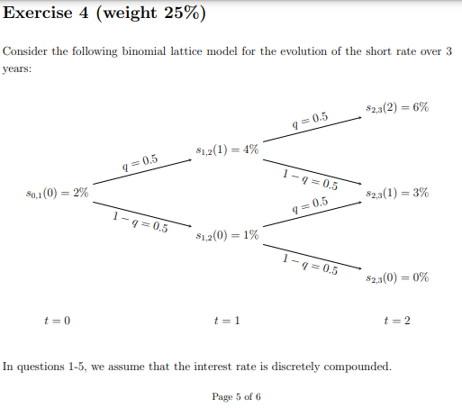
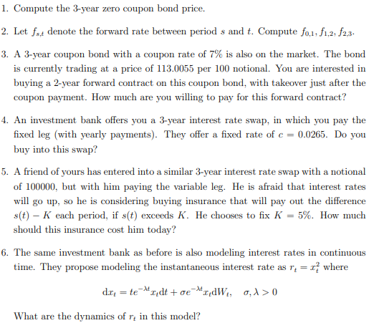
We find state prices.
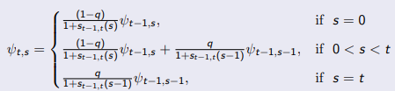
$$ψ_{1,0}=\frac{1-q}{1+s_{0,1}\left(0\right)}=\frac{0,5}{1+0,02}≈0,49019608$$
$$ψ_{1,1}=\frac{q}{1+s_{0,1}\left(0\right)}=\frac{0,5}{1+0,02}≈0,49019608$$
$$ψ_{2,0}=\frac{0,5}{1+0,01}·0,4902≈0,24267327$$
$$ψ_{2,1}=\frac{0,5}{1+0,04}·0,49019608+\frac{0,5}{1+0,01}·0,49019608≈0,47834252$$
$$ψ_{2,2}=\frac{0,5}{1+0,04}·0,49019608≈0,23567119$$
$$ψ_{3,0}=\frac{0,5}{1+0}·0,24267327≈0,12133663$$
$$ψ_{3,1}=\frac{0,5}{1+0,03}·0,47834252+\frac{0,5}{1+0}·0,24267327≈0,35354174$$
$$ψ_{3,2}=\frac{0,5}{1+0,06}·0,23567119+\frac{0,5}{1+0,03}·0,47834252≈0,34337076$$
$$ψ_{3,3}=\frac{0,5}{1+0,06}·0,23567119≈0,11116566$$
$$B_{0,T}=\sum_{s=0}^{T}{ψ_{T,s}}$$
$$B_{0,3}=0,1213+0,3535+0,3434+0,1112=0,9294$$
$$s_{0,t}=B_{0,t}^{-\frac{1}{t}}-1$$
$$s_{0,1}={\left(0,49019608+0,49019608\right)}^{-1}-1≈0,019999997$$
$$s_{0,2}={\left(0,24267327+0,47834252+0,23567119\right)}^{-\frac{1}{2}}-1≈0,022386411$$
$$s_{0,3}={\left(0,12133663+0,35354174+0,34337076+0,11116566\right)}^{-\frac{1}{3}}-1≈0,024700167$$
$$f_{0,1}=\frac{\left(1+0,02\right)}{1}-1≈0,02$$
$$f_{1,2}=\frac{{\left(1+0,0224\right)}^{2}}{\left(1+0,02\right)}-1≈0,024805647$$
$$f_{2,3}=\frac{{\left(1+0,0247\right)}^{3}}{{\left(1+0,0224\right)}^{2}}-1≈0,029315534$$
Since we first take over the bond after the second coupon payment, we need to include cost of carry.
$$F_{0,T}=\frac{S\left(0\right)}{d_{0,T}}-\sum_{k=0}^{T-1}{\frac{c_{k}}{d_{k,T}}}$$
$$d_{0,k}·d_{k·T}=d_{0,T}⇒d_{k,T}=\frac{d_{0,T}}{d_{0,k}}⇒\frac{1}{d_{k,T}}=\frac{d_{0,k}}{d_{0,T}}$$
$$F_{0,2}=\frac{S\left(0\right)}{d_{0,2}}-c_{k}·\left(\frac{d_{0,1}}{d_{0,2}}+\frac{d_{0,2}}{d_{0,2}}\right)$$
$$F_{0,2}=\frac{113,0055}{{\left(1+0,0224\right)}^{-2}}-7·\left(\frac{{\left(1+0,02\right)}^{-1}}{{\left(1+0,0224\right)}^{-2}}+1\right)≈103,95121$$

$$c=\frac{1-d_{0,t_{n}}}{\sum_{i=1}^{n}{d_{0,t_{i}}}}=\frac{1-{\left(1+0,0247\right)}^{-3}}{{\left(1+0,02\right)+\left(1+0,0224\right)}^{-2}+{\left(1+0,0247\right)}^{-3}}≈0,024288675$$
It is priced too expensive. We do not buy into the swap.
Pay off tree:
$$t=1 \left(up\right):0 \\ t=1 \left(down\right):0 \\ t=2 \left(up\right):100000·\left(0,06-0,05\right)≈1000 \\ t=2 \left(up,down\right):0 \\ t=2 \left(down\right):0$$

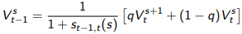
$$V_{1}^{1}=\frac{1}{1+s_{1,2}\left(1\right)}·q\left(V_{2}^{2}+V_{2}^{1}\right)=\frac{1}{1+0,04}·\frac{1}{2}\left(1000+0\right)≈480,76923$$
$$V_{1}^{0}=\frac{1}{1+s_{1,2}\left(0\right)}·q·\left(V_{2}^{1}+V_{2}^{0}\right)=\frac{1}{1+0,01}·\frac{1}{2}·\left(0+0\right)=0$$
$$V_{0}^{0}=\frac{1}{1+s_{0,1}\left(0\right)}·q·\left(V_{1}^{1}+V_{1}^{0}\right)=\frac{1}{1+0,02}·\frac{1}{2}·\left(480,76923+0\right)≈235,67119$$

$$V=0,01·0,23567119·100000=235,67119$$

We use ito’s lemma.
$$dX\left(t\right)=a\left(t,X\left(t\right)\right)dt+b\left(t,X\left(t\right)\right)dWt$$
Then.
$$df\left(t,X\left(t\right)\right)=\left(\frac{∂f}{∂t}+a\left(t,X\left(t\right)\right)·\frac{∂f}{∂X}+\frac{1}{2}b{\left(t,X\left(t\right)\right)}^{2}·\frac{∂^{2}f}{∂X^{2}}\right)dt+b\left(t,X\left(t\right)\right)·\frac{∂f}{∂X}dW_{t}$$
$$dr_{t}=\left(0+\left(t·e^{-λt}x_{t}\right)·2x_{t}+\frac{1}{2}·{\left(σ·e^{-λt}x_{t}\right)}^{2}·2\right)dt+\left(σ·e^{-λt}x_{t}\right)2x_{t}dW_{t} \\ =\left(2t·e^{-λt}+σ^{2}e^{-2·λt}\right)x_{t}^{2}dt+\left(2·e^{-λt}\right)x_{t}^{2}dW_{t}$$

Reeksamen 2022:

Exercise 1:
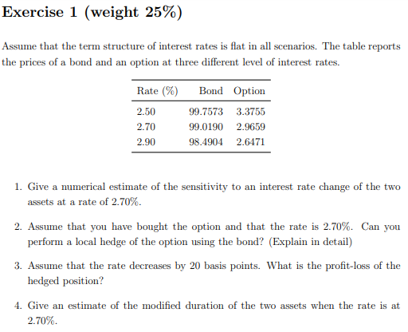
$$ΔP=-D_{M}·P·Δλ⇒-D_{M}=\frac{ΔP}{P·Δλ}$$
$$\frac{ΔP}{Δλ}$$
$$\frac{1}{2}·\left(\frac{99,0190-99,7573}{0,0270-0,0250}+\frac{98,4904-99,0190}{0,029-0,027}\right)≈-316,725$$
$$\frac{98,4904-99,7573}{0,004}≈-316,725$$
$$\frac{2,6471-3,3755}{0,004}≈-182,1$$

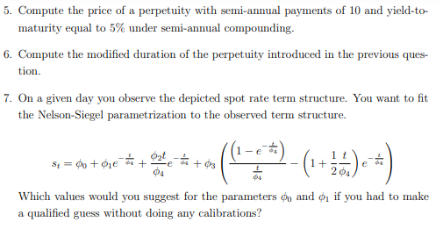
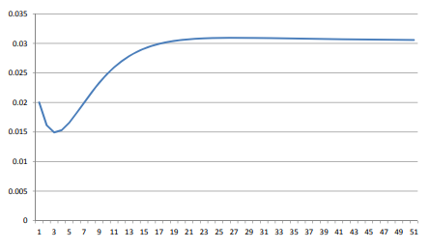

Exercise 2:
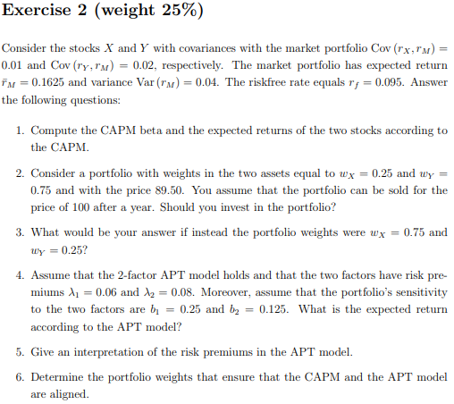
$$β_{X}=\frac{Cov\left(r_{X},r_{M}\right)}{σ_{M}^{2}}=\frac{0,01}{0,04}=0,25$$
$$β_{Y}=\frac{0,02}{0,04}=0,5$$
$${\overline{r}}_{i}=r_{f}+β_{i}·\left({\overline{r}}_{M}-r_{f}\right)$$
$${\overline{r}}_{1}=0,095+0,25·\left(0,1625-0,095\right)=0,111875$$
$${\overline{r}}_{2}=0,095+0,5·\left(0,1625-0,095\right)=0,12875$$
CAPM expected return:
$$0,25·0,1119+0,75·0,12875=0,1245375$$
“Private” expected return:
$$r=\frac{P_{1}-P_{0}}{P_{0}}=\frac{P_{1}}{P_{0}}-1=\frac{100}{89,5}-1≈0,11731844$$
Since the market expect it to perform better, we should invest.
CAPM expected return:
$$\overline{r}=0,75·0,1119+0,25·0,1288=0,116125$$
Now the market expect it to perform worse, hence we do not invest.

$$\overline{r}=λ_{0}+b_{1}·λ_{1}+b_{2}·λ_{2}$$
$$λ_{0}=r_{f}$$
$$\overline{r}=0,095+0,25·0,06+0,125·0,08=0,12$$
The $λ_{k}$’s can be interpreted as risk premiums. The factors $f_{k}$ are stochastic, hence they carry risk. The $λ_{k}$’s can be interpreted as the price of that risk.
$$x·0,1119+y·0,1288=0,12$$
$$x+y=1$$
$⇕$ Ligningssystemet løses for x,y vha. WordMat's 'Løs Ligninger' funktion,
$$x=\frac{88}{169} ∧ y=\frac{81}{169}$$
$$\frac{88}{169}≈0,52071006$$
$$\frac{81}{169}≈0,47928994$$

Exercise 3:
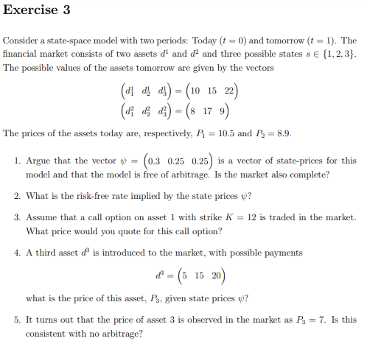
$$D=\left(\begin{matrix}10 & 15 & 22 \\ 8 & 17 & 9\end{matrix}\right)$$
$$P=D·ψ=\left(\begin{matrix}10 & 15 & 22 \\ 8 & 17 & 9\end{matrix}\right)·\left(\begin{aligned}0,3 \\ 0,25 \\ 0,25\end{aligned}\right)=\left(\begin{matrix}12,25 \\ 8,9\end{matrix}\right)$$
$$10·0,3+15·0,25+22·0,25=12,25$$

$$ψ_{0}=\sum_{s=0}^{S}{ψ_{s}}=\frac{1}{1+r_{f}}$$
$$0,3+2·0,25=\frac{1}{1+r}$$
$⇕$ Ligningen løses for r vha. WordMat.
$$r=0,25$$
$$q_{s}=\frac{ψ_{s}}{ψ_{0}}$$
$$q=\left(\begin{aligned}\frac{0,3}{0,8} \\ \frac{0,25}{0,8} \\ \frac{0,25}{0,8}\end{aligned}\right)≈\left(\begin{matrix}0,375 \\ 0,3125 \\ 0,3125\end{matrix}\right)$$
$$C_{0}=\frac{1}{1+0,25}·\left(0,375·\max\left(10-12;0\right)+0,3125·\max\left(15-12;0\right)+0,3125·\max\left(22-12;0\right)\right)=3,25$$
$$5·0,3+0,25·\left(15+20\right)=10,25$$
$$P=D·ψ⇒ψ=D^{-1}·P={\left(\begin{matrix}10 & 15 & 22 \\ 8 & 17 & 9 \\ 5 & 15 & 20\end{matrix}\right)}^{-1}·\left(\begin{aligned}10,5 \\ 8,9 \\ 7\end{aligned}\right)≈\left(\begin{matrix}0,68173516 \\ 0,17853881 \\ 0,0456621\end{matrix}\right)$$
They are strictly positive, so yes.

